Royal Berkshire Fire Authority

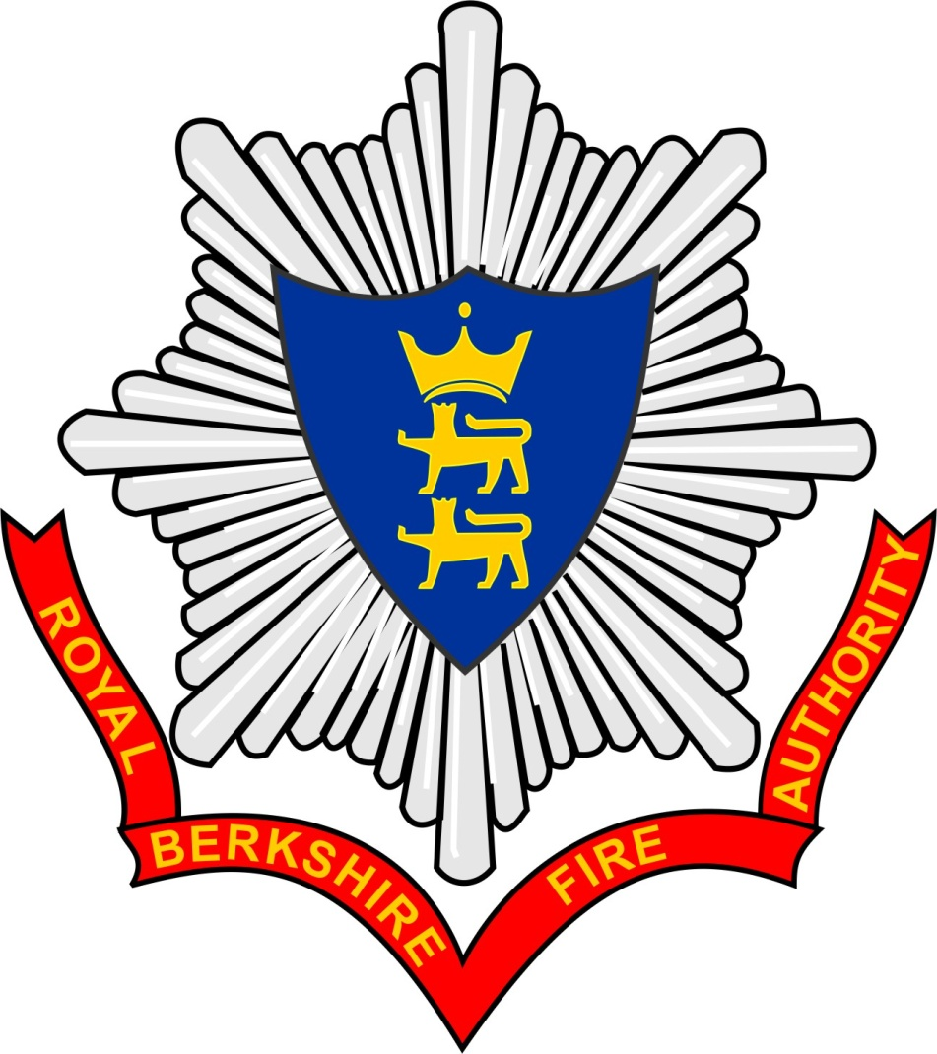

Role Descriptions
for
Royal Berkshire Fire Authority Members 2018/19

Introduction
This document contains the role description with person specification for the following roles in Royal Berkshire Fire Authority:
- Member of the Fire Authority
- Chairman and Vice-Chairman of a Fire Authority Committee
- Chairman and Vice-Chairman of the Fire Authority
- Fire Authority Lead Member
- Fire Authority Member Champion
The above 5 Members roles will be appointed annually at the Annual Fire Authority meeting held in June.
For clarity, where the above document has reference to Fire Authority this means Royal Berkshire Fire Authority.

Royal Berkshire Fire Authority - Member Role Description
- Accountabilities
- To Royal Berkshire Fire Authority and Royal County of Berkshire
- All Councillors will at all times observe the Members’ Code of Conduct and Member / Officer Protocol.

- Role and Functions of all Councillors
- To represent the interests of the population of the whole area of the Fire Authority
- To represent the views and interests of the constituent Unitary Authority and its communities on the Fire Authority
- To liaise with other Elected Members, principal authorities, officers and partner organisations to ensure Strategic Commitments of the Fire Authority are identified, understood and supported
- To be a channel of communication to the community on Fire Authority strategies, policies, services and procedures
- To be an advocate for the Fire Authority

  - Making decisions and overseeing Fire Authority performance
- To participate in Fire Authority meetings, reaching and making informed and balanced decisions, and overseeing performance
- To participate in informed and balanced decision making on Fire Authority committees to which they might be appointed
- To adhere to the principles of democracy and collective responsibility in decision-making
- To promote and ensure efficiency and effectiveness in the provision of Fire Authority services

  - Representing the Authority (subject to appointment)

- To represent the Fire Authority on outside bodies as an appointee of the Fire Authority
- To represent the Fire Authority on local partnership bodies, promoting common interest and co-operation for mutual gain
- To represent and be an advocate for the Fire Authority on national bodies and at national events
  - Internal governance, ethical standards and relationships
- To promote and support good governance of the Fire Authority and its affairs
- To provide leadership and promote citizenship as a representative of the Fire Authority

  - Personal and role development
- To participate in opportunities for development provided for members by the Fire Authority
3 Rights and Duties
- Councillors will have such rights of access to documents, information, of the Fire Authority as are necessary for the proper discharge of their functions and in accordance with the Local Government Act 1972 (section 100B)

- Councillors will not make public, information which is confidential or exempt without the consent of the Fire Authority or the subject of the information, or divulge personal information or information given to them in confidence to anyone other than a Councillor or officer entitled to know it without consent.

- For these purposes, “confidential” and “exempt” information are defined in the Local Government (Access to Information) Act 1985

- Councillors will mediate fairly and constructively, and encourage trust by representing all sections of the community

- Councillors will act ethically, consistently and with integrity when communicating values or representing group views in decisions and actions

Chairman and Vice Chairman of a Committee - Role Description

Committee Chairman
4 Accountabilities
- To the Fire Authority and Royal County of Berkshire
- To the Members of the Committee

- Role and Functions of Committee Chairman and Vice Chairman

  - Provide leadership and direction
- In addition to Member Job description in sections 1-3, the Committee Chairman are required to:
- To provide confident and effective management of meetings to facilitate inclusivity, participation and clear decision making
- To demonstrate integrity and impartiality in decision making in accordance with legal, constitutional and policy requirements
- To delegate actions to sub committees as appropriate

  - Promoting the role of the Committee
- To act as an ambassador for the Committee, facilitating understanding of the role
- To act within the constitutional requirements to oversee the functions of the committee fairly and correctly
- To ensure thoroughness and objectivity in the Committee, receiving and responding to professional advice in the conduct of meetings
- To promote and support good governance by the Authority

  - Effective meeting management
- To set agendas containing clear objectives and outcomes for the meeting
- To ensure that the necessary preparation is done beforehand
- To ensure that all participants have an opportunity to make an appropriate contribution
- To report on progress against the work programme to the Authority.

6. Committee Vice-Chairman

- To fulfil the duties of the Chairman in his or her absence
- To assist the Chairman in specific duties as required.

Fire Authority Chairman (and Vice-Chairman) Role Description

Chairman
7. Accountability
- To the Fire Authority and Royal County of Berkshire

- Role and Purpose of Activity
8.1 In addition to Member Job description in sections 1 – 3, the Fire Authority Chairman as the elected leader and as a symbol of the Authority’s democratic powers are required to:
- To uphold the democratic values of the Authority
- To be the elected representative’ figurehead for the Authority and be the principal political spokesperson for the Authority
- To provide leadership in building a political consensus around the Authority’s policies
- To provide strong, clear leadership in the coordination of policies, strategies and service delivery
- To represent the Authority at civic and ceremonial functions
- To preside over meetings of the Authority, so that its business can be carried out effectively and efficiently
- To ensure that the Authority conducts its meetings in line with the Authority’s Standing Orders

  - Managing and leading the work of the Authority
- To ensure the effective running of the Authority by managing the forward work programme and ensuring its continuing development
- To ensure the work of the Authority meets national policy objectives
- To advise and mentor other Authority members in their work; to prepare and manage an annual work programme for the Authority to meet its legal and statutory obligations (e.g. budget setting, Risk Reduction Planning etc.)
- To chair meetings of the Authority in line with its Standing Orders

  - Participating in the collective decision making of the Authority
- To work closely with other Authority members to ensure the development of effective Authority policies and the budgetary framework for the Authority, and the delivery of high quality services to the local community
- To accept collective responsibility and support decisions made by the Authority once they have been made

  - Working with officers to lead the organisation
- To liaise with the Chief Fire Officer, and other appropriate officers, on a regular basis
- To work with employees of the Authority in relation to the strategic commitments and direction of the Authority

  - Leading partnerships and community leadership
- To give leadership to local strategic partnerships and local partners in the pursuit of common aims and priorities
- To negotiate and broker in cases of differing priorities and disagreement
- To be a recognised media contact
8.7 To promote Internal governance, ethical standards and relationships set out on 2.3

Vice-Chairman
8.8 To fulfil the duties of the Chairman in his/her absence
- To assist the Chairman in specific duties as and when required
- Therefore, to understand and carry out the Chair’s job purpose as set out above.

Lead Member Role Description
9 Accountabilities

- To the Fire Authority and/ or Management Committee

- The Structure of the Fire Authority have allocated the following Lead Member roles
      - Budget and Income Generation
      - Integrated Risk Management Plan
      - Strategic Asset Management, and
      - Collaboration

      - Role and Responsibilities

10.1 In addition to Member Job description in sections 1-3, the role Lead Members are required:
- To represent area of business to Members on the Management Committee and / or Fire Authority
- To understand appointed area of business within the Fire Authority
- To lead and support local initiatives related to the interest
- To represent the position of the Fire Authority to the community in relation to the interest
- To understand the Fire Authority’s Strategic Commitments and Policy Direction.
- To engage with a range of members and officers around the area of business in and out of Committee meetings
- To be the first point of contact for Directors / Head of Service in briefing / liaising and updating areas of business

- To receive regular updates on the progress of their area of business

- To be involved in the content of the report to be presented to Management Committee and / or Fire Authority

- To provide assurance to the Management Committee and or Fire Authority that recommendations and decisions arising from the business area are sound and evidence based, have followed appropriate processes, and are aligned to strategic commitments/ policy direction.

- To introduce reports on their area of business to Management Committee and / or Fire Authority, and if necessary establish Task and Finish Groups to provide additional Member involvement in specific areas of business.

- To attend conferences/seminars relevant to area of business

- To be a recognised media contact

- To publish an annual report on work undertaken for consideration by the Fire Authority

Role of Member Champions
- Accountabilities

- Royal Berkshire Fire Authority

- The Structure allocates the following Member Champion roles:

- Community Safety Champion

- Safety, Health, Fitness and Wellbeing Champion

- Organisational Development Champion

- Roles and Responsibilities

  - The roles and responsibilities outlined below have been created to align to Royal Berkshire Fire Authority’s Strategic Commitments and to make the best use of a Member’s experience and interest, whether gained in their constituent authority, working life or through a personal hobby.

13.2 In addition to Member Job description in sections 1-3, Member Champions are required:
- To promote their area of interest both within and outside the Fire Authority

- To act as an advocate on their area of business within and outside the Fire Authority

- To work alongside officers in making contact with local organisations and the community to establish effective and regular consultation arrangements with those organisations

- To represent the views of such organisations to the Fire Authority

- To become familiar with the needs and priorities of the relevant section of the community, or range of activities concerned, and to weigh up interests expressed in order to provide sound advice on the implications of alternative courses of action.

- To feedback decisions of the Fire Authority and to explain the Fire Authority’s position on specific issues of concern to relevant organisations and to individuals involved.

- To attend meetings / conferences related to their area of business on behalf of the Fire Authority

- To publish an annual report on work undertaken for consideration by the Fire Authority.

