Safe Space
Royal Berkshire Fire and Rescue Service premises are a safe space.
We will offer you a place where you can receive information about helpful organisations. Some of these are listed below:
Mental health – Mind.org.uk or call their Infoline 0300 123 3393
Samaritans – call 116123 for free
Childline – free and confidential service, call 0800 1111 for free

Bright-Sky.org.uk is for anyone in an abusive relationship, or if you’re worried about someone else.
Women - Refuge's National Domestic Abuse Helpline is on 0808 2000 247 and is available 24 hours a day seven days a week for free, confidential specialist support.
Men - can call Respect Men's Advice Line (mensadviceline.org.uk) on 0808 8010 327 (Monday and Wednesday, 9am to 8pm, and Tuesday, Thursday and Friday, 9am to 5pm) for non-judgmental information and support
Also call ManKind on 0182 3334 244 (Monday to Friday, 10am to 4pm)
LGBTQ+ - call Gallop (gallop.org.uk) on 0800 999 5428 for emotional and practical support.
Forced Marriage and Honour Crimes - Karma Nirvana (karmanirvana.org.uk) on 0800 5999 247 (Monday to Friday 9am to 5pm) for forced marriage and honour crimes. You can also call 020 7008 0151 to speak to the GOV.UK Forced Marriage Unit
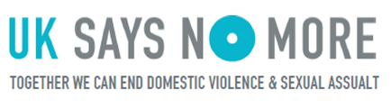
Email contacts – you will need to give an email address which is safe to respond to
- Women can email helpline@womensaid.org.uk Staff will respond to your email within 5 working days
- Men can email info@mensadviceline.org.uk
- LGBT+ people can email help@galop.org.uk
- Refuge (nationaldahelpline.org.uk) to fill in a webform and request a safe time to be contacted or to access live chat (live chat available 3pm-10pm Monday to Friday).
If you feel afraid, harassed or are under immediate threat call 999

