Equality, Diversity and Inclusion Objectives Consultation
  - Summary Report

Contents
- Consultation Headlines 4
- Executive Summary 5
What We Consulted On 5
- Methodology 6
Consultation Resources 7
Local and Online Media 7
Online Survey 7
Website 8
Media 8
External Promotion 8
Social Media 8
Analytics 9
Internal Communications 9
- Equality, Diversity and Inclusion 9
- Analysis of Responses 10
Quantitative Data 10
Qualitative Data 10
Response to Consultation 10
Main Findings 11
Overall Response 11
Summary of Themes 11
- Equality and Diversity Monitoring 13
Respondents Profile 13
- Summary and Next Steps 21
- APPENDIX 1 22
Respondent comments 22

Consultation Headlines

Total Responses
252

Social Media Engagement

23,771 reached
452 engagements

Community contacts were contacted
1,373
113 visits to the webpage
Spending an average of 3.24 minutes on the page

Story posts resulted in 9 more clicks to complete the survey

Respondents completed the entire survey
67.8%

Comments received on
the online survey
200

93.3% agreed with Objective 3: Improving our service delivery by creating strong links with our community: We will connect and communicate with our diverse local community to develop meaningful and sustainable links, which help us to increase our understanding of their needs. We will ensure that we tailor our prevention, protection and response activities accordingly and target the most vulnerable people with the greatest risk.
82.78% agreed with Objective 1: Increasing the diversity of staff at all levels: We recognise the value that a diverse workforce brings and will take action to increase the diversity of job applicants, seeking individuals with the right behaviours and skills to help us reflect and engage with our local communities.

16 engagements
320 impressions

73 engagements
4,217 impressions

93.89% agreed with Objective 4: Creating an inclusive culture of equality and diversity. We will take action to ensure we have a culture where everyone feels valued and is treated with dignity and respect, and support all staff to contribute to the creation of an inclusive working environment.

Social Media Engagement

11,153 reached
12,386 impressions

340% increase in responses from business owners compared to our last public consultation

53% increase in responses overall compared to our last public consultation

622 video views
3,011 impressions

452 engagements
25,890 impressions

195 video views

Email Responses
11

Hard Copy Responses
32

Easy Read Responses
4

90.56% agreed with Objective 2:
Leadership and corporate commitment: We will support our organisational leaders to understand their role in tackling inequalities and demonstrating inclusive behaviours, in line with our Behavioural Competency Framework. This commitment means we will be strong and visible in our leadership and ensure that all staff and members of our local communities have confidence in our commitment to equality, diversity and inclusion.

Executive Summary
This report summarises the main findings from the Equality, Diversity and Inclusion Objectives consultation, which was carried out by Royal Berkshire Fire and Rescue Service (RBFRS) on behalf of Royal Berkshire Fire Authority (RBFA).
The consultation ran from 28 February 2022 – 4 April 2022, allowing five weeks for respondents to provide views on the proposed equality, diversity and inclusion objectives.
During the consultation, we received 252 responses from various stakeholders. Details of responses and respondent demographics are included within the report, but overall the consultation response demonstrated that there was agreement with the proposed objectives.
This document provides information on how the consultation was conducted and presents an analysis of the data gathered.

What We Consulted On
In line with the requirements of the Public Sector Equality Duty (PSED) as set out in the Equality Act 2010, the Fire Authority encouraged as many people as possible to have their say on our four revised Equality, Diversity and Inclusion Objectives.
The four objectives proposed were:
- Objective 1 – Increasing the diversity of staff at all levels: We recognise the value that a diverse workforce brings and will take action to increase the diversity of job applicants, seeking individuals with the right behaviours and skills to help us reflect and engage with our local communities.
- Objective 2 – Leadership and corporate commitment: We will support our organisational leaders to understand their role in tackling inequalities and demonstrating inclusive behaviours, in line with our Behavioural Competency Framework. This commitment means we will be strong and visible in our leadership and ensure that all staff and members of our local communities have confidence in our commitment to equality, diversity and inclusion.
- Objective 3 – Improving our service delivery by creating strong links with our community: We will connect and communicate with our diverse local community to develop meaningful and sustainable links, which help us to increase our understanding of their needs. We will ensure that we tailor our prevention, protection and response activities accordingly and target the most vulnerable people with the greatest risk.
- Objective 4 – Creating an inclusive culture of equality and diversity: We will take action to ensure we have a culture where everyone feels valued and is treated with dignity and respect, and support all staff to contribute to the creation of an inclusive working environment.
Respondents were asked whether they agreed or disagreed with each objective, and were furthermore offered the opportunity to express more detailed views in comments on each individual objective, as well as overall.

Methodology
As noted, the Equality Act 2010 sets out the requirement for public authorities to comply with the Public Sector Equality Duty. Essentially, this places a duty on public bodies to consider how policies and decisions conducted by the organisation affect people who are protected under the Equality Act.

The intention of this duty is to accelerate progress towards equality, by placing a responsibility on public bodies to consider how they can work to tackle inequalities and discrimination specifically relating to individuals with protected characteristics as defined by the Equality Act.

The requirements of the PSED are categorised into general and specific duties:
General Duties
- Section 149 of the Equality Act 2010 requires us to demonstrate compliance with the PSED
- Eliminating unlawful discrimination, harassment, victimisation and any other conduct prohibited by the Equality Act 2010
- Advance equality of opportunity between people who share a protected characteristic and people who do not share it
- Foster good relations between people who share a protected characteristic and people who do not.
Specific Duties
- Publish information to demonstrate compliance with the Equality Duty, at least annually
- Set equality objectives, at least every four years.
This consultation period ran for five consecutive weeks from 28 February 2022 – 4 April 2022. In carrying out the consultation, RBFRS followed the legal principles that underpin consultation. These are known as the four ‘Gunning Principles’ which specify how public bodies should consult. They specify that:
- Consultation should be carried out when proposals are at the formative stage;
- Sufficient information is provided to allow intelligent consideration of the proposals;
- Adequate time is given for response; and
- Responses are conscientiously considered before decisions are taken.
RBFRS’ Consultation Strategy can be accessed online.

Consultation Resources
The Equality, Diversity and Inclusion Objectives consultation was publicised across the Service’s digital channels, including social media platforms, website, intranet (available to RBFRS staff) and online and local media.
Consultation materials were made available via a number of accessible methods.
These included:
- Online via rbfrs.co.uk/consultations
- By emailing consultations@rbfrs.co.uk
- By writing to:
  - Chloe Duncan,
  - EDI Co-ordinator
  - Royal Berkshire Fire and Rescue
  - Newsham Court
  - Pincents Kiln
  - Reading
  - Berkshire
  - RG31 7SD

Local and Online Media
In order to improve engagement with the consultation, specific stakeholders were identified and contacted directly.
Feedback from all stakeholders were obtained using the following engagement methods:

Online Survey
The consultation team designed an online survey to collect quantitative and qualitative data responses to the consultation questions. This enabled the team to analyse numerical data and also provided an in-depth look at the nature of responses given.

Website
A section was created on the RBFRS website on the ‘Consultation’ page. This included:
- An introduction, detailing what the consultation was focusing on.
- Information on how people could take part in the consultation.
- A link to the survey.
- An email address, postal address and telephone number to provide alternative methods of response.
- Details on accessibility, for people requiring alternative formats or languages.

We had a total of 113 visits to the website page during the time it was running, with users spending an average of 3 minutes and 24 seconds on the page.

Media
A press release was issued to media contacts at the beginning of the consultation on Monday, 28 February 2022, which provided details of the consultation and how to get involved, outlining the reasons for the consultation and the importance of taking part.

External Promotion
Letters were sent via email to various partner agencies and contacts, including other Fire and Rescue Services, the Leaders of the unitary authorities, MPs and Town and Parish Councils, and representative bodies including the Fire Brigades Union. Moreover, 1,373 community contacts across a broad range of organisations – from schools to faith groups and disability inclusion organisations – were also contacted. This wide range of contacts was used in order to encourage as many areas of our community as possible to take part in our consultation – particularly those who have been under-represented in our consultations in previous years.
Details of the consultation were shared with local authorities to include in their residents’ newsletter and featured in the Royal Borough of Windsor and Maidenhead’s newsletter on 18 March 2022.

Social Media
To complement the channels above, social media was used throughout the consultation programme to enable respondents to share the information and to encourage engagement.
Information was posted on RBFRS’ Facebook, Twitter, Instagram and LinkedIn pages at regular intervals, to encourage people to participate in the consultation.
We also engaged partner organisations to further raise awareness of the consultation, including the Business Disability Forum and Inclusive Employers, both organisations of which RBFRS is a current member.

Analytics
Analytics for Facebook, Twitter, LinkedIn, YouTube and Instagram are as follows:
Our Facebook posts resulted in 23,771 people being reached and 452 engagements. We posted in more than 50 community groups to raise awareness of the consultation.
In total, our Twitter posts received 4,217 impressions and had 73 engagements.
Our LinkedIn posts achieved 320 impressions and 16 engagements. Our posts on Instagram resulted in a further 9 clicks directly through to the consultation survey.

Internal Communications
Siren (our service intranet page) featured an announcement of the opening of the consultation and regular reminders for staff to take part. Ahead of the public consultation period, the EDI Forum was consulted and offered the opportunity to share input regarding the revised objectives. This provided the opportunity to discuss the proposed changes and promoted understanding of the drivers for change.
On the day of launch, an email was sent to all staff on behalf of the Chief Fire Officer, outlining the details of the consultation and explaining the importance of taking part.
Updates were also posted on Workplace, a platform for businesses run by Facebook. It allows members to post in various groups with different groups of staff. The survey link was shared on Workplace to encourage more staff to take part.

Equality, Diversity and Inclusion
RBFRS recognises the importance of Equality, Diversity and Inclusion (EDI).
In line with consultation best practice, an Equality Impact Assessment (EIA) was completed for the consultation process. The intent of the EIA is to ensure that we are aware of the risks and impacts of our work on individuals or groups who share protected characteristics, and other non-statutory social characteristics as identified within our documentation (such as rurality, homelessness and those with caring responsibilities).

Analysis of Responses
The majority of the data was gathered via an online survey conducted using ‘Survey Monkey’. All data was anonymised in line with best practice.

Quantitative Data
Quantitative data was used in a number of ways during this consultation. Our Survey Monkey platform enabled us to provide an indication of response rate to the survey, including skipped questions and impartial completions. It also provided:

- Equality and diversity information to analyse the demographic profile of respondents.

- The overall percentage of responses who agreed or disagreed with each objective. This indicated the weight of preference from the respondents in total.

Qualitative Data
The option to provide further comments as part of the survey response was used to enable respondents to provide individual and specific feedback on the consultation proposals.
Responses were analysed using coding methodology and common themes in the feedback were highlighted.
We received 252 responses to the consultation, 199 specific comments on the objectives and 54 additional comments which are included in Appendix 1 below.

Response to Consultation
We received 252 responses to the consultation in total, via the online survey platform. We consulted more widely than ever before, using a range of communications channels, as outlined above.
The tables and figures below illustrate the demographic profile of the respondents who gave their feedback to the consultation through our Survey Monkey platform.

Within our data reporting, we have noted the number of questions that were answered, as well as the number of questions skipped. We have presented this data in order to be transparent. We felt that it was important that respondents do have the option to skip questions, in order to encourage participation and a higher response rate. If we were not to allow respondents to skip questions, we may have achieved a lower response rate or missed an opportunity to collect data and feedback about our proposals across the survey.

Main Findings

Overall Response

The data shows that:
- Overall, the predominant response to each objective was agreement.
- The lowest agreement rate was for Objective 1 (increasing the diversity of staff at all levels) at 82.78%, equating to 149 responses in agreement and 31 disagreeing with this objective.
- The highest agreement rate was for Objective 4 (creating an inclusive culture of equality and diversity) at 93.89%, equating to 169 responses in agreement and 11 disagreeing with this objective.
- Between this, both Objective 2 and Objective 3 were largely supported by respondents. Objective 2 was agreed to by 163 respondents, with 17 disagreeing. Similarly, Objective 3 was agreed to by 168 respondents, with 12 in disagreement.

Summary of Themes
Respondents were offered the opportunity to add comments for each individual objective as well as the overall consultation, with a significant number choosing to do so as detailed in the table below:

Objective | Number of Comments
1 | 71
2 | 45
3 | 37
4 | 46
Overall | 54

A number of common themes were identified amongst respondents to the consultation. Responses were analysed and coded by theme to assess the concerns of respondents and to identify key positive and negative thoughts around the proposed objectives.
Objective 1:
- Positive responses were conditional on ensuring that we still select the best person for the job
- Negative responses included a small proportion of extreme negative responses; general disagreement related to the objective was based on a misconception that we would not select on merit; that this constitutes positive discrimination; that we are incorporating targets/numbers
- Neutral comments were concerned with how we would measure achievement of this, and the need for the service to be trained on why this is important. They also suggested inclusion of retention and progression considerations.
Objective 2:
- Positive responses were conditional on the need for further support and training for staff; support for leaders challenging inappropriate behaviour; a desire more for visibility of and access to SLT
- Negative responses again included a small proportion of extreme negative responses, with other disagreement related to concern that this is not related to our primary role of fighting fires
- Neutral comments suggested the importance of supporting the objectives with clear actions.
Objective 3:
- A greater proportion of comments provided for this objective were positive; respondents agree that this is an important objective, that the Service should seek to acknowledge and be reflective of the diversity of Berkshire, and that we currently do not have sufficient understanding of our communities and their needs. They also emphasised the importance of acting on this commitment
- Disagreement was primarily related to the concern that we are suggesting that diverse communities are automatically the most vulnerable; that this is not our job and we should focus on our primary role of fighting fires
- Neutral comments expressed concern that the Service doesn’t have sufficient infrastructure to resource this.

Objective 4:
- Positive responses acknowledged that an inclusive culture should be a given in every organisation.
- There was again a small proportion of extreme negative responses; broader disagreement related to the misconception that this objective involves employing people specifically to create diversity, and questioned what actions would be taken to achieve this objective.
- Neutral comments expressed concern about the difficulty of achieving this objective, and noted that this is an important objective to achieve but emphasised the importance of ensuring that this is the reality of experience for all staff.

Equality and Diversity Monitoring
We are continually working to improve the way in which we reach and engage with different groups across Royal Berkshire and continue making conscious efforts to increase the accessibility and availability of the consultation material and methods, in order to further improve engagement with individuals and communities. In the future, we will additionally be considering the pre-engagement work we may be able to do with different groups within our County to inform our consultation activity and promote inclusivity within our work with the public.
Within this consultation, it is useful to note that we have expanded the opportunity for respondents to self-describe. This has been offered to increase the inclusivity of the consultation. For future consultations, we will be considering how we can continue to develop the accessibility and inclusivity in line with good practice.
The following provides an outline of key themes from the equality monitoring questions included in the consultation, separated by characteristic in line with the consultation questions, which all respondents were given the option to complete.
Figures used for representation of the population of Berkshire are taken from the most recent National Census in 2011, as well as The Office for National Statistics. We await the publication of the next Census later this year and will use it to inform our understanding of the community we serve.

Respondents Profile
The figures below illustrate the demographic profile for all responses via the Survey Monkey questionnaire. RBFRS are committed to promoting equality and diversity, and therefore by collecting this information we are able to monitor the response rate to our consultation across a range of communities and backgrounds. This enables us to continually evaluate our work and to improve efforts to engage a representative sample of people within Royal Berkshire as a process of ongoing development. The equality and diversity information also enables us to monitor the weight of responses from RBFRS personnel in comparison to members of the public.

Unitary Response Rates
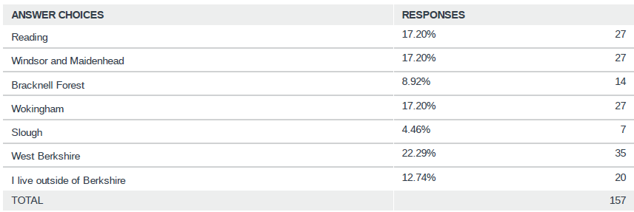
This data shows:
- The largest response group was West Berkshire
- Similarly significant proportions from Reading, Windsor and Maidenhead, Wokingham
- A small amount of responses from Bracknell Forest, fewest from Slough
- Comparatively similar pattern to some previous RBFRS consultations.

Age
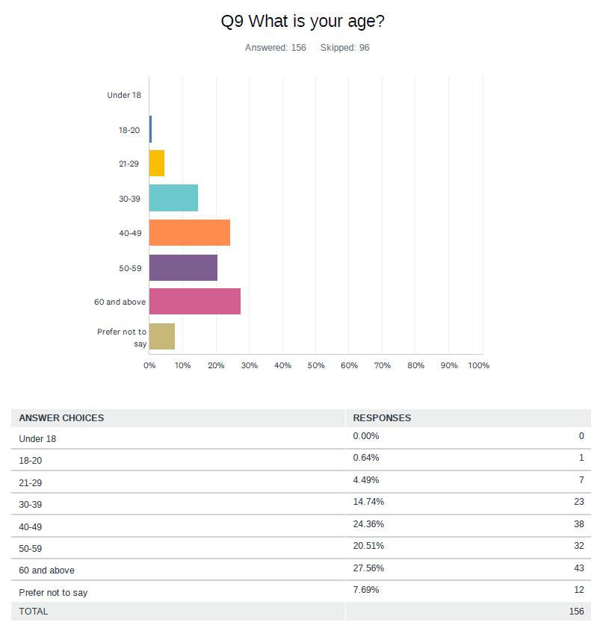
This data shows:
- Largest response groups – 40-49, 60+, followed by 50-59, 30-39
- Small number of responses from younger age groups
- Comparatively similar pattern to previous RBFRS consultations regarding lower proportions of responses from younger age groups.

Gender Identity
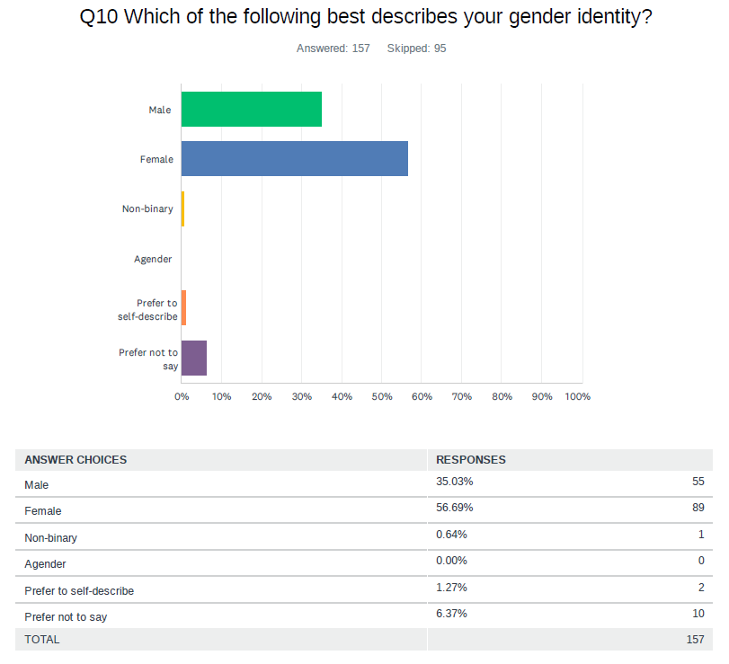
This data shows:
- 56.69% female, 35.03% male
- Small % of non-binary, prefer to self-describe and prefer not to say
- This is in contrast to some other RBFRS consultations, where there is a tendency for higher proportion of responses from those identifying as men.

Ethnicity
This data shows:
- 78% of respondents were White British, all other represented groups had totals of less than 3%; 5.33% selected prefer not to say
- Comparatively similar pattern to previous RBFRS consultations
- It is important to note that ethnic diversity ranges significantly across the County; 2011 census 27.32% of census respondents were from groups other than White British
- Further work is required to ensure seldom heard groups are included in our consultations.

Religion and Belief
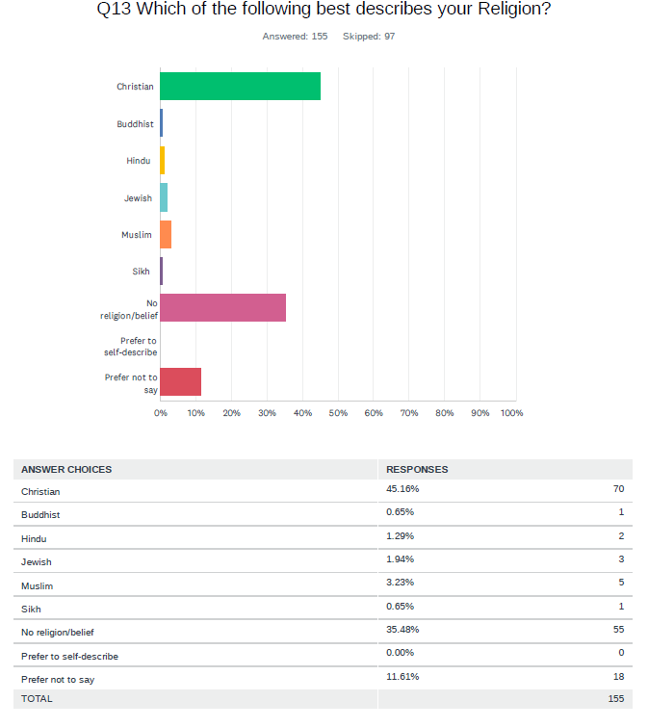
This data shows:
- 45.16% Christian, 25.48% no religion or belief, very small percentage of respondents identified their religion or belief as Buddhist, Hindu, Jewish, Muslim and Sikh.
- Comparatively similar pattern to previous RBFRS consultations.
- Christianity and no religion are the predominant groups in Berkshire, but the response rate for this consultation is still not reflective of proportion of other groups according to ONS Local Authority data. Further work is required to engage more effectively with these under-represented groups.

Disability
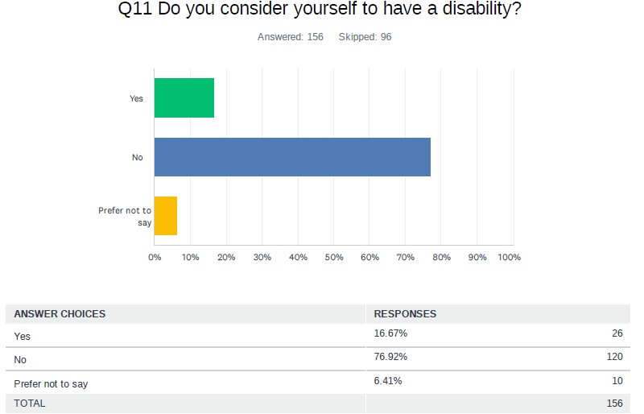

This data shows:
- 16.67% respondents do consider themselves to have a disability
- For future consultation activity, this data has highlighted the continued need to work towards a more representative response from those who identify as having a disability and that we may focus our engagement strategy to encourage more participation from and/or make our consultation methodology and materials increasingly accessible to those identifying as having a disability or long-term health condition.

Sexual Orientation
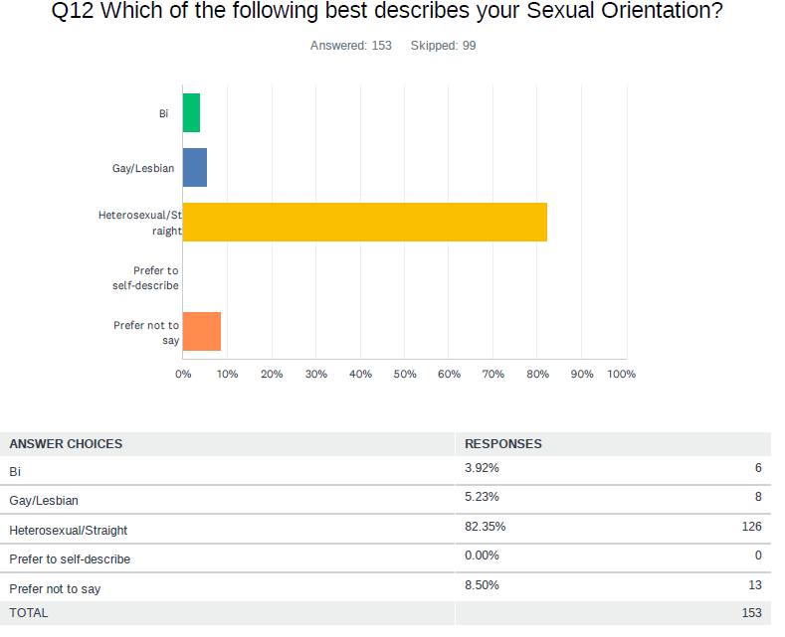
This data shows:
- The largest response group was those identifying as heterosexual/straight with 82.35% of responses
- There were responses also from those identifying in LGBTQ+ groups including bi, gay/lesbian, although it is important to continue to consider how we can engage with our local LGBTQ+ community in future consultations.

Summary and Next Steps
RBFRS will continue to review its consultation methods to ensure we communicate with our stakeholders in an effective and meaningful way. We welcome any feedback you may have, so please email consultations@rbfrs.co.uk with any suggestions.
On 28 April 2022, Royal Berkshire Fire Authority will conscientiously consider the outcomes of this report. The final objectives will be published accordingly following this.

APPENDIX 1

Respondent comments
Please note comments are lifted directly from consultation responses and only amended with asterisk * where necessary.

Objective 1
Excellent! This is exactly what we need!
Will this be by only allowing applications from the group you seek to improve representation from?
Providing the best person is always chosen for the job in hand and not just to make targets
People should be selected on merit, without positive or negative discrimination.
Yes as long as it is the right person for the role and not to meet targets. For instance: Someone in a customer facing role must have good English language skills with any other languages as a bonus
It is always a positive thing to try and include people from every walk of life as long as the people who are being hired and employed are also the best candidates for the job and not just being employed to represent a minority group.
It is important that our service reflects the communities we serve
Woke, Marxist, anti-merit, anti-white racist, anti-indigenous, misandrist, heterophobic, claptrap. Seriously damaging to capability, the workplace, and social cohesion.
This is a good policy as long as it does not impact on the skill level of new employees. Appointing people solely on the efthnicity / gender rather than a more qualified applicant is counter -productive.
You can't take on people from other ethnic backgrounds if there not capable of doing the job just so you can virtue signal and say you're diverse. That's where this kind of idea gets you.
Diversity creates disorder and inefficiency.
Diversity is not preclusion to competence, competence is
I believe in diversity and equality in the employment place providing that those who are employed are the right people for the job and not employed for "diversity sake" !!
An organisations first priority should be to ensure that new workplace candidates have the necessary skills, experience and knowledge for the job itself regardless of the individuals colour, race or sex. The organisation should not consciously be tasked to increase diversity and accept a candidate because they are LBGT.
Providing you are selecting the best candidates, reverse discrimination isn’t the answer. Give everyone a fair chance
I think that any organisation should pick the people who can do the job properly regardless of sex, nationality, ethnicity or sexual orientation.
I would need to know if there is a problem or not at first
We need diversity in a diverse society
Selection should be primarily based on ability to perform the required roles to maximum effectiveness, regardless of 'diversity'.
You need the right people not just because they meet diversity Does any diversity relate to the same proportion as the population in Maidenhead?
Appoint the best people for the job
Subject to the caveat that a candidate should always be appointed on merit, not just because they are in a protected or under-represented cohort
The most appropriate person based on skill set
But it’s broader than gender….diversity of culture, Neurodiversity etc
Can they do the job? Beyond that I don’t care
Please also consider knowledge along with skills and behaviours
It is a progressive plan of action for sure.
Your recruitment processes need to proactively encourage those from minority communities to apply, to offer pre-application upskilling if needed and to recognise that the right 'behaviours' must not be defined through a British white male lens
Hire people on merit. By pushing the EDI narrative you exclude people from having the same opportunity. Until society rejects this equality, diversity and inclusion nonsense you will never eliminate racism/prejudice of any kind. A society that doesn't see race or hold prejudice of any kind would jot need this policy and I feel that mostly we don't live in a racist society, it does exist, but it is a tiny minority that you will never eliminate. Policies such as this only reinforce people's prejudices
Employons people n basis of skills / interest for the job rather than ethnicity
If children from diverse backgrounds see/know of people like then in FS they can have aspirations
Work with West Berkshire Council - long established policies for staff and now working with community
You must avoid a numbers game approach. Must be best person for job, not meeting targets.
Should be based on ability as opposed to positive discrimination
Wording too conditional - does not sound trustworthy or genuinely earnest
I believe that diversity is extremely important as it will bring different sets of skills, cultural background and different language speaking ability amongst the team. This country or most part of it is extremely multi-cultural and there are so many different nationalities amongst us. I believe that having people from similar backgrounds will improve communication.
Your staff should be recruited on their ability to be a firefighter.
I want the right person for the job, despite their race, sex, orientation etc
Every organisation needs a range of abilities and for those abilities to be recognised and valued.
The right person for the right job regardless of gender or race
Merit is all that matters, only select the best candidates - it doesn’t matter what it looks like. Anything else is putting firefighters and the publics lives at additional risk. Additionally, EDI inevitably leads to anti-white/indigenous racism, misandry, & heterophobia, it also damages social cohesion. This is Woke, cultural Marxist, nonsense.
The objective is sound, tangible evidence to measure progress in its achievement may be lacking however.
There is a great deal of published evidence that more diverse work forces are more successful - see:- McKinsey’s May 2020 report, “Diversity wins: How inclusion matters”. A summary of the report can be found at https://www.mckinsey.com/featured-insights/diversity-and-inclusion/diversity-wins-how-inclusion-matters
Does 'job applicants' refer only to recruitment into the service? If yes, how do we plan to cover progression for those staff already employed? This feels like a common omission, whereby retention and progression seem to fall off the end.
always assuming staff are equal to the job in hand irrespective of Race Colour Creed Nationality or Sex
What scientific evidence do you have to support that diversity is helpful in a fire and rescue service? Appointments at all levels should be based purely on competency and ability rather than diversity targets. People from minority groups will start to feel self conscious that they are appointed because of their minority status rather than ability.
What is the measure of success for this? Is it the action taken or is it the number of applicants with diverse characteristics? This is important.
Its important that we are able to reflect the community we serve, However, what remains an absolute priority is that no change in standards occur to facilitate this happening.
Slough has a very mixed ethnic population so it is important to give any interested individual a chance to apply
An excellent objective to achieve
This should be in all work places
A more diverse workforce with the right skills presents a positive image to the public.
Right skills and behaviours = right candidate . Nothing else matters
As you say, a diverse workforce adds value to an organisation
Surely applicants should be employed by the behaviours and skills and not because you are simply ticking the box that isn't ticked yet. Whether that be by nationality, skin colour, accent or whatever other reason. Skills are the most important thing.
This may not always be possible, would focus more on the effort to drive diversity rather than the result.
Diversity doesn’t necessarily mean different race, religion or gender, and you could have a watch of all ‘white males’ that are also diverse as they have different backgrounds and perspectives that add value to a team, that should also consider those that are neurodivergent
Not sure what you are meaning with the term diverse, as individuals we are all diverse? Are you stating certain jobs will only be open to specific persons to apply for. To achieve your outcomes this implies you will be discriminating in favour of particular groups.
An increase in diversity of staff at all levels can only benefit the organisation and better represent the community we serve
It is not just about seeking individuals with the right behaviours, but actively challenging unacceptable behaviours and publicise the examples of those who fail to uphold your aspirations and the sanctions taken.
Why should it be action be increased? If you can't already employ ethnic diverse people now with all the openess and diversity stuff what makes you think it will change anymore?
We are focussed too much on not upsetting anyone and we should just employ the right people, take the focus off of gender, sexuality or race etc
I agree you should be seeking a workforce representing the community but you must not stray into positive discrimination
This definitely needs work. There is a huge lack of understanding within the service and not enough training in certain areas
na
YES, however, the second part of that sentence should be remembered and actioned upon, " right behaviours and skills" not just an afterthought or a nice to have this is equally as important as the first part to me.
This needs to be rolled out within both uniform and corporate members of staff
Must still be fair.
I agree, however this should not descend into positive discrimination. The best staff should be sought regardless of any bias.
I support this but wonder how you will do it?
Berkshire has a diverse range of people and RBFRS should reflect this.

Objective 2
Absolutely! Spot on.
Excepted
the principles of this objective are honorable and definitely what should be happening, however i am aware of several occasions where employees from minority groups have been treated with more leniency. This appears to be out of fear on the behalf of RBFRS.
More woke nonsense
Of course if there are inequalities or unfair behaviours they should be tackled
I couldn't care less. I want people in the volunteer fire service who can put out fires, not waste their time on diversity.
This isn't a priority, competence in role is
But please see my response above
equality, diversity and inclusion DO NOT USE this sort of language for an objective. For an older generation it is difficult to understand and also laughable. From the top down the first duty of a manager is to manage and to lead by example correcting any that are not following the basic rules of good manners and business. Bad behaviour is dealt with through warnings and dismissals. Plain and simple.
Strong leadership skills set a good example
It is not an employer's role to tackle inequalities. That is the responsibility of wider society. I am all in favour, however, of inclusive behaviours including listening and encouraging participation. However, at the end of the day, leaders have to take decisions, which should be on an objective basis regardless of diversity as such unless an HR type issue.
Getting the work done and informing the public of what is right is more important than telling the public you are looking at diversity It should just happen
All people should be treated equally
The critical point is what action sits behind the EDI objectives …perhaps a mention of the NFCC code of ethics maybe helpful
Can they do the job? Beyond that I do not care
Not quite sure who your organisational leaders, are they specifically your management? Regardless communication is the key and as long as there is open and honest dialogue then it can only lead to progression.
Without appropriate training opportunities and sanctions for those whose behaviour falls short - whatever their rank, this is going to be an objective that will be difficult to achieve
See previous comment
Ok to learn how to manage differences within team, accounting for culture ethnicity, learning / physical adjustment / age/ gender etc needs so long as all equally considered
It sounds good but EVERYONE needs to behave professionally- banter can still be racist, sexist, homophobic etc...it needs to be stamped out. Discrimitory behaviour needs to be challenged
As long as leaders don't operate in fear of diversity and inclusion as it can weaken an organisation very quickly. Remember there are individuals and groups seeking to undermine organisations using D&I anamolies.
But as always - who is represented at leadership? A SOP, if there is no diversity representation
I agree but this needs to be used in practice and not on only on paper
You are firefighters. That is your job. I don’t care if you are equal, diverse or inclusive, I want you to be able to put out a fire.
If you give the best person the job and promote accordingly, that should be enough!
This should be mandatory for all organisations.
If managers stop micro managing and have trust and faith in their staff
More woke, divisive, cultural Marxist nonsense
This is really positive that leaders should take responsibility for tackling inequality, but I think some still need support and further training to understand this as many still don't 'practice what they preach' or see the value in commitment to EDI
The objective is one that will realise greater levels of engagement, providing for operational tools that allow access to SLT on a more consistent basis
Nothing happens if the leadership are not involved
What evidence do you have to support that your leaders aren’t already tackling inequalities? Support your leaders in identifying talent, experience and ability regardless of minority group.
Seems like this objectives are the wrong way around. Suggest the objective is local communities and staff having confidence in the corporate commitment. Therefore put this at the top of the objective not at the end.
I like to know how many people are there in your leadersip position and how many ethnic minorities
Eliminating covert racism, favouritism, encouraging open management is a positive way of supporting leaders.
How will measure whether this has been effective or not?
But please be aware that what you call inclusiveness, may be offensive to others (because of religion/beliefs) and balance that sensitively. Otherwise you risk further alienating some minorities while trying to prove inclusivity to others.
All people should be treated equally. Inequalities and exclusivity should be tackled in the workplace. It shouldn't mean though that people who are in management should be selected just because they are of a diverse nature. They should be selected because of their talent to manage.
All for equality. I did try to read through the behaviour competency but gave up, not sure it will mean much to the man on the street other than showing you are box ticking.
Lead from the front is a great maxim, but leaders and managers need to challenge the behaviours they see immediately and correct them, or the cultural norm will prevail. Weak leadership will turn a blind eye to hard decisions
Definitely important to have knowledge and understanding of the factors that effect everyone
Senior managers should be commuted to working with the community and proactively work with schools to promote the objectives
As per previous
above my pay scale, will do what is asked
It needs to be actions as well as words. Too often, objectives are written down and then put to one side.

Objective 3
Very true. The best public services are those which actively engage with and LISTEN to their communities! Very important.
Agreed
Working in a very diverse community I have always striven to make and maintain contacts in the local community, as I truly believe this helps all parties involved to gain an understanding of each other.
Woke nonsense
And the point is?
This needs to be organic and not forced, links are forged through shared experiences.
PLEASE re- word this objective it is too wordy and again not basic enough for the average person . YOU are a fire service at the end of the day DO NOT lose sight of that . The general public understand that you are there to provide a service and the services you provide. Why do you need to create stronger links with the community and especially target the most vulnerable. I agree you need to know what your staff are going to be faced with when visiting a home and you should have a tie in with the local social services and doctor surgeries but your objective sounds like you may favour a vulnerable individual more so over someone perhaps at greater risk.
Im not sure what this has to do with diversity?
This is supposed to be a fire and rescue service, not a social service. The aims and objectives should be around objective fire and rescue issues.
But i have some concerns with how this will be achieved. This needs resources and time committed to it which I don't feel we have in place. To target those groups we don't know about and the most vulnerable needs a specific team building trust and relationships on an on-going basis. I feel that we currently dont have a sufficient structure in place to support this.
The importance of linking in with third sector and infastructure organisations too
It should benefit the local area, it may s irrelevant if they are vulnerable, everyone should get the same service
How are you going to ensure that you can find those vulnerable people to target?
This is just HR dept waffle, trying to say the right thing. You won't connect with the community anymore than you have previously. The fire service is respected and to retain that respect they should just concentrate on providing a fire and rescue service to anyone that needs it, which as far as I can tell, this is what you are already doing
Fire service serves all of community, therefore equally answerable to all of community
A fire is a fire is a fire regardless of who the victims are and the target should be to serve the whole community.
Diverse communities are the most vulnerable? This is actually two different things - insulting and disingenuous as it is written
Please include awareness of hidden needs such as autism and adhd - and please use people from these communities for this training. I cannot stress how important this point is as there is so much misunderstanding even among professionals.
You are a fire service, irrespective of who you are, the fire service should give the same response, as a gay man, what different do I need to a nlack or asian or white person, you are there to fight fires
I would hope this would already be in place.
More woke, divisive, cultural Marxist, nonsense. There is no “community”, diversity has destroyed the community and social cohesion
RBFRS is a long way away from achieving this objective.
Very important to do.
Appreciate these are high level objectives but very interested to know the 'how' ?
As long as it’s all communities and not just your target minority groups
I agree with this
Being seen to support with safety information diverse communities will improve communication.
There are a lot of vulnerable people who feel they get overlooked, and so creating strong links and being in touch with the community, no matter who they might be, is very important.
The correct targeting of those most at risk, maintaining links with them and - where relevant - their community, is essential to deliver a wide benefit to the community. Delivery at community level should also improve appreciation of the importance of these activities as a core function and not an 'add-on'.
I would hope this was the case anyway?
I think this is really important as currently we do not have a good understanding of who our local communities are so are not able to tailor our activities to this.
we need to be creating and maintaining links to better represent and be welcomed into diverse communities
Those groups hard to reach may not know what help is available to them
Strongly believe action should be based on historic data not assumption
it's a bit of an assumption that we have a diverse local communities in the west of the county, I don't feel we do in comparison to other parts of the county such as east and central. That feels like a very generic statement. Targeting most vulnerable could be achieved by a referals only basis when it comes to safe and wells
I agree this is an important area to focus on but I have heard this a lot over the years and then those links are very rarely made and carried through. Therefore if we are as a service committed to doing this, we must act on this rather than just talking about it.
This is vital, Berkshire is a very diverse county and this should be reflected in the community engagement.

Objective 4
Absolutely agree, all should feel valued and treated with dignity, regardless of ethnicity or sexual orientation
Absolutely. Top stuff. This will make for a very happy and committed work force.
Accepted
This should also include respect for those who do not agree with certain prevailing attitudes about, for instance gender, for moral religious or other grounds.
Ensuring that non-uniform and uniformed workers have the same respect, authority (with regard to grade) and include both in teams to deliver an objective
This is definitely how we should be work but again this needs to be applied fairly and consistantly across the board.
Anti-merit, anti-excellence, invariably anti-indigenous, anti -white, misandrist, heterophobic, and anti-Christian. Just recruit and promote people on merit.
Everyone should always be valued and treated equally.
Is it equality or equity?
Stop it. This woke nonsense. I'll have no respect for you if you continue in this way, and I won't be alone. Ironically, it shows you have no understanding of the local community if you don't get it.
A culture of excellence and competence would be far more useful
Artificial. Just a reminder you need to quickly weed out unacceptable behaviour from the start and you will end up with a happier working environment
Select the most qualified candidates wherever they come from
That should be a given for any employer
This is really important
This is vital.
The objective should be to create a culture of fairness and an objective of being the best at preventing fires and tackling them and rescuing people whatever condition they get into when they need help. This encourages too much navel-gazing and inward looking.
What *****, everyone should be treated with respect and dignity!
Maybe you could have a steering group. Made up of one person from each area who could meet and discuss or come up with ideas to improve motivation, culture to ensure inclusion and empower individuals.
The thing most likely to get in the way of this objective will be expecting new comers to join in with an existing culture. The culture of the organisation ha to expand in its expression so those who fall outside traditional social norms feel comfortable being themselves at work.
More HR waffle, it's meaningless. Just provide a fire a rescue service to whoever needs it, when they need it. The term 'inclusive culture' means that you will be excluding some part of society
Equality key,
It is very easy to change the balance of actions to far and destroy an organisation.
As long as they are competent in the first place.
Well isn't that how it should be?
This should already be a part of every organisation but there is always room for improvement.
Only works when everyone us treated the same regardless of background, race, gender and rank/role
DEI always drives anti-white/indigenous racism, misandry, heterophobia, and significantly reduces standards.
Again, the objective is sound. However, the organisation has not improved diversity across the workforce for a period spanning 20 years. For example, the most respected national voice in fire safety has recently left the organisation. He was from a BAME background, how are recruiting and retaining the best BAME people from our communities?
Actions are key for all these objectives and for tangible actions to take place.
sometimes harder than you think
When will you begin to do this?
As long as the white heterosexual male/female feels valued and you are not virtue signaling.
all I can offer is my best wishes to the success of this endeavour
I agree
Dealing quickly, firmly and fairly with any incidents will encourage staff to feel valued.
It is extremely difficult to have a culture where everyone feels valued and equal, as views vary due to religion, beliefs, or lack thereof. However, of course you should try so yes I broadly agree.
Everyone should be treated the same.
Yes this goes without saying, surely. However we cannot "create" a diverse workplace culture. This is still dependent on attracting and being attractive to a diverse general public, them applying for and being suitable for whichever role. We cannot just employ persons from a diverse background to fit this criteria.
Lead from the top and live the values, ensure managers challenge unacceptable behaviours and those who experience exposure to these behaviours must feel supported throughout the organisation. Take the hard decisions, do not be afraid to advise the formal route and not the informal one. Do not try to sweep under the carpet.
Shouldn't people already feel valued and treated within your brigade....its 2022 now
Sounds great
This is a given for any organisation
Being someone with a hidden disability, I agree with this however I am facing real struggles. Line managers who simply don't have a clue and cast assumptions. Managers who don't listen to the individual or disagree with what they say about their condition
Agreed
Unfortunately, there are too many instances where members of staff are not respected or treated with dignity.

Additional Comments

Excellent initiative. Well done
I agree with all of the above comments and agree that RBFRS want to succeed at this, however there is one element that makes it difficult for certain demographics which is the lack of varied working hours especially for operational staff.
no
Fire and rescue are demanding jobs and the focus needs to be on training and support don’t let woke agenda’s be the primary focus. But that’s what I think!
Like most of the British public, I am sick to death of this woke, cultural Marxist, *****. If I am in an accident or a fire, I want the best, fittest, strongest, firefighters to arrive and rescue me. I will not give a ***** about diversity or inclusion at my hour of need. If I were a firefighter, I would only want the best, fittest, strongest, most robust, firefighters stood next to me in a serious incident - I would not want someone who was there simply because of their gender, sexuality, skin colour. You are putting the public and firefighters at unnecessary risk by your woke nonsense.
No
no
Stop the woke nonsense!
I hope this does not divert you from the work you are supposed to be doing
No
This is a terrible survey. Questions are framed to get the response you want. Shame on you
No
No
If only it was written in a way that could be understood by the not so clever.
No
The Service should focus on having the most capable people in their roles, irrespective of their colour, creed, ethnicity or other irrelevant considerations.
This diversity is background work to make sure the culture is right.
Decency and fairness are very important
They are good objectives but it's unclear what the targets are, how progress will be measured and whether culture change will be achieved
No
No
This is bloody ridiculous, just give a good fair service!
None
Engage with others who have long established policies and procedures. Engage your employees.
Be careful!
No
An awesome set of objectives, inclusion, recognition of diversity. Dignity and respect for all. What is there not to like about this eh?
Why nothing on recruitment, development or promotion of and for a diverse workforce
No
Regarding Q1 I wish to see the strongest candidate possible in each role - irrespective of gender or race.
What a waste of time and effort. Employ the best people for the job in a fair and competitive interview. As a gay man, I do not need gay fire fighters turning up if I had a fire!
Stick to what you do best at and cut the political rubbish, I want the best firefighters for the job
These are laudable objectives, but I feel that they are just 'saying what we want to hear' There seems to be little substance about how you're going tp make this all happen.
Wokeness is a cancer in society, it is destroying the Armed Forces, police, and Fire & Rescue services.
When looking at the efforts of our neighbours, in particular LFB, it’s frankly criminal that we haven’t done more to recruit and retain more female and BAME staff to front our organisation to better reflect the communities we serve.
When we have high profile influencers working for us, we happily let them go.
The service has a long way to go to being able to produce tangible progress in this space, we need better recruitment but stronger retention too. I fear we’re a generation away from improving our broken culture.
Objectives are important for all to take on board and actions are key for all this involved. Also, how will these actions benefit the communities the fire service serves, how will this be evident?
No
no apart from GOOD LUCK
I have seen organisations include diverse population in front level services but when you get to leadership position it is hard work and unachievable due to institurional racism even there are more qualified and skilled persons are available
The Fire Service does a hazardous job very well and also tries to keep people safe with information and smoke alarms. Well done.
Further information on how this will be implemented would be interesting and informative.
Of course we need to reflect the communities we serve. But also must not lose sight on the employees we already have and ensure their needs are being met. In turn not discount the achievements and good service we already provide.
As above, it is incredibly tricky balancing inclusivity as what one person considers correct, can be seen as very offensive to another person. And getting terms correct is difficult and can vary (one person might say "person with autism", then some get offended and say "not person with autism! It's autistic person" just as one very small example). Having a friendship group that includes meetups with people from 4 different major faiths plus those with no faith, fringe religions, neurodivergent people and neurotypical people, we find it easiest to avoid many subjects and focus on what we're all there for (children's activity). I would therefore suggest that avoiding virtue signaling on social media is important when trying to access ALL communities and potential employers, and stick to focusing on the main part of the job. This reduces the chance of inadvertently offending people. However, having information in more than one language, and hiring staff from more sectors of the community, has a huge impact.
If people were treated equally, without prejudice, then you wouldn't need to do this survey. I was brought up to see that we're all human and should treat people how you'd want to be treated yourself.
No
Equal opportunity should include those that have ‘learning difficulties’ such as dyslexia or autism when considering recruitment as there’s no encouragement, support or promotion for those that come under that aspect of diversity and therefore doesn’t mean inclusion for all! I would argue that those of that background can offer a different perspective that adds value to a team especially for the tasks required!
Personally I think we need more patience when addressing the community. Engaging with the black / people of colour I think will really benefit us as a service. We need to make them feel that they can be part of the service and that they will play a great part and do a great job. Make them aware that the roles are there for them too.
Are you able to provide any % of numbers that you are aiming to achieve per diverse group in relation to staff numbers and how will you know when you have reached you objective.
I think the objectives are clear and relevant, actions aligned to these objectives are key to bringing further improvements to service provision and workforce inclusion
I sometimes feel that the more companies concentrate on what makes people different and how to include them just creates more of a divide
No
No
none
no

