Royal Berkshire Fire Authority
Corporate Plan and Community Risk Management Plan
2023 - 2027
Contents
Foreword 2
Our Corporate Plan and CRMP 3
Royal Berkshire Fire Authority 5
The purpose of RBFA 6
Strategic commitments of RBFA 6
RBFRS vision 7
Your Fire and Rescue Service 9
Workforce and culture 9
How we are financed 10
Delivering our objectives 10
Integrated Service Delivery Strategy 11
CRMP methodology 11
Our Approach to Managing Risks in Berkshire 12
How we mobilise to incidents 19
Our priorities for the next four years 19
Corporate strategies 22
Evaluating our performance 24
Corporate risk 24
Assurance 24
Respond to our consultation 25

Foreword
Welcome to the Royal Berkshire Fire Authority’s Corporate Plan 2023 – 2027, which includes our Community Risk Management Plan (CRMP). We are very pleased to be jointly introducing this important document, which sets out, in strategic terms, the aims and objectives of what Royal Berkshire Fire and Rescue Service (RBFRS) intends to achieve over the next four years.
This plan explains how we evaluate risk in the community and make decisions about how best to allocate our resources. This enables us to reduce risk to the community, work effectively with our partners and ensures we remain a professional, well-trained and diverse Service. A Service that is dedicated to reducing harm, saving lives and protecting all communities within the Royal County of Berkshire.
Through the collective effort of our staff, we have overcome many challenges within Berkshire over the past years, including our response to adverse weather conditions and other major incidents. As we look ahead to the next four years, we are preparing to meet similar challenges, in addition to managing the difficult economic circumstances the Service faces.
The years ahead are likely to be some of the most challenging we have faced, which is why we are focussed on working ever closer with our local communities, businesses and partner agencies to deliver a first-rate service.
Of course, this would not be possible if it were not for the most important asset we have at our disposal – our people. We are committed to being an employer that all communities want to work for and will endeavour to invest in, recruit and retain staff to meet the future demands upon our service. We are proud of the work that our staff deliver and we will continue to challenge ourselves to be the best that we can be.
With a sustained ‘oneteam’ culture, we will face these challenging times together, while delivering on our goals, and meeting the high-standards that the community expects.
Our Corporate Plan and CRMP clearly sets out what our priorities are for protecting Berkshire. It explains, not only the importance of our work, but also why we need to do it and how we intend to achieve it. The plan will also set out how we intend to measure our effectiveness in meeting our objectives and evaluate our success.
We welcome your feedback, and your views on how you, as a valued member of our community, can be best served by your fire and rescue service. We manage community risk and we need your help to shape our future.
 | 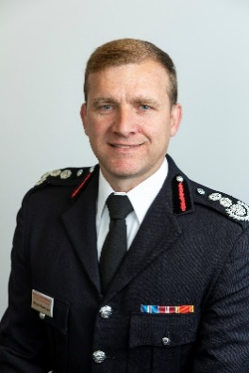
 | 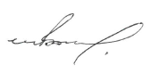
Councillor Paul Gittings  Chair  Royal Berkshire Fire Authority | Wayne Bowcock  Chief Fire Officer and Chief Executive,  Royal Berkshire Fire and Rescue Service

Our Corporate Plan and CRMP
All Fire and Rescue Authorities are required to produce a CRMP. This plan must consider all foreseeable fire and rescue related risks that could affect our communities. These risks include those traditionally associated with Fire and Rescue Services such as house fires, road traffic collisions and chemical spills. They also include other less common hazards such as wide area flooding, terrorist attacks and building collapse.
We have a plan that explains how we will reduce or manage these risks. We do this either by changing the way we work, collaborating with other agencies, or by building new capabilities. We understand the impact such incidents have on the lives of people in Berkshire so our aim is to prevent emergencies from happening whenever we can. We do this by providing education and support to people who need our help and by enforcing fire safety law. When emergencies do happen we respond as quickly as possible. This CRMP will explain what we believe to be significant risks to the people of Berkshire and provide an overview of how we intend to manage them with the resources we have at our disposal.
Our Corporate Plan explains how Royal Berkshire Fire Authority (RBFA) intends to meet its goals and achieve its objectives. The Corporate Plan describes how we make decisions, allocate our resources and ensure we are an effective and resilient organisation. Our corporate planning process makes sure that our operations are orderly and that everyone is working towards the same goals. The Corporate Plan also helps us to identify challenges and gives us the tools to overcome them.

Legal requirements and mandatory duties
RBFA has a number of legal powers and duties that derive from a range of Acts of Parliament, Frameworks and national standards:
Fire and Rescue Services Act 2004 | Health and Safety at Work etc. Act 1974
The Regulatory Reform (Fire Safety) Order 2005 | Equality Act 2010
Civil Contingencies Act 2004 | Policing and Crime Act 2017

The Fire and Rescue National Framework for England 2018
The Fire and Rescue National Framework for England explains the priorities that Government sets out for RBFA.
In order to comply with the National Framework a CRMP must:
- Reflect up to date risk analyses including an assessment of all foreseeable Fire and Rescue related risks that could affect the area of the authority.
- Demonstrate how prevention, protection and response activities will best be used to prevent fires and other incidents and mitigate the impact of identified risks on its communities, through authorities working either individually or collectively, in a way that makes best use of available resources.
- Outline required service delivery outcomes including the allocation of resources for the mitigation of risks.
- Set out its management strategy and risk-based programme for enforcing the provisions of the Regulatory Reform (Fire Safety) Order 2005 in accordance with the principles of better regulation set out in the Statutory Code of Compliance for Regulators, and the Enforcement Concordat.
- Cover at least a three-year time span and be reviewed and revised as often as it is necessary to ensure that the authority is able to deliver the requirements set out in this Framework.
- Reflect effective consultation throughout its development and at all review stages with the community, its workforce and representative bodies and partners.
- Be easily accessible and publicly available.
The Framework sets out the following priorities for RBFA:
- Make appropriate provision for fire prevention and protection activities and response to fire and rescue related incidents.
- Identify and assess the full range of foreseeable fire and rescue related risks their areas face.
- Collaborate with emergency services and other local and national partners to increase the efficiency and effectiveness of the services they provide.
- Be accountable to communities for the services they provide.
- Develop and maintain a workforce that is professional, resilient, skilled, flexible and diverse.

Royal Berkshire Fire Authority
RBFA is a combined fire authority, which means it is made up of 20 elected councillors from six unitary authorities within Royal Berkshire (Bracknell Forest, Reading, Royal Borough of Windsor and Maidenhead, Slough, West Berkshire and Wokingham). It is led by a democratically elected Chair from the 20 councillors.
It is the responsibility of RBFA to provide an effective and efficient fire and rescue service for communities across Berkshire. The Fire Authority is accountable to the residents and business owners of Berkshire and is fully committed to delivering the CRMP to improve community outcomes.
The Fire Authority is a legal body with statutory duties and responsibilities, including the scrutiny of the Service as a whole. It is responsible for setting the strategic direction, policies and priorities of the Fire and Rescue Service. The Fire and Rescue Services Act 2004 (FRSA) obliges RBFA to secure the provision of the personnel, services and equipment that efficiently meet all normal requirements and to secure the provision of training for such personnel in relation to firefighting.
Summary of FRSA 2004 duties:
- Promotion of fire safety.
- Extinguishing fires, and protecting life and property when fires do occur.
- Minimising damage to property arising from firefighting operations.
- Rescuing people involved in road traffic collisions.
- Dealing with other types of emergencies, as specified by the Secretary of State in Statutory Instruments (Orders). Currently, a single Order has been issued – The FRS (Emergencies) (England) Order 2007.
- Ensuring the provision of the resources necessary to meet all normal requirements (Our Evidence Base defines what constitutes ‘normal’).
- Ensuring necessary training for firefighters.
- Ensuring that calls for assistance can be dealt with effectively.
- Obtaining information needed to respond safely and effectively to emergencies.
Delivery of these services and professional advice to RBFA is the responsibility of the Chief Fire Officer.
The Fire Authority manages its responsibilities through full Fire Authority meetings and two committees, the Audit and Governance Committee and the Management Committee. They meet regularly to ensure the proper running of RBFRS. You can find out more about RBFA on our website.
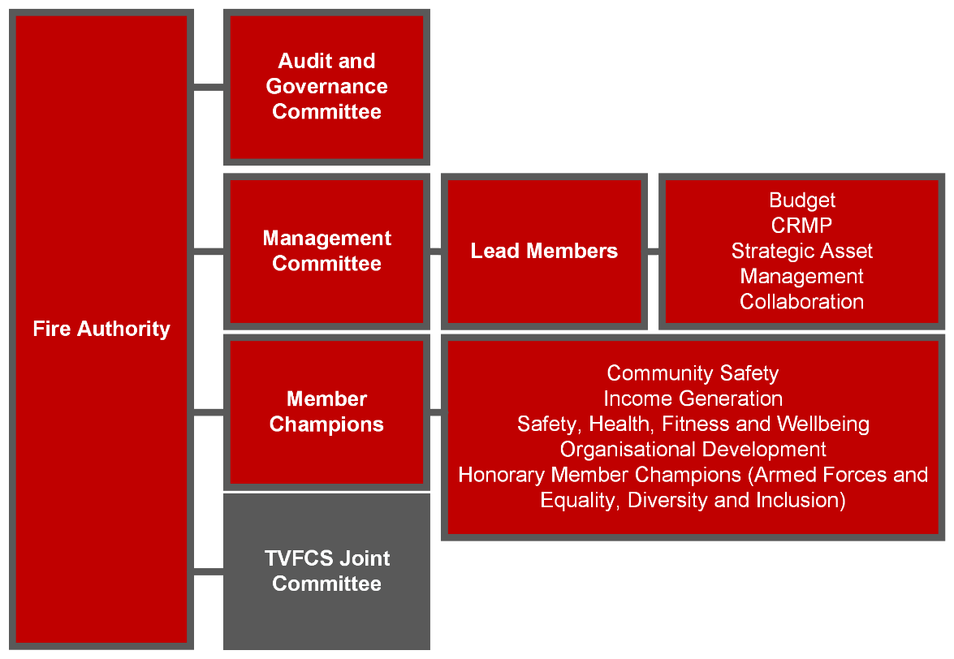
RBFA publishes an annual Statement of Assurance. This explains how RBFA and RBFRS have ensured that our Service is meeting its legal duties and how we are managing risk. This annual statement is designed to provide assurance to the community and government that we are managing our finances, governance and operational duties.

The purpose of RBFA
We create safer more resilient communities by preventing incidents, protecting homes and businesses and responding to emergencies.

Strategic commitments of RBFA
RBFA has a set of commitments that we regularly review. They explain how we intend to achieve our purpose:

Prevention
We will reduce the risk to our communities through our partnership duties and prevention activities, ensuring that our services are accessible to all.

Protection
We will support those with responsibility for premises to understand their duties in ensuring the safety of all people using buildings covered by the Building Safety Act 2022 and Regulatory Reform (Fire Safety) Order 2005, whilst ensuring that our services are accessible to all.

Response
We will ensure that our people are trained and resources are located to provide the most effective response and to have a positive impact on incidents in our communities.

Resilience
We will ensure our resilience and work with our partners to promote and build resilience in the communities we serve.

Sustainability
We will ensure that we provide a financially sustainable and environmentally friendly service to our communities.

People
We will support our staff by providing a safe and inclusive environment for them to thrive in, building a diverse organisation that is engaged with, and accessible to, our communities.

RBFRS vision
To achieve our purpose, we place the community at the heart of all that we do and deliver the service through our four overarching principles:

Culture
- We work together as One Team for the communities we serve. We co-create ways of working that support our staff to fulfil their potential and enjoy being part of RBFRS.
- Enjoyment and sense of belonging encourages professional curiosity and innovation and ultimately drives every part of the Service to want to be really good at what they do.
- Our One Team culture is visible both within and outside the Service and is part of our attraction to new staff and partners. Our inclusive approach and culture is clear and we always strive to improve it.
- Our staff never ‘walk past an issue’, they are honest and realistic about what we do and this is one of our key strengths, it makes us good at what we do.
- Placing communities at the heart of all we do means that we continually focus on the relationships we have with our communities. This inspires trust, confidence and pride in their service and encourages people from all communities to want to join us.

Capability
- We value and invest in developing our people to ensure we can deliver the best possible service.
- We challenge ourselves when we fall short of our own high standards and we commit to learn from each other to continually improve.
- Our behaviours and employee code of conduct guide us and support our excellent culture, and we hold ourselves and others to account by these commitments.
- We focus our limited resources to make sure they are used as efficiently as possible to manage risk and ensure community trust.

Risk Management
- We carefully and robustly analyse the risks to our communities and use this intelligence transparently to make sure we use our resources as well as we can.
- We work closely with partner organisations to ensure that we are prepared for all foreseeable risks and importantly we deal with them well together.
- We protect the availability and resilience of our valuable assets and resources to make sure that we can continually deliver our purpose

Sustainability
- We care about protecting the environment and our impact upon it and we will significantly improve our environmental sustainability in the next five years.
- We will ensure that as custodians of public resources we provide the best possible value and that we develop resilient systems and processes in order to fulfil our purpose.

Your Fire and Rescue Service
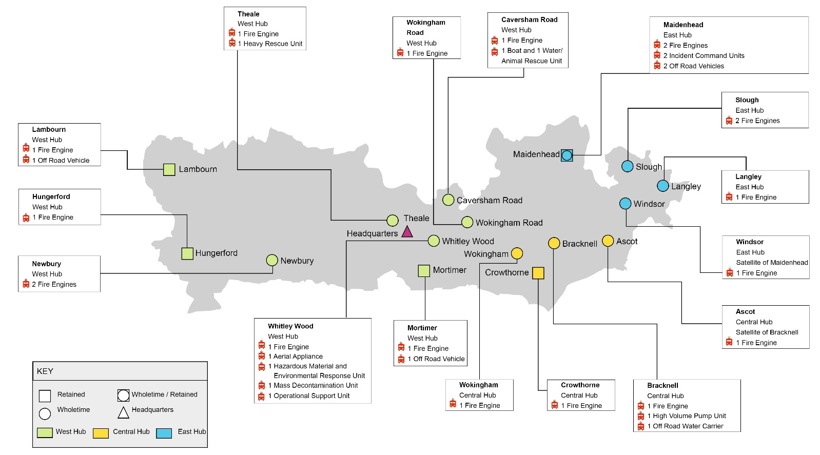

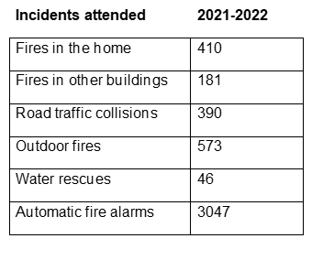
Staff | 584
Non-operational | 168
Wholetime | 324
On-call | 65
Volunteers | 27
Fire Stations | 16
Wholetime | 11
On call | 4
Wholetime and on-call | 1

Workforce and culture
The RBFRS Vision is to work together as One Team for the communities we serve. In order to fulfil our vision it is vital that our staff work in a safe, supportive and inclusive environment. We continue to drive towards creating a Service that reflects the communities it serves, although we recognise that there is more work required to achieve this goal.
The Service has a well-developed Health and Wellbeing Action plan and we have made a commitment to improve the mental health of every employee and volunteer across the Service. We continue to deliver a range of activities in support of this aim:
- Tackling mental health stigma.
- Improving workplace wellbeing.
- Building resilience.
- Improving access to information.
- Improving pathways to support.
The safety of our workforce remains a priority for the Service and firefighter safety is regularly reviewed at a senior level, as part of the Corporate Risk Register.

How we are financed
We are committed to delivering value for money across the services we provide. During 2022-23 our funding comes from three sources:
- Council Tax: 69%
- Central Government Funding: 22%
- Business Rates: 9%

In terms of financial support from the Government, the Authority was expecting a multi-year settlement for 2022-23. The Government decided on a one-year rollover of funding when it announced the Settlement Funding Assessment for local government. Our Settlement Funding Assessment (SFA) for 2022-23 increased by just 0.97%, which equates to an extra £101,000. The SFA comprises Revenue Support Grant, Business Rates Top-up Grant and the Government’s estimate of our share of Berkshire business rates.

Our Efficiency Plan has now delivered £2.4m of savings since 2016-17. Officers are continually looking at how the service provided to the public can be more efficient and effective.

We were granted precept flexibility by the Government for 2022-23, enabling the band D precept to be increased by £5 (7.25%). We remain in the lowest quartile of precepting Fire Authorities in the country. The average band D householder in Berkshire pays £73.95 per year for their Fire and Rescue Service. At just under £1.42 per week we think this represents excellent value to the people we serve.

Delivering our objectives
The way we manage risk throughout RBFRS ensures that the CRMP informs the plans of the whole organisation. We ensure that we regularly review what we are doing to ensure that everyone understands how their work contributes to making Berkshire safer. We have processes in place to help us gather learning and assist the ongoing development of our CRMP.
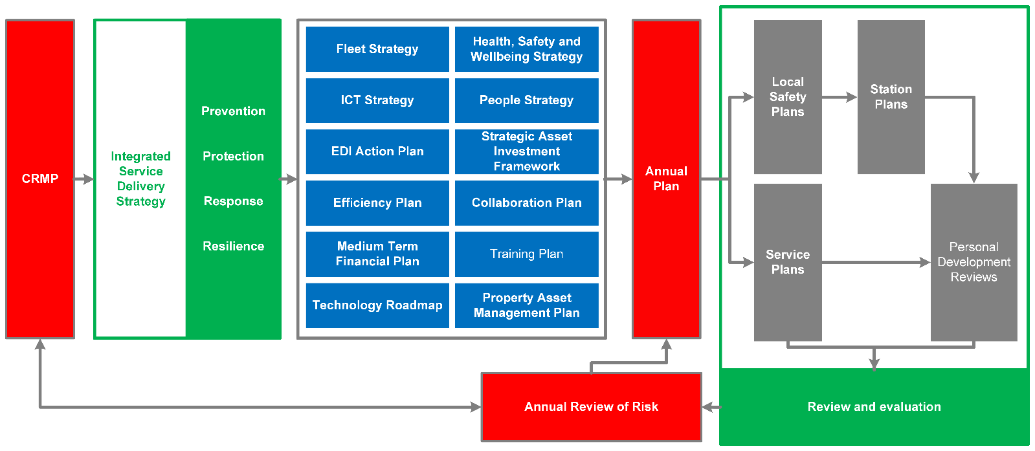

Integrated Service Delivery Strategy
We manage the risks we identify through an integrated approach. This means we consider the full range of treatments we have at our disposal and identify the most effective and efficient way to reduce community risk. We intend to formalise this approach by adopting an Integrated Service Delivery Strategy (ISDS).This means that for each hazard we manage, we will consider all of the methods at our disposal to drive down risk in our communities.
We work closely with our neighbouring Fire and Rescue Services, notably through long standing collaboration with Thames Valley partners and the wider Thames Valley Local Resilience Forum. These partnerships and collaborative activities allow us to share our understanding of risk and contribute to wider regional risk reduction. We actively seek collaborative opportunities, such as sharing the facilities in our fire stations with Thames Valley Police and South Central Ambulance Service, joint procurement arrangements and our joint Thames Valley Fire Control Service. Working together leads to greater resilience and increases our efficiency and effectiveness.

CRMP methodology
We use a five-step process to assess community risk and prioritise our actions to mitigate the risks we identify. We understand risk by focusing on the hazards in our community, identifying the people, places, environment and economy at risk and prioritising our resources where we have the greatest impact. We align with national good practice and have contributed to, and adopted, community risk management work undertaken by the National Fire Chiefs Council.
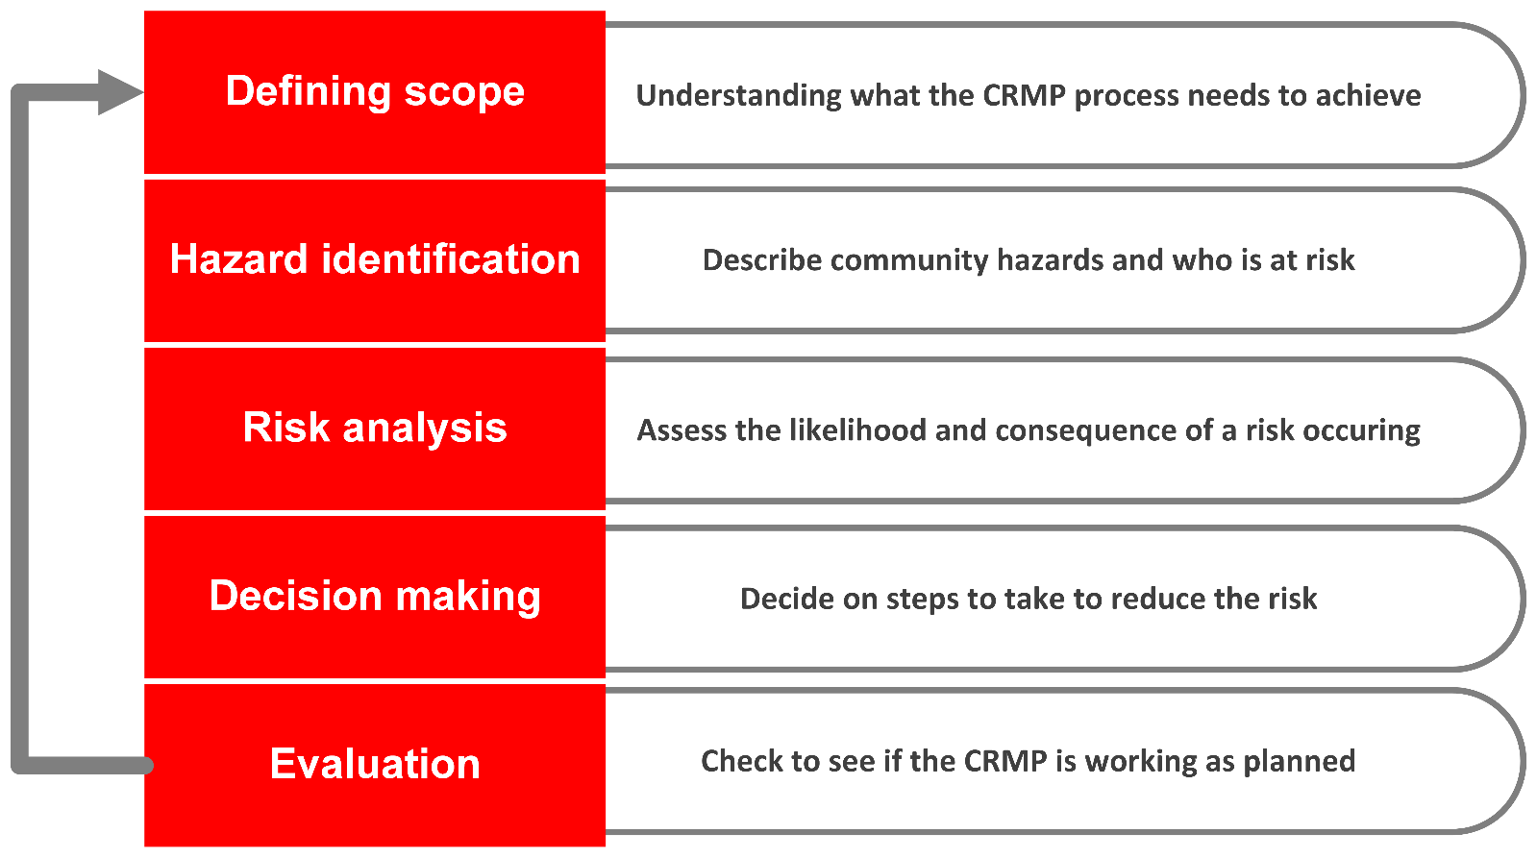

Our Approach to Managing Risk in Berkshire
Our analysis of community risk helps us understand the range of foreseeable Fire and Rescue Service related risks and their potential impact on the communities we serve. This analysis of risk can be found in our CRMP Evidence Base document.
We will use our ISDS to identify the most appropriate intervention for incidents. Our first principle is that we want to stop emergencies happening whenever we can. Our prevention and education activities are the most effective way to achieve this. We also use our duty to enforce fire safety law to reduce the chances of fires starting and, if there is a fire, effective fire protection measures should be in place to ensure people escape quickly and safely.
Unfortunately we will never be able to prevent all emergencies. When they happen we respond swiftly and professionally to resolve the situation and support the restoration of normality.
We have identified that the following hazards represent the greatest risk to communities in Berkshire. This section of the CRMP explains our existing activities and outlines areas where we think we can do more to reduce the impact.

Fires in the home
Fires in the home are one of the biggest concerns for our communities. In 2021-22, 334 people died in accidental dwelling fire in Great Britain. Over the past 6 years in Berkshire there have been 9 fatalities and 167 non-fatal casualties in dwelling fires. Even when there are no casualties, the impact of a fire on the lives of those involved can be catastrophic.
Current activities
- Schools education programme including teacher resources
- Fire cadets
- Adults at risk programme
- Safe spaces initiative
- Partner referral Safe and Well visits (SAW)
- Provision of assistive fire safety technologies to the most vulnerable
- Community visits and provision of meeting rooms
- Preventing fire-setting behaviours amongst children
- Arson prevention advice
- Fire safety advice in languages other than English
- Joint inspections of high-risk dwellings, such as high-risk multi-occupancy
- Hub based integrated delivery model
- We provide training and equipment for firefighters to respond to incidents in the home
CRMP development
Our evidence suggests that we can do more to target those at greatest risk from dwelling fires. We will address this by using our understanding of risk to better inform how we approach prevention. We propose that a Risk Based Prevention Programme will help us to identify and work with those at the greatest risk from fires in the home.
We will also strive to target our resources to risk more effectively and increase resource availability to ensure we use the most appropriate interventions within our integrated service delivery strategy. For example increasing our efficiency in fighting fires in the open will allow us to maintain higher levels of fire appliance availability for dwelling fires. The integrated approach will allow RBFRS to adapt to change in the community, both in the built environment and in demographic shifts such as the increasing density of dwellings in town centres and Berkshire’s growing population changing the risk RBFRS must manage.

Fires in other premises
Fires in buildings which are not dwellings, present a significant risk to our communities. Examples of these higher risk properties include places where people sleep, hospitals, hotels and residential care homes. In addition to life risk, buildings often have cultural, economic or heritage value that is worthy of protection. Reducing loss and harm caused by fires in these buildings represents a significant objective for RBFRS.
Current activities
- Our Risk Based Inspection Programme (RBIP) helps us enforce fire safety law in premises which are at risk from fire and where risk to life is greatest. A consequence of our intervention is to reduce potential financial loss and protect economic wellbeing. The RBIP has been developed in line with the principles of better regulation as set out in the Statutory Code of Compliance for Regulators, and the Enforcement Concordat
- Undertake proactive and reactive fire safety audits including short audits where appropriate.
- Enforcement of the Fire Safety Order, including using our powers to prosecute where necessary.
- We provide operational intelligence, training and equipment for firefighters to respond to incidents in these buildings.
- Firefighters carry out site visits to familiarise themselves with the premises in case there is an incident.
CRMP development
The Unitary Authority development plans in Berkshire indicate a drive to build new homes. We will monitor both strategic housing developments and construction methods to ensure our activities match new and emerging risk in the built environment. We will also need to continuously develop our response model to mitigate the risks within the county. This will help us to ensure our fire appliances, specialist vehicles and staff are best placed to respond to incidents.
We will evolve our Risk Based Inspection Programme to ensure we are targeting those premises that represent the greatest risk and that we are making the best use of our inspecting officers’ skills to regulate where they are most needed.
In order to improve our efficiency we will work with businesses to reduce the impact of unwanted fire alarms to drive down the need for our operational crews to attend these types of incidents. We will provide training and development to our operational crews to help educate businesses about their responsibilities under the Fire Safety Order 2005 in lower risk, simple premises. This will assist us in the delivery of our statutory duties and improve safety outcomes.

Tall Buildings
Tall buildings include residential flats, hotels, institutions, hospitals, commercial offices and mixed occupancy buildings. Due to the complex nature of these types of buildings, fires in tall buildings are difficult and require a lot of resources.
Current activities
- We provide advice and guidance to residents and regulate where appropriate.
- Our Risk Based Inspection Programme helps us to ensure that fire safety precautions are in place and adequate.
- Firefighters carry out site visits to familiarise themselves with premises in case there is an incident.
- Partner referral Safe and Well visits.
- We provide operational intelligence including electronic premises information plates, training and equipment for firefighters to respond to incidents in these buildings.
- Since the Grenfell tragedy, we have been engaged at a national level, to improve information sharing and learning.
- We remain up to date with the latest developments and legislation to ensure we provide the most appropriate response to fires in tall buildings
CRMP development
Many of our objectives for managing risk in tall buildings are shared with our approach to fires in other premises. Developing our response model, our Risk Based Inspection Programme and monitoring change in the built environment will help us to reduce risk. In addition to this work our proposed Risk Based Prevention Programme will help us to identify tall buildings in areas of higher fire risk and develop suitable interventions.

Road traffic collisions
Incidents on our roads have a tragic impact on communities and lives in Berkshire. On average over the last decade someone is killed or seriously injured every 16 minutes on UK roads. During our CRMP analysis period there have been 91 fatalities and 954 serious injuries (not including pedestrians) in road traffic collisions in Berkshire. These incidents represent a significant risk.

Current activities
- We carry out road safety education in schools for 11–15 year-olds;
- We participate in the delivery of Safe Drive Stay Alive to young adults who are at risk road users;
- Collaborative delivery of Biker Down workshops for motorcyclists;
- We provide training and equipment for crews to deal with these types of incidents; and
- We provide a heavy recue vehicle to support crews at incidents.

CRMP development
We propose that a Risk Based Prevention Programme will help us to identify and work with at-risk road users. This programme will also support collaborative road safety initiatives. Development of our response model will take account of the need to mitigate the risk to road users, recognizing that road traffic collisions are dispersed across Berkshire. We will ensure our response model takes account of changing road use, for example the implementation of smart motorways and the increase in use of battery powered electric vehicles. This work will help us to protect the community and ensure firefighters have safe systems of work in place.

Fires in the Open
Incidents involving fires in the open range from large wildfires, as we saw in the summer of 2022, to field fires involving farm land and small fires in the open such as trees, refuse and vehicles. In Berkshire they primarily cause harm to the environment and property. During hot weather multiple fires in the open happening at the same time reduces our capacity to respond to other emergencies.
Current activities
- We work with landowners and educate members of the public to reduce the number of fires in the open.
- We work with Community Safety Partnerships to reduce antisocial behaviour and fire setting.
- Training and equipment for crews to deal with these types of incidents.
- Provision of specialist vehicles including high volume pumping equipment, water carrier and 4x4 vehicles to support crews at incidents.

CRMP development
We have identified a need to develop a comprehensive response to the impact of climate change. Although the effect of human activities on climate will continue to be felt well beyond the life of this CRMP, it is important that we put mechanisms in place now to adapt the services we deliver. This includes provision of equipment and training in wildfire tactics, gathering suitable operational risk information, developing tactical plans and adapting our response model. This work will support the ongoing development of safe systems of work for our staff. We must ensure we can provide resilience in the face of the increased likelihood of spate conditions from spring through summer when fires in the open are more likely.
We will include fires in the open and wildfires in our Risk Based Prevention Programme, building on evidence gathered during this CRMP, to identify the communities at most risk. We will develop operational risk information and tactical plans relating to wildfire risk in Berkshire. We will also develop our operational crewing model to improve our ability to respond to risk across Berkshire, recognising the differing levels of community risk.

Water incidents - flooding and rescues from water
RBFRS attends a variety of water related incidents. These can be due to flooding caused by sudden rainfall or rising water levels in our water courses. These incidents can have an impact over wide areas of Berkshire or may be localised (for example, flooding caused by burst water mains). We also attend water rescue incidents, where a person or animal has become stranded in a body of water. Although we undertake this work, it is not a statutory duty and we receive no funding for water incidents.
Current activities
- We deliver water safety education to 11–15 year-olds.
- We train for and provide equipment to crews to deal with these types of incidents.
- Provision of specialist vehicles including high volume pumping equipment and 4x4 vehicles to support crews at incidents.
- We utilise a water rescue unit, to support rescues from large scale flooding incidents
- Work with partners on the Thames path, to provide advice on the best location for life rings and emergency information.

CRMP development
We will develop our prevention activities and response model to reduce the impact of flooding both to the Service and the people of Berkshire. We will use our data and local knowledge to lead our prevention activities. Implementing a Risk Based Prevention Programme will help us identify water risk in the community, improve equality of access to our services by targeting our prevention resources to those at most risk, and ensure that we use our resources in the most efficient and effective way. We will identify those that are at most risk from water incidents and build on our current prevention activities.
We will work collaboratively with partners who have a statutory duty to manage water risk to support the improvement of community outcomes. We will engage with these partners to develop the most effective approach to resolving incidents that currently are not part of our statutory duties. We will do this through our targeted prevention activities and, if required, our emergency response model. These changes will support us to use capacity to deliver our other priorities

Major Incidents and high risk premises
Major incidents are those incidents which greatly disrupt our ability to provide our services and require a level of resourcing beyond our normal planning assumptions. They happen infrequently and usually require RBFRS to request support from other agencies. Major incidents can happen in any part of Berkshire.
We have also identified a number of high risk premises in Berkshire that, if involved in fire, present a significant risk to the occupants or to the wider community.
Current activities
- Partnership working with other agencies to develop plans and training to be able to deal with such incidents.
- Active membership of Thames Valley Local Resilience Forum.
- Collaborative input to Thames Valley Community Risk Register
- Carry out site specific risk inspections and familiarisation visits to understand the risk presented by these types of premises

CRMP development
We will ensure our service delivery model is resourced as efficiently as possible to meet fluctuating levels of demand to provide a resilient service. We want to continue to deliver good value for money and to provide our services as efficiently as possible.

We will aim to crew all 19 of our frontline appliances, whenever possible, to maximise our resilience. As a baseline service provision (where it is not possible to crew all 19 appliances) we will provide a minimum service of 14 frontline fire appliances. To ensure this baseline provision we will work to improve the availability of our on-call crews.

Other incident types

There are a number of other types of incident that are infrequent but may result in a major impact to communities. These include rail and air incidents, building collapse, terrorism and hazardous materials.

Current activities
- Mutual aid agreements with each of our neighbouring Fire and Rescue Services.
- Access to specialist equipment and trained personnel both in Service and from the wider UK Fire and Rescue Service community.
- Long standing national resilience arrangements that allow us to scale our emergency response to meet the demands of complex or protracted incidents.
- Provision of a national resilience specialist capability within Berkshire.
CRMP development
We will ensure that we embed our process of monitoring local, regional and national resilience issues through an ongoing horizon scanning process and an annual review of risk.

Automatic Fire Alarms (AFA)
False alarms caused by automatic systems continues to be a real problem for businesses and RBFRS. Over a 5 year period, on average, RBFRS was called to 2937 automatic fire alarm activations each year. We do not send a response to approximately a quarter of these calls.
This is an unacceptably high level and it is diverting the service from more impactful work that could be carried out to better reduce community risk.
Only 1% of automatic fire alarm activations are actually fires. They represent a drain on our resources, reducing our fire cover and our ability to carry out essential activities such as training, risk information gathering, fire safety education and prevention activity.
Current activities
- Call challenge (checking whether people at the building have confirmed if there is a fire) carried out by Thames Valley Fire Control.
- AFA reduction activities carried out by Protection Officers.
CRMP development
We will continue to seek ways to reduce this burden while ensuring we provide a response to high-risk premises such as dwellings, hotels, care homes and hospitals.
We will further develop our work with businesses to reduce the impact of unwanted fire alarm calls. It is our intention to reduce these as far as possible. We will develop our operational crews to educate businesses about their responsibilities under the Fire Safety Order 2005 in lower risk premises to help with this goal. Avoiding the unnecessary diversion of our resources will help us use our valuable people and assets in the most effective way to reduce risk through prevention and ensure we are maximising the time for operational training and risk intelligence gathering.

How we mobilise to incidents
We have collaborated with Buckinghamshire and Oxfordshire County Council Fire and Rescue services, to provide a joint control room, Thames Valley Fire Control Service. Our state-of-the-art control room receives 999 calls and maintains a borderless mobilising system that send the nearest available fire appliance, irrespective of borders across Thames Valley.

Response Standard
When an incident occurs we provide lifesaving interventions as quickly as possible to reduce the impact of the incident to individuals and the community. We have a single response standard for our first attending fire appliance at all incidents, this helps us to monitor our performance.
Our response standard is that the time from a call being received until the first fire appliance arrives at the incident should be within 10 minutes. We aim to achieve this standard on 75% of occasions.

Resilience
To ensure that we can sustain our commitments to the communities of Berkshire, we have national and local agreements in place to support large scale incidents such as flooding and wildfire. These arrangements are co-ordinated nationally by the Fire and Rescue Service Coordination and Advisory Framework (NCAF) and locally with signed agreements between our neighbouring Fire and Rescue Services.
We are an active member of the Thames Valley Local Resilience Forum (LRF), which brings together a variety of agencies under the Civil Contingencies act 2004. The forum assesses the risk of an emergency occurring and develops plans for dealing with the emergency.
We have business continuity arrangements in place to ensure the continued operation of the Service in the event of local disruptions such as loss of power.

Our priorities for the next four years
Through our CRMP process we have identified a number of areas where we feel improvements can be made to deliver a more efficient and effective service to the communities of Berkshire. We will work on these areas during the lifespan of this CRMP.

Priority 1. We will develop our Integrated Service Delivery Strategy to meet the changing profile of risk in Berkshire due to climate change, societal and technological shifts.

We anticipate that climate change and technological adaption will change the types of emergency incidents we attend. The summer heatwave of 2022, saw RBFRS attend a very large number of fires across the county. Increasingly wet winters are also predicted and we anticipate more frequent flooding. As society adapts, through increased use of alternative and renewable energy systems in vehicles, homes and businesses, we must adapt what we do to mitigate the risk. The hazards we manage are changing and we must keep pace with these changes.

We will develop our prevention activities and response model to reduce the impact of wildfires and to support our response to flooding. These changes will improve the resilience of RBFRS and the community.

We will develop our prevention activities and response model to reduce the impact of incidents from alternative fuel sources, both to the Service and the people of Berkshire.

Through our annual review of risk we will continue to monitor developments in new technology.

Priority 2. We will develop a Risk Based Prevention Programme to target those most vulnerable and at risk from emergency incidents.

We will implement a Risk Based Prevention Programme which helps us identify those that are most at risk in the community. To enable us to carry out early intervention activities, preventing them from becoming vulnerable to risk. We will ensure that we use our resources and capability in the most efficient and effective way.

We will identify those most vulnerable through our various partnerships such as safeguarding referrals, to ensure that we are targeting our prevention interventions most effectively.

We will better understand our communities by using data and local knowledge to reduce the likelihood and severity of emergency incidents across Berkshire.

Priority 3. We will develop our response model to ensure that we are providing the most effective response to incidents within Berkshire, ensuring that it is sustainable and provides value for money.

We recognise that we are entrusted with public money and have a duty to spend it wisely. In order to ensure we provide our services efficiently we will seek to ensure that we deliver good value for money.

We will develop our response model to ensure its effectiveness in responding to incidents. We will match our resources to the risks within the county by ensuring our fire appliances, specialist vehicles and staff, are best placed to respond to incidents.

We will ensure that we continue to maintain our response standard of the first fire appliance arriving at the incident within 10 minutes on 75% of occasions, and that this is maintained or improved with any development of our Service.

Priority 4. We will review the incidents we attend and reconsider whether we should continue to go to those that do not form part of our core statutory responsibilities.

We will work with our partners to develop the most effective approach to resolving incidents that currently are not part of our statutory duties. We will do this through our targeted prevention activities and after careful consideration of our emergency response model. These changes will support us to use capacity to deliver our other priorities.

Priority 5. We will develop our Fire Protection service to support the resilience of businesses, to ensure the safety of all people using buildings covered by the Fire Safety Act 2021, Building Safety Act 2022, and Regulatory Reform (Fire Safety) Order 2005 to ensure that our enforcement role is effective and clear.

We will develop and build upon our Risk Based Inspection Programme to ensure we are targeting those premises with the greatest risks and using our inspecting officers skills to regulate where they are most needed.

We will work with businesses to educate them on their responsibility under the Regulatory Reform (Fire Safety) Order 2005.Fire Safety Order 2005 to reduce the impact of unwanted fire signals (automatic fire alarms) on our operational crews.

Sprinkler systems within buildings are an effective initial intervention in reducing the impact of fires in commercial buildings, we will strengthen our campaign for introducing these in buildings where it is not currently a requirement.

We will work with the Building Safety Regulator within our capacity under the new Building Safety Act 2022.

We will develop our way of working to be able to enforce the Regulatory Reform (Fire Safety) Order 2005.

Priority 6. We will provide a minimum of 14 frontline fire appliances utilising our Wholetime and on-call staff as effectively as possible.

We will aim to crew all 19 of our frontline appliances, however this is not always possible due to unforeseen short term staff absences and training. As a baseline service provision we will provide a minimum service of 14 frontline fire appliances utilising our wholetime and on call crews. Ensuring that we continue to maintain our response standard of the first fire appliance arriving at the incident within 10 minutes on 75% occasions.

We recognise that we are entrusted with public money and have a duty to spend it wisely. In order to ensure we provide our services efficiently we will seek to ensure that we deliver good value for money.

Corporate strategies
Our corporate strategies provide direction and guidance to our organisation. They drive change and improvement and provide a clear picture of how we intend to achieve our objectives.

People Strategy
The People Strategy supports our staff to become the best they can be, creating a workforce that can deliver an efficient and effective service to our communities on behalf of the Fire Authority, and to manage all foreseeable Fire and Rescue related risks that could affect the people of Berkshire.
The People Strategy supports our workforce planning. We take a proactive approach to workforce planning, looking ahead and at previous trends to assess the overall health of the organisation. Pressures on the workforce remain due to the rising cost of living, pension agreements and staff turnover. We forecast staff turnover and look at skills mapping to ensure we have the right skills in the right places.

Health, Safety and Wellbeing Strategy
Our commitment to ensuring the health, safety and wellbeing of our staff and volunteers extends beyond our legal obligation. We recognise the economic benefits of establishing a healthy workforce and working environment and that paying attention to wellbeing is morally the right thing to do.
The three core aims of our Health, Safety and Wellbeing Strategy are safe and healthy people, safe and healthy places, and safe and healthy processes. Each of our planned activities will contribute towards those aims, and our key objective, which is to continually improve the health, safety and wellbeing of our staff and reduce work related injuries, physical and mental ill health, which will in turn improve employee engagement and performance. We recognise that the health and wellbeing of our staff is of equal importance as their safety so we take an integrated and holistic approach to our activities.

Employee Code of Conduct
Every RBFRS employee is expected to behave in a professional manner and to offer the highest standards of service to the public. The way we carry out our duties must promote and maintain public confidence and trust in our Service. Our Employee Code of Conduct provides a framework for the behaviour, decisions and actions of employees. It is based on the national Core Code of Ethics for Fire and Rescue Services in England and supports a consistent approach to ethics and behaviours across RBFRS.

Behavioural Competency Framework
The link between our People Strategy and Employee Code of Conduct is the RBFRS Behavioural Competency Framework (BCF). This is a tool which allows us to easily identify the behaviours that drive successful performance. The BCF builds on the NFCC Leadership Framework and defines how, as a team, we can work together to ensure that we deliver an outstanding service to the communities we serve. The BCF ensures we all understand the organisations goals and can identify ways to improve and embrace change.

Medium Term Financial Plan
The economic backdrop presents significant challenges for RBFA. The increased inflationary pressures are pushing up the cost of supplies and services. The Authority is one of the lowest precepting fire authorities in the country and those authorities in the lowest quartile of precepts face the greatest challenges in addressing immediate pressures. The Medium-Term Financial Plan (MTFP) sets out how the Authority intends to manage its finances. It provides clarity on how RBFA is funded, how it makes efficiency savings though the efficiency plan, generates income and explains where we face budgetary pressure. The MTFP sets out the overall impact of funding and how RBFA will prudently manage its finances to ensure the best possible service to the public.

Strategic Asset Investment Framework
Our Strategic Asset Investment Framework (SAIF) sets out how we will maintain and renew the vital capital assets, necessary to support our service delivery. Our capital assets include:
- Our buildings, which includes 16 fire stations and our headquarters.
- Our fire appliances, equipment and support fleet.
- Our ICT infrastructure and systems.
Together, these assets represent a major capital investment. The efficiency of these assets can also have a significant impact on our revenue budget as older stations, fire appliances and ICT require additional maintenance and are often more expensive to run.

Property Asset Management Strategy
The Property Asset Management Strategy (PAMS) provides a statement of the overall approach to providing property to meet the needs of Royal Berkshire Fire Authority. It considers property as just one of the many corporate resources needed by the Service to deliver its essential emergency response to the people who live and work within the county of Berkshire. This Strategy identifies the extent of the property portfolio owned by the Authority, our approach to property management, what we have and its condition. Through the adoption of best practice and collaboration in everything we do, the Service seeks to make best use of the assets and investment available to achieve its objectives.

Vehicle Fleet and Equipment Strategy
This strategy sets out how we design and implement an efficient, reliable and resilient, fit-for-purpose vehicle fleet that supports effective delivery of services across RBFRS. It enables the infrastructure we need to provide our technical and operational capability. This strategy also facilitates the design and implementation of delivery plans that support the CRMP, Corporate Plan, Strategic Commitments and Strategic Asset Investment Framework.

ICT Strategy
People and Information are the two key resources available to RBFRS. The ICT strategy exists to enable the provision of technology that enhances, amplifies and accelerates the capabilities of the organisation. It helps us to make access to information secure, fast, simple and intuitive. The ICT Strategy supports our staff to become the best public servants they can be, by providing tools that enable an efficient and effective service on behalf of the Fire Authority. It is critical in our management of all foreseeable fire and rescue related risks that could affect the people of Berkshire.

Evaluating our performance
We will review our CRMP, associated risk analysis and our strategic priorities annually to ensure we are delivering on our commitments. In order to achieve this and ensure our interventions are helping to reduce the impact of these risks we will use the following forums to monitor our progress.
- Strategic Leadership Team meeting- we will report progress to the meeting and commission the work required to achieve our CRMP.
- Performance management framework- this framework will create key performance measures that we will report on quarterly to the Fire Authority.
- Strategic Performance Board- will monitor the key performance measures.
- Annual review of risk and annual planning cycle- to see how our priorities are having an impact on the risk.
- Programme Board- will monitor the progress of our individual projects.
- Equality, Diversity and Inclusion Steering Group - will ensure that any changes will not adversely affect our staff our the public
- We carry out operational audits of our fire stations, to ensure they are well run and to identify any requirements for support

We will continue to develop our programme of evaluation of projects and interventions to ensure we are confident that these are effective and have the intended impact.

Corporate risk
To help us effectively manage community risk we must manage risks that affect our organisation. These are risks that could stop us achieving our objectives. We monitor and manage these risks and have a comprehensive organisational risk management policy, to ensure that organisational objectives can be achieved.

Assurance
Public assurance is provided by rigorous external audits that is supported by regular reporting of our performance.

His Majesty’s Inspectorate of Constabulary and Fire and Rescue Services
His Majesty’s Inspectorate of Constabulary and Fire and Rescue Services (HMICFRS) awarded us with ‘Good’ across all three areas of Efficiency, Effectiveness and People. Actions for improvements identified in the findings have been incorporated into our plans and we continue to work to deliver the necessary changes. During the COVID-19 pandemic HMICFRS stated that RBFRS adapted and responded effectively. We were since inspected in 2022 and await the outcome report from HMICFRS.
For more information on the inspection of Fire and Rescue Services, please visit the HMICFRS website.

RBFA Audit and Governance Committee
The RBFA Audit and Governance Committee monitors and receives reports on the performance of Royal Berkshire Fire and Rescue Service and summaries from Internal and External Auditors. It has nine members appointed by the Fire Authority and is politically balanced.

Respond to our consultation
If you need this document in an accessible format, please email consultations@rbfrs.co.uk call 0118 945 2888 or get in touch via our website www.rbfrs.co.uk/consultations with details of the request and your contact information. We will consider the request and respond to you. For more information on accessibility at Royal Berkshire Fire and Rescue Service, please read our Accessibility Statement.
Responding to this consultation
We are committed to consulting with our communities, and our key internal and external stakeholders, on our Corporate Plan and CRMP. This is an opportunity for interested parties to offer feedback and to help shape and influence our plans. We want to hear your views on the content of our plans and we also want to understand whether it has been presented in an appropriate format.
Consultation is vital to ensuring that our plans truly represent the needs of the communities we serve and that they express risk as it is experienced in the community. Consultation is also a legal requirement and we are accountable for ensuring that all feedback is consciously considered before we make decisions that change the services we provide.
We will ensure that there is sufficient time available for consultation and will publicise opportunities for comment. These will be through a variety of channels. When our consultation period ends we will review all feedback and include it in a consultation report. This report will also be publically available to provide transparency in our decision making processes.
We welcome your feedback on our plans. You can respond to our consultation in a number of ways.
Online survey
Please click this link to be taken to a short survey where you can share your thoughts.
Respond by post
CRMP Consultation
Royal Berkshire Fire and Rescue Service
Newsham Court
Pincents Kiln
Reading
Berkshire
RG31 7SD
Respond by email
You may also respond by email to consultations@rbfrs.co.uk
respond by telephone
Please call: 01189 452888

