Corporate Plan and Community Risk Management Plan 2023 - 2027 Consultation
  - Summary Report

Contents
- Consultation Headlines 5
- 5
- Introduction 6
- Executive Summary 6
What We Consulted On 7
- Part 1: What the consultation tells us 8
Strategic commitments 8
Priority One 11
Priority Two 13
Priority Three 16
Priority Four 19
Priority Five 24
Priority Six 26
- Organisations, groups and business responses 29
Thames Valley Fire Control Service 30
Neighbouring Fire and Rescue Services 30
Representative Bodies 31
Unitary Authorities 31
- Proposed amendments to CRMP Priorities based on feedback 31
- Part 2: Consultation Methodology 35
- Analysis of Data 35
Overview of Consultation Responses 37
- Benchmarking 38
Consultation Resources 38
Communications 39
Website 40
Media and Partners 40
Social Media 41
Consultation Activity 42
Focus Groups and Engagement Sessions 45
- Equality, Diversity and Inclusion 45
Equality and Diversity Monitoring 46
Respondents Profile 47
Respondent Group 47
Local Authority Area 48
Age 50
Ethnicity 51
Religion or Belief 52
Disability 53
Gender Identity 54
Sexual Orientation 55
- Summary and Next Steps 56
- Appendix A 57
- Appendix B 62

Consultation Headlines
Total Responses
662

Resident responses by Authority:
Bracknell Forest 10.1%

Reading 16.5%

Slough 6.4%

West Berkshire 28.1%

Windsor and Maidenhead 9.3%
Wokingham 11.3%
Outside of Berkshire 11.9%

Prefer not to say 6.4%

–

66.3% increase in responses overall compared to our last IRMP consultation

150% increase in responses from organisations and groups compared to our last IRMP consultation

18.8% of respondents said they work in Berkshire

54.1% of respondents identified as Berkshire residents
31.5% of respondents said they are employees
1,625 website page views

149 intranet page views

11 virtual briefing sessions
59,327 reached on Facebook, Twitter and Linked In.

2,798 Engagements

Total number of comments received
584

Average approval rating across the six priorities
90.4%

9.5% of respondents were responding on behalf of an organisation

XXX engagements
XXX impressions

XXX video views

Survey
XXX

Hard Copy Responses
XXX

‘Easy Read’ Responses
XXX

Introduction
Royal Berkshire Fire Authority is required to produce an Integrated Risk Management Plan (now known as a Community Risk Management Plan, CRMP) by the Fire and Rescue National Framework for England 2018. The Framework requires that the CRMP must:
- Reflect up-to-date risk analyses including an assessment of all foreseeable fire and rescue related risks that could affect the area of the Authority;
- Demonstrate how prevention, protection and response activities will best be used to prevent fires and other incidents and mitigate the impact of identified risks on its communities, through authorities working either individually or collectively, in a way that makes best use of available resources;
- Outline required service delivery outcomes including the allocation of resources for the mitigation of risks;
- Set out its management strategy and risk-based programme for enforcing the provisions of the Regulatory Reform (Fire Safety) Order 2005 in accordance with the principles of better regulation set out in the Statutory Code of Compliance for Regulators, and the Enforcement Concordat;
- cover at least a three-year time span and be reviewed and revised as often as it is necessary to ensure that the authority is able to deliver the requirements set out in this Framework;
- Reflect effective consultation throughout its development and at all review stages with the community, its workforce and representative bodies and partners; and
- Be easily accessible and publicly available.
The development of the draft 2023-27 CRMP was undertaken to meet the requirements of the Framework. This report considers the outcomes of a public consultation on the draft CRMP priorities. It is intended to support Royal Berkshire Fire Authority’s conscientious consideration of the matters at hand in line with the principles set out in the RBFRS Consultation Strategy 2023-2027.
The Fire and Rescue Authority should give due regard to the professional advice of the Chief Fire Officer while developing the Community Risk Management Plan and when making decisions affecting the fire and rescue service.

Executive Summary
The 2023-2027 Corporate Plan and Community Risk Management Plan consultation has concluded. This report highlights the key messages from public feedback. Some of the headlines are:
- We held an 11-week public consultation from January to March 2023.
- We had 662 responses to the consultation from members of the public, stakeholders and employees.
- Our Strategic Commitments received an approval rating of 90.5%.
- Our six key CRMP priorities received an average approval rating of 90.4%.
- This report contains quantitative and qualitative analysis of the consultation data.
Feedback gathered during the consultation has led to changes in the proposed wording of the Strategic Commitments and CRMP Priorities. This consultation report and the draft Corporate Plan and Community Risk Management Plan 2023-2027 will be presented to Royal Berkshire Fire Authority on 27 April 2023.

What We Consulted On
We held an 11-week public consultation from January to March 2023 on the Royal Berkshire Fire Authority draft Corporate Plan and Community Risk Management Plan 2023 – 2027. The CRMP identifies and outlines how we will mitigate community risk from fire and rescue related incidents in the County of Berkshire. The consultation sought feedback from a wide range of stakeholders on our new Strategic Commitments and six key priorities for the next four years. These commitments and priorities have been developed to address areas of risk that has been identified through our CRMP process.

New Strategic Commitments
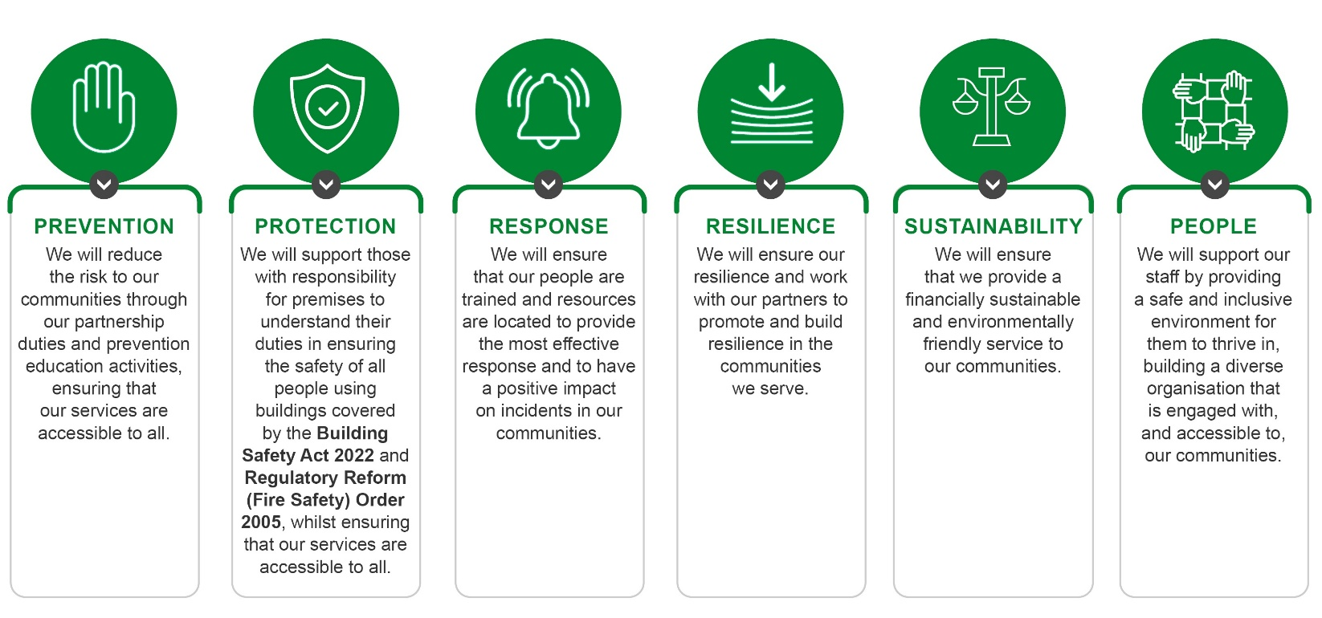

CRMP Priority Proposals
Priority 1. We will develop our Integrated Service Delivery Strategy to meet the changing profile of risk in Berkshire due to climate change, societal and technological shifts.
Priority 2. We will develop a Risk Based Prevention Programme to target those most vulnerable and at risk from emergency incidents.
Priority 3. We will develop our response model to ensure that we are providing the most effective response to incidents within Berkshire, ensuring that it is sustainable and provides value for money.
Priority 4. We will review the incidents we attend and reconsider whether we should continue to go to those that do not form part of our core statutory responsibilities.
Priority 5. We will develop our Fire Protection service to support the resilience of businesses, to ensure the safety of all people using buildings covered by the Fire Safety Act 2021, Building Safety Act 2022, and Regulatory Reform (Fire Safety) Order 2005 to ensure that our enforcement role is effective and clear.
Priority 6. We will provide a minimum of 14 frontline fire appliances utilising our wholetime and on-call staff as effectively as possible.

Part 1: What the consultation tells us

Strategic commitments
We asked whether, overall, whether respondents agreed or disagreed with Royal Berkshire Fire Authority’s strategic commitments and whether the CRMP will help deliver the strategic commitments.
399 people responded to this question, with 96.2% responding that overall, they agree with the Strategic Commitments. Agreement was high (over 94%) for all respondent groups.
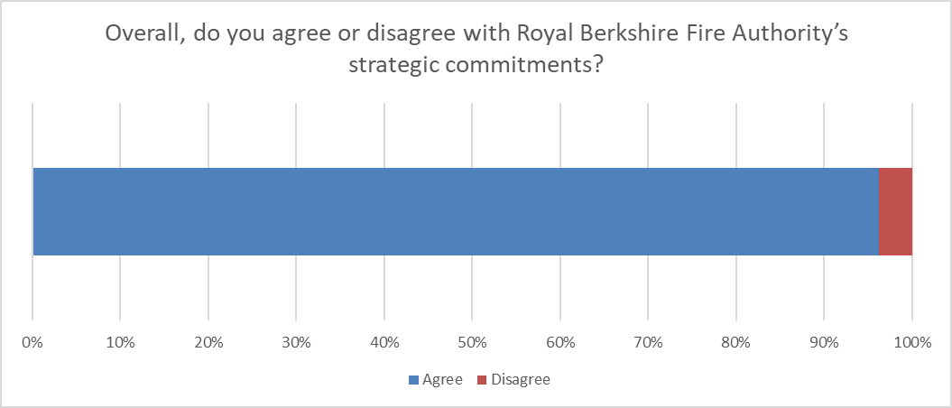
90.5% of our respondents agreed that our Corporate Plan and CRMP would help deliver our strategic commitments.
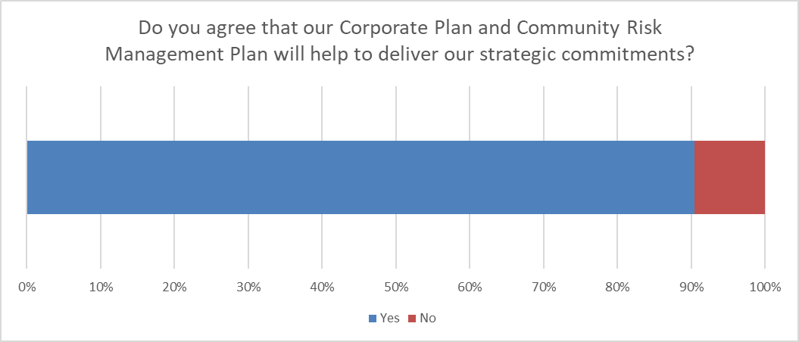

 | Employee | Resident or works in Berkshire | Group or organisation
Common themes | Importance of people focus | EDI and behaviour focus | Importance of education
 | Staff retention & lean model | Organisational and community resilience | Partnership working
 | Sustainability | Funding | Organisational learning

 | Issues raised | Response
Confidence | “No, these are excellent commitments”  “I believe that your commitments make sense and are achievable for the service.”  “They should be implemented immediately”  “Thank you for all your great work” | The proposed strategic commitments received strong levels of approval amongst respondents.  The importance of EDI issues, culture and people is clearly expressed by non-employee respondents. This survey was conducted within two months of the Independent Culture Review of the London Fire Brigade, and concerns around culture and behaviours appear to have resonated with respondents.  Concerns from employees were limited and related in the main to the staff retention and lean operating model preventing the workforce from achieving its potential.  Groups and organisations that responded to the consultation all agreed with the proposed strategic commitments and emphasised the need for ongoing community education and a desire to work collaboratively with RBFRS to further our mutual aims and objectives.  As a service we continually look to improved and learn from national incidents as this helps ourselves to be prepared for these types of incidents. We are an active member of the LRF, attending and chairing meetings where needed.
Concern | “Given the problems with behaviors that I read about in the news people should be at the top of your list.”  “Education of residents and partners seems like an important commitment to include more explicitly, as it links to a number of wider issues. It is also known that continued substantial partnership working will be required to achieve the priorities. Partnerships are referenced within the strategic commitments but we suggest that this is further considered and included throughout the plan.”  “It is essential that RBFRS is an active member of the Local Resilience Forum to ensure it can achieve a number of these priorities. The prioritisation of multi agency working needs to be maintained even in the event of a challenging financial environment. Staff need to be provided with dedicated time and capacity to ensure the effective working of the LRF. There is also a need to learn from other major incidents nationally (e.g. Manchester arena / Grenfell as recent examples)”  “I would prefer to see a stronger relationship in language between your commitments and your statutory duties as a FRS and public service.”  “I want to see a more diverse and inclusive workforce, on every Protected Characteristic measure as defined by the Equalities Act 2010.”

Priority One
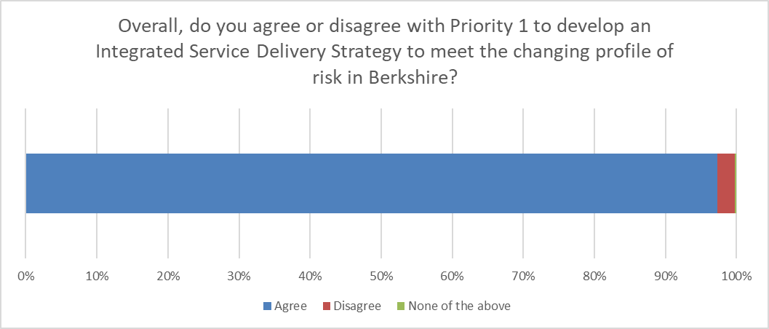
- 477 responses
- Overall agreement – 97.3%
We received 56 qualitative comments in relation to Priority 1, 51 came from those who agreed with this priority and 5 from those who disagreed.
 | Employee | Resident or works in Berkshire | Group or organisation
Common themes | Impact of climate change – spate conditions and incident types | Climate change - preparedness | Climate change – changing risk profile
 | Crewing levels | Water Safety & Flooding | Adapting to legislative change
 | Staff retention | Council tax increases | Flooding risk

 | Issues raised | Response
Confidence | “I believe that this priority makes perfect sense in response to climate change, especially in responding to wildfires and flooding incidents”  “Climate change is a big issue. The for service should be prepared for it“  “It's a good idea to adapt to changing risk in Berkshire and I'm pleased to see that climate change is being highlighted as an area of concern after the severe weather of 2022.”  “Agree very much. However , 1) Much better conversations needed on how to extinguish electric car fires - or not, as seems to be a move away from the large quantities of contaminated water. 2) Better deployment of resources at a small wildfire, and effective operational effectiveness controls a small fire and stops the big fire. I feel improvements with incident management at wildfires are needed.” | The intent of this priority is to adapt to changes in existing risks and prepare for emerging risks.  An integrated service delivery strategy will be designed to account for community risk and present RBFRS with a comprehensive ability to use its functions (Prevention, Protection, Response and Resilience) as efficiently and effectively as possible.  Our understanding of risk will help us develop station level plans that address the risk within their respective community. This is important as hazards are not distributed evenly across Berkshire.  Understanding that risk can be highly localised means that it may be necessary to ensure resources are deployed in a manner that supports the mitigation of community risk.  It is not the intention of this priority to reduce front line resources. This priority is designed to facilitate the use of RBFRS’ understanding of community risk, developed during this CRMP process, to ensure that the service is fit for purpose in a changing risk environment.  The other proposed CRMP priorities are designed to support the delivery of this priority. For example, in order to implement an integrated service delivery strategy the response model must align. Consideration should be given to how the priorities will work as a package of measures.  Feedback from those who responded as members of RBFRS staff noted the need to be aware and plan for crewing levels and resource to meet the demand of a changing risk profile. There was also a degree of concern from staff that there may be a reduction in frontline resource to meet the changing risk profile.  Qualitative feedback from residents and people who work in Berkshire focused on preparedness for climate change, the changing risk profile and operational challenges that may be associated with increased adoption of new technologies.  This group also expressed concern about increasing tax burdens and the risks presented by flooding.
Concern | “But do not use it as an excuse to cut front line appliances and crews”  “I agree that we should be changing our priorities however this means money shifted into "projects" when frontline staffing during the summer was run on barebones and without the amount of staff taking overtime it would have been extremely dangerous. I.e. Fund recruitment more than projects.”  “It's just a smokescreen to try and bleed more money out of hard pressed taxpayers”  “Prevention activities for Water Rescue? Given what occurred last summer?”

Priority Two
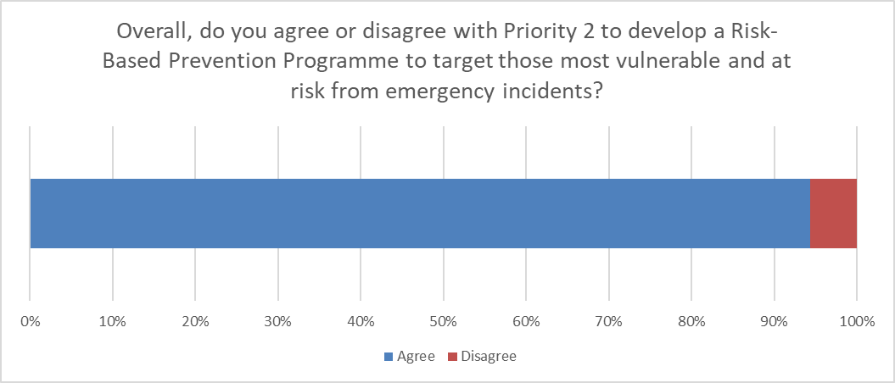
- 444 responses
- Overall agreement – 94.4%
We received 54 qualitative comments in relation to Priority 2, 44 came from those who agreed with this priority and 10 from those who disagreed.
 | Employee | Resident or works in Berkshire | Group or organisation
Common themes | Crewing levels | Better targeting of communities | Collaboration with partners
 | Efficiency | Efficiency | Partnership working
 | Better targeting of communities | Equality of access | Build community resilience

 | Issues raised | Response
Confidence | “Developing innovative approaches delivered in partnership with other key agencies is critical to use FRS skills effectively to help reduce risk to the most vulnerable. You must be prepared to do new work in order to have maximum benefit for your communities.”  “Excellent idea to continue working with health & social partners to give an integrated service.”  “This aligns to the developing national expectation that risk should be aligned to local demographics as described in the UK Resilience Framework published in December 2022. This requires close working with multi agency partners to identify and share an understanding of vulnerable individuals across cat 1, cat 2 and non cat responders”  “It makes sense to better target communities that are most at risk. We have difficulties in reaching communities in Slough so it makes sense for us to use more resources in this area.” | Support for this priority is high amongst respondents. It is important to note that it was not unusual for respondents to agree with the proposal but raise questions in the free text section.  A number of comments we received related to ensuring that developing a risk based inspection programme is cost and resource effective and efficient. Some feedback also referred to a suggestion to work more closely with the community and other organisations to support vulnerable people.  A number of responses from RBFRS staff in particular expressed a need to review the current way people are identified as being at risk.  The intention of this priority is to develop existing partnerships and mechanisms for fire prevention referrals. Community fire safety education is a statutory duty for RBFRS and the service needs to ensure that it is deploying its resources in an effective and cost efficient manner.  Protection teams prioritise their work by developing and maintaining a risk based inspection programme for fire safety audits. This proposal will support the development of a risk based prevention programme to help target resources to those at greatest of fire in the home.  Introducing this programme will also help RBFRS identify where areas of high risk are under resourced and where new partnership links need to be developed.  This proposal is intended to support the development of more nuanced station level community safety planning.
Concern | “I don't think this will be achievable. Operational crews are happy to aid in prevention, but if front line crews keep coming off the run due to crewing shortfalls, due to the very lean model, front line appliances won't be available to take part in prevention activities.”  “The way in which the most vulnerable is prioritised doesn't work. Crews are sent to perform safe and well visits to people with linked alarm systems, whilst their are young families with small children that don't have working smoke alarms. Yet they are not deemed vulnerable. This needs to change”  “It is not clear whether the reference to working with partner agencies such as health and social care commits to the existing processes, or new mechanisms. Further detail and exploration would be welcomed. Continued and enhanced partnership working with the Berkshire Resilience Group (BRG) and/or TVLRF should be considered as a priority. Specifically in relation to wider Business Continuity Promotion and Community Resilience activities across Berkshire in order to build resilience across the area and therefore reduce the impact of any emergency incident.”  “The Safe & Well Technicians role is at the forefront of directly reducing risk in the Community addressing RBFRS's biggest concern - Fires in the Home. This role however does have suitable and sufficient training to actually carryout the job effectively. This includes a distinct lack of training to even include basics such as Fire Behavior & Development, IOSH, Risk assessment. Targeted campaigns such as residential sleeping risks over commercial premises. Revisit inspection strategy for high risk residential homes.”  “Having lived in other fire durisdictions I know others do much more about educating others on risk. One of the ones which worries me most is balcony fire safety - you need to do what others like manchester fire have done with teaming up with balcony specialists.”

Priority Three
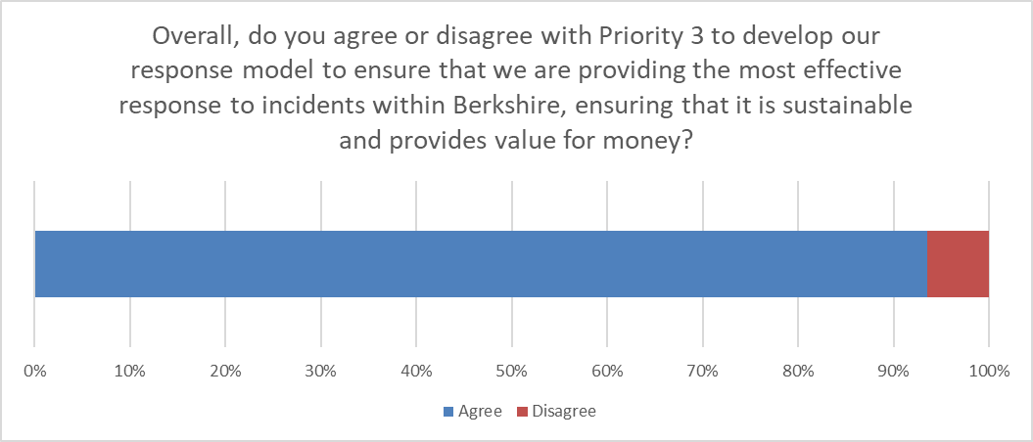
- 430 responses
- Overall agreement – 93.5%
We received 85 qualitative comments in relation to Priority 3, 66 came from those who agreed with this priority and 19 from those who disagreed.
 | Employee | Resident or works in Berkshire | Group or organisation
Common themes | Crewing levels | Concerned by the standard | Prioritise response time
 | Risk based approach | Invest in response | Partnership working
 | Response standard | Sustainability | Proportionality

 | Issues raised | Response
Confidence | “To achieve this we need all appliances available for the maximum amount of time, more investment to support our On Call stations and more recruitment of Wholetime to maintain our establishment to stop Wholetime pumps coming off the run with the degradation policy.”  “Important that we have sufficient resources to respond effectively. Water rescue should be a key consideration. “  “The cost of living crisis is still having a really big impact. My council tax is really expensive so it's right that you make sure you are spending wisely.”  “The response model should be developed in consultation with multi agency partners to best understand the range of capabilities they offer and where services can be streamlined but equally where services are required.”  “The current response model is very weak in the support of larger scale incidents or incidents that require the FRS to support partner agencies. Staff need to be able to respond and also train within their normal working hours without an over reliance on overtime to crew normal response. The plan should include an analysis of items such as who provides training on elements such as specialist vehicles (e.g. ALP, HVP etc.) and specialist response (MTA, Hazmat etc.). The model also needs to take account of the service commitment to national assets and capabilities and how these will be supported without degrading normal incident response.”  “I think the Fire Service has been under-invested in for years, so completely support this priority and trust public money will be spent wisely.”  “But, you should avoid cutting the service you provide. Efficiency gains should be made first! “  “If you are planning on becoming more sustainable you'll need to invest in clean vehicles and efficient buildings. Is there a plan for how to find AND deliver this in line with government zero carbon targets?”  “Need to tackle areas of cost wastage like amount of sick leave and other non-productive activity” | The intent of this priority is to facilitate the development of a new response model based on understanding of risk. This review will consider how resources are deployed in line with risk and will consider appliances (both frontline and special appliances), officer cover, technical specialisms and capability to respond to beyond normal risk events.  The qualitative feedback from RBFRS staff reflected comments that the response model should be risk based and not just derived from response time.  The foremost concern for staff was that the current headcount is too low to support effective response. Concerns around on call were also expressed, both in support of the system and suggesting it should be replaced with wholetime resources. There were also suggestions that RBFRS should measure a second appliance attendance time and that the measure does not reflect local attendance times as it averaged across the County.  Residents and public expressed concern with the response standard. Some respondents feel that 10 minutes is not quick enough.  There were calls from residents and the public for investment in response resources and a resistance to budget cuts in service delivery.  Residents and the public are interested in ensuring that RBFRS is sustainable, both from an environmental perspective and in terms of organisational resilience.  There were fewer responses from groups and organisations, but their focus was that response times should be prioritised, that our response model seems proportionate and that future development should involve partner agencies to help identify efficiencies.  Some respondents asked that cost wastage be considered. This was reflected in responses that focused on seeking collaborative opportunities, preventing unnecessary mobilisations and effective management of sickness absence and extractions for training.  Some had concerns about the number of Firefighters reducing year on year, the service has seen a number of personnel transfers to other service or leave for other reasons, over the past few years. We continually review the number of leavers and recruit to fill the gaps that are created.
Concern | “I believe that this should not just be response based, this should also be risk based too”  “Response time not very reassuring, more resources seem to be needed to improve risk response.”  “a first pump attendance of 75% in 10 minutes is fine but the second and third pump attendance should also be measurable, that is what leads to speedy resolution and lives saved”  “Crewing levels are too lean. The crews are struggling to keep appliances on the run during a time in the year when leave figures are showing single figures.”  “But, you should avoid cutting the service you provide. Efficiency gains should be made first!”  “Number of firefighters has reduced year on year and nothing seems to be done to prevent people leaving the service. Changing shift patterns will only make this situation worse”.  “The best way of achieving this is through raising establishment which we do not achieve. Changing shifts will lead to worse staff retention. Training courses and leave should be managed better. wholetime staff where available should be detached to on call stations, this includes training centre staff, hub managers, those running 'projects even down to FF's”

Priority Four
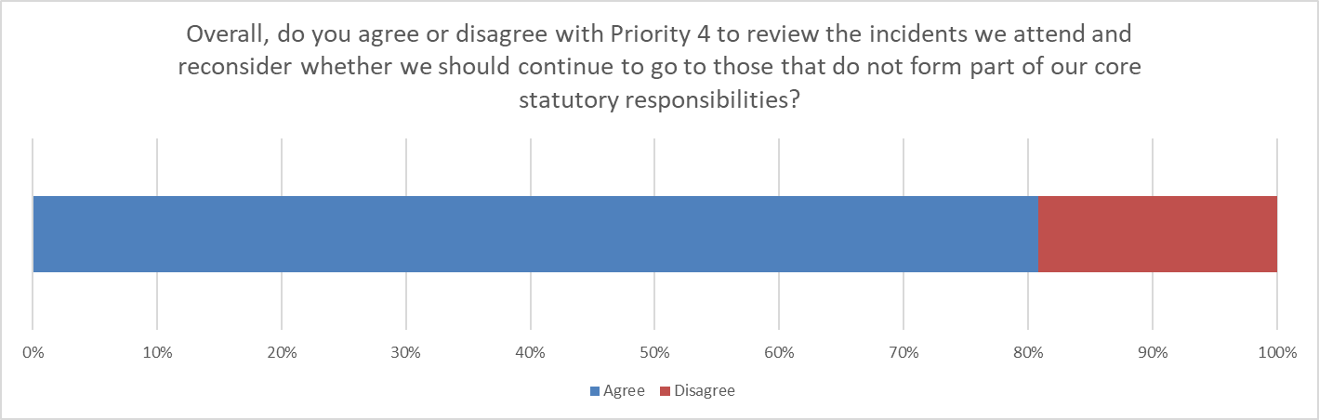
- 422 responses
- Overall agreement – 80.8%
We received 124 qualitative comments in relation to Priority 4, 73 came from those who agreed with this priority and 51 from those who disagreed.
 | Employee | Resident or works in Berkshire | Group or organisation
Common themes | Moral/public expectation | Continue animal rescue | Risk of creating a capability gap
 | Seek funding | Seek funding | Need for ongoing communication/consultation
 | Reducing attendance at AFAs | Moral/public expectation | Continue to attend non-statutory incidents

 | Issues raised | Response
Confidence | “Absolutely. I think focusing on your core service should help to strengthen and improve the overall service you deliver to the community. It would be interesting to see how you go about withdrawing from duties that don't form a part of your core statutory responsibilities, without it leaving a gap or groups of people vulnerable.”  “Yes that priority should be core services however the fure service is best placed to help search for missing people as appropriate especially in areas where the other services are less equip and stranded animals. I agree that fire alarms maybe should be re prioritise”  “Review is necessary. Automatic fire alarms DEFINATLY Smell of burning – Defiantly needs adjusting to 1 pump PDA – Better information gathering from control is required. There is a clear difference between someone on the street smelling burning and seeing smoke coming from a house vs someone in the house, can smell burning, but can’t see smoke or fire. I feel we should attend all water rescue incidents, including sub surface to stop others from getting into the water, and also lock ins / lock outs, as these do a lot of good with limited demands on resources, and can lead to lots of good work carrying out fitting of smoke alarms and information gathering for future incidents / improving public relations.”  “Whilst I agree, it is unfair to expect the public to accept a reduction in service they are paying for and have come to expect. Maybe you shouldn't have started providing the service in the first place! Government should be clear about your role and evolve it in the same way you as a Service would like to. The fire service should be properly funded for the services it provides as identified in its risk management plan.”  “Need funding for extra duties like water rescue”  “Although I agree with this action, I would hope that onward communication with other services or volunteer organisations, will be part of the process and that no distress will be caused.”  “Suggest that the organisation only respond to incidents required under statutory duties to improve performance in these areas”  “Good this is being reviewed. Automatic alarms should be checked initially by the owner of the property first not sending a crew, especially from a busy station.” | The intent of this priority was for RBFRS to undertake a review its statutory duties and identify work undertaken in addition to those duties.  The purpose of this exercise is to understand the time and cost impact of non-statutory work and to ensure that focus is maintained on delivering core duties to a high standard.  The drivers for this proposal are various, and comprise understanding the cost to the taxpayer of different types of activity, ensuring organisational focus, supporting response modelling and assessing current and future capability requirements.  The feedback we received from residents in Berkshire was supportive of the need to review the work undertaken by RBFRS. However this group also reflected a concern about community safety if RBFRS were not to attend incidents that weren’t part of the statutory duties  Employees, residents and people who work in Berkshire commented on the importance of animal rescue. Some respondents spoke about the tension between this priority’s reference to water rescue as a non-statutory response and Priority 1’s mention of flooding as a risk associated with climate change.  It was also common for respondents from these groups to suggest that the Fire Authority should lobby government for funding for these duties.  Equally there were a number of comments that suggested that a focus on strict legal duties overlooked an implied moral and ethical duty that RBFRS has to deliver humanitarian aid.  Groups and organisations were concerned about the potential for this priority to create a capability gap and the need for ongoing communication and consultation around future plans.  The concern expressed around this priority was not with the suggested review, but with potential outcomes and consequences of the, as yet, uncompleted review.  This report notes that concerns around the role of Fire and Rescue Services have been recognised at a national level. The HMICFRS identified this in the State of Fire and Rescue: The annual assessment of Fire and Rescue Services in England 2022 report.  The Government White Paper on Reforming Our Fire and Rescue Service may provide clarity on the role of Fire and Rescue Services and influence implementation of this CRMP priority.
Concern | “It’s important that the fire service continue with large animal rescue, as a farmer in rural Berkshire this is critical”  “If your aren't funded for this work why are you not lobbying for change?”  “We agree with the review but we do not agree that the RBFRS should not attend non-statutory incidents”  “Whilst money and resources are tight, there is a moral obligation on all Cat 1 responders to attend incidents outside of their statutory responsibilities. This has been custom and practice and communities expect this to continue. Fine to review those that you are really not required to attend but consideration must be given to 'if not the F&RS, then who' question”  “It is important to consider in the context of TVP and wider partner long term changes too, there is a risk of emergency resourcing gaps. Also, it is relevant to further explore the responses to non-statutory incidents to identify what may be prioritised. The voluntary sector could be key partners in this and are not included within the plan. Setting clear expectations with the public through communications, engagement and education would be essential if some responses are to be reduced. It is unclear if the assessment of incidents to attend are fixed for the plan period, or if there will be an ongoing review mechanism and flexible attendance to some incidents”  “Automatic fire alarm responses should be undertaken by the dedicated person in charge of the building. Animal rescues and missing people requires specialist equipment, not necessarily available in the volunteer sector - some Lowland rescue organisations have the ability to respond to missing people, but the politics within some of these organisations takes over from what should be the priority, the missing person, in that personal preferences in the use of equipment and resources overrides the key decision making process. Animal rescues requires just the equipment you have available (i.e. lifting gear) for large animals - would you let these animals just die as there doesn't seem to be a practical alternative in the volunteer sector”  “Who will rescue animals or go to floods if your don't?”  “I am concerned about reducing what you do. Who will help us if the fire service doesn't??”  “I agree a review over the incidents that you attend, but missing person or automatic fire alarms as non-statutory should be attended”  “Disagree with not going to animal rescues as other people will try to help and you will end up with more casualties”  “However, in times of need the Fire and Rescue Service has always been there when people need us, regardless of whether it is our legal duty. When there is no-one else to call we are usually the ones stepping forward. Should we stop initiatives such as safe spaces because it isnt a legal obligation, or should we do what is morally right?”  Can you look at establishing wider links in the community to still be a part of community planning for such events?

Priority Five
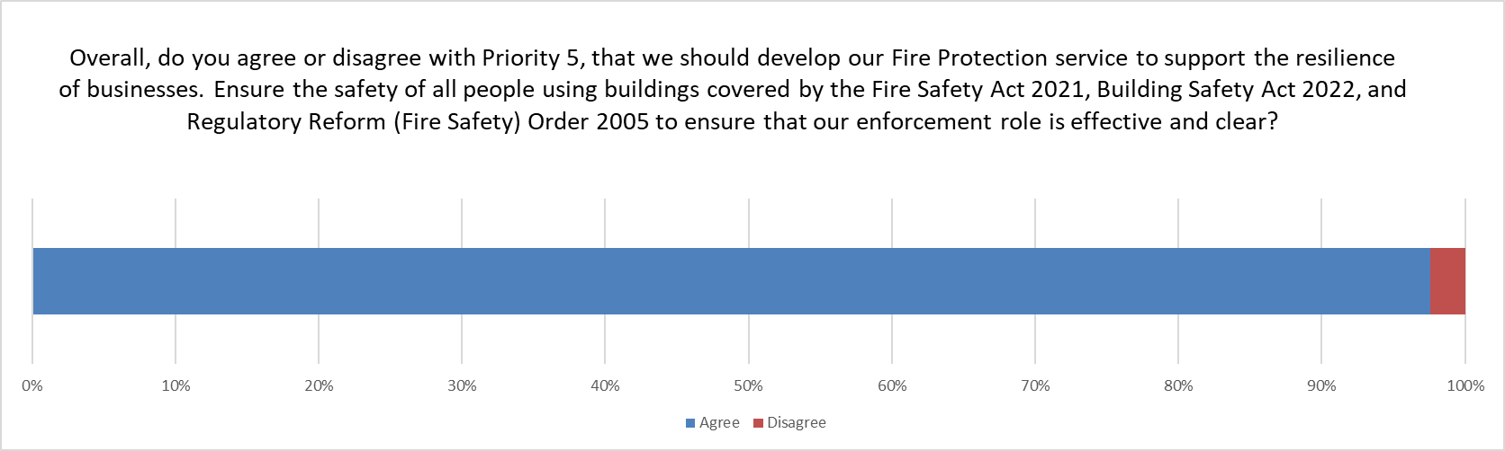
- 414 responses
- Overall agreement – 97.6%
We received 47 qualitative comments in relation to Priority 5, 44 came from those who agreed with this priority and 3 from those who disagreed.
 | Employee | Resident or works in Berkshire | Group or organisation
Common themes | Do more to promote sprinklers | Do more to promote sprinklers | Increase number of inspections of businesses
 | Protection staff retention | Concerned about high risk premises: tall buildings, cladding and HMOs | Willing to collaborate
 | Advice and guidance to local businesses | Reduce burden of AFAs | Beware of emerging risk in protection

 | Issues raised | Response
Confidence | “We support the priority to target this area where there are still many business owners who do not fulfil the responsibilities required of them under the RR(FS)O. An audit by an external enforcement agency is required with subsequent actions”  “The only aspect that is for debate here appears to be the reduction of UWFs. If capacity is limited then reducing this demand more significantly seems sensible.”  “Would be nice to have more building inspections. They tend to focus on high rise and HMO's but not businesses.”  “Your efforts in this area are actually well appreciated by those involved in design and use of buildings!”  “Strongly agree. Most businesses want to do right by the fire service and any advice that can be given to lessen any unwanted impact on the fire service is good in my opinion.”  “Upskills front line operational staff to carry out safety inspections instead of continually employ more non ops staff for such tasks”  “Could this be expended to support the promotion of Business Continuity planning by businesses especially SME”  “Sprinklers are hugely important, are often unpopular with developers/ planning officers - anything you can do to remedy this this will be a massive achievement”  “Also, there needs to more building fire safety education available to the public. Enforcement and regulation is important, but in an increasingly complex regulatory environment reliable advice is vital.” | This priority was proposed in the CRMP consultation as delivery of fire safety regulation is a statutory duty and the legislative landscape has shifted over recent years. In the post-Grenfell world the CRMP has identified shifting patterns of residential development that require RBFRS to be live to the potential for increased demand on protection services and the need to consider how business safety education can be delivered alongside legal enforcement.  Support amongst respondents was high. It is interesting to note the frequency of comments around the need to support wider adoption of sprinklers to increase public safety.  There were comments from staff members, groups and organisations about wider engagement with the business community, both in terms of audits and the provision of advice. There was also a call for increasing the specialist protection knowledge of operational staff.  Residents expressed concern about tall buildings, and respondents called for wider inspection of residential premises. These are generally beyond the ambit of the Fire Safety Order and when these comments are considered in the light of the comment about the need for better engagement may suggest a need for ongoing education around fire safety responsibilities. These are complex and technical; increasing public understanding may help to improve clarity and perception of the role of the Fire and Rescue Service in regulation and enforcement.  There was concern as to the number of inspectors available to carry out inspections. We have recently been provide extra funding from the Home Office for additional posts linked to the Building Safety Regulations.
Concern | “The cladding scandal still hasn't been fixed. The fire brigade should be helping make residents lives safer”  “Much better relationships and engagement is required with businesses owned by ethnic minority groups who ate often disproportionately impacted by enforcement orders”  “Please can flats, residential homes etc also be a priority”  “How will you achieve this when there are fewer inspectors out inspecting than ever before?”

Priority Six
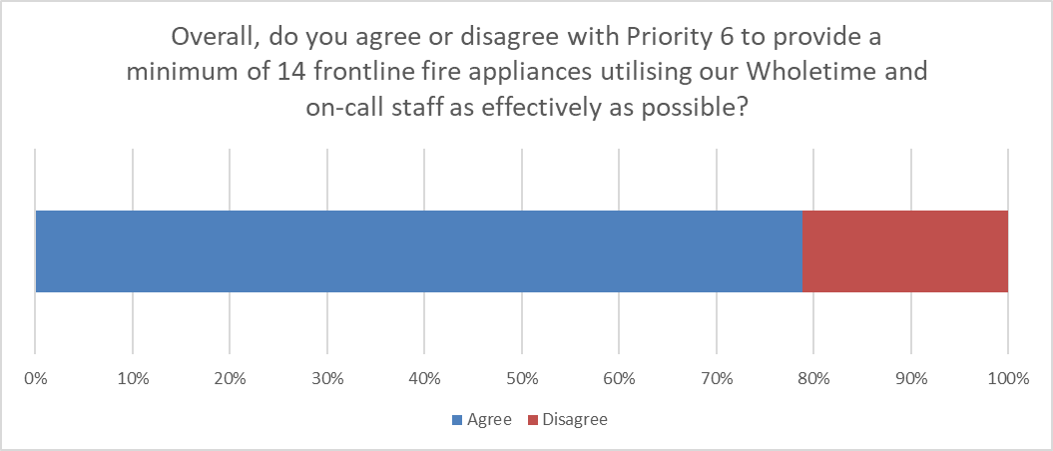
- 411 responses
- Overall agreement – 78.8%
We received 133 qualitative comments in relation to Priority 6, 64 came from those who agreed with this priority and 69 from those who disagreed.
 | Employee | Resident or works in Berkshire | Group or organisation
Common themes | Crewing too lean | 14 Appliances is not enough | Collaborate and communicate around change
 | Good to recognise on call FFs | Fund and crew all 19 appliances | What is the impact on response times?
 | Don’t pick a number – align to risk | Recruit more staff | 14 Appliances is not enough

 | Issues raised | Response
Confidence | “This seems sensible providing the level of service provided by both types of crew is comparable.”  “You are the professionals so I rely on your assessment that this will give you enough staff to keep the public safe and the firefighters safe.”  “Will be good for on-call to play a big part if they are available.”  “This seems like sensible use of all your resources. However, you must guard against allowing this becoming the new normal minimum.”  “Caveat that you are happy that 14 frontline appliance is sufficient in the the event of a large emergency - AWE, terrorist attack etc”  “I completely agree with recognising the on-call with regards to minimum of 14”  “Improve the relationship between WT & On call & over the border crews. Increase crewing to ride 5 on each appliance.” | The intent of this priority is to recognise that RBFRS has 19 frontline appliances and to maintain the baseline service provision of 14 available appliances at any one time.  The proposed change is to utilise the on call appliances to maintain fire cover. This is only intended to happen where an on call unit is available for the entire shift in question. From a response perspective, there is no difference in the qualification or competence between on call and wholetime members of staff.  There was a higher degree of concern about the implications of this priority when compared to other proposals.  There were concerns amongst staff about the leanness of the response establishment. Residents expressed concern that 14 appliances was too few to provide sufficient cover. It may be that public perception about the size of organisation does not match the reality. However this can only be inferred and is not an objective finding.  Some employees expressed a concern that the provision of appliances was based on an arbitrary number. The full consultation document and evidence base were both published alongside the survey. It may be necessary to undertake more work to raise awareness of these documents. This should be captured for future learning as part of an evaluation of this consultation.  Some employee respondents support further integration of on call firefighters as a frontline asset, others pushed back against this citing concern around perceived competence and response times. These were expressed as barriers to the provision pf a professional response capability.  Due to the way the survey questions were configured, and the need for anonymity, it is not possible to differentiate between employment statuses among the respondents. The report infers that there are cultural barriers that persist amongst wholetime and on call colleagues that should be addressed if they are not to hinder implementation of this priority.  Groups and organisations are keen that future change is clearly communicated and expressed concern around the impact on response times. Some organisational respondents also expressed concern around the minimum provision of 14 appliances.  Some respondents to this question felt they did not have enough information to form an opinion about whether a minimum provision of 14 appliances was sufficient. Rationale, including dwelling fire risk, appliance travel times and appliance utilisation was published within the CRMP evidence base document.
Concern | “14 is too few when 19 is the standard”  “Will service levels be openly communicated to partners and public ?”  “I agree with the number of appliances but not with utilising the on call to maintain this number. 14 should be maintained with whole time appliances”  “14 is unfortunately not realistic after many years of cuts to staffing, last year we struggled to get 8/10 appliance in the summer months”  “This is not directly solving the crewing issue. By incorporating the on-call as part of the 14 that is not value for money for the people of Berkshire and not directly dealing with the crewing issues within RBFRS.”  “We need to address staff retention first and aim to keep all pumps available.”  “With an increasing population, thus denser building and travel time limitations due to volume of traffic, reducing the number of appliances available is just wrong and likely to lead to an increase in deaths, whether this be through delays getting to a fire where people are trapped, or delays getting to road accidents where people need cutting out whilst suffering potential life changing or limiting injuries - more response vehicles, not less should be your proposal to reach your targets.”  “A minimum of 14 for engines just doesn't seem like enough. How will you guarantee that it doesn't drop below that? Perhaps you need to recruit more staff.”  “It's a minimum, but doesn't seem like enough for the million residents in Berkshire.”  “We feel 14 frontline fire appliances is too low”  “You either need 19 frontline appliances or you don't. If part time staff are trained to the same standard as wholtime firefighters then there is something wrong with the wholetime training regime.”  “We can neither agree nor disagree as it is not clear what the previous operating levels were, and what the impact of 14 frontline fire appliances would mean compared to 19. It is not clear which areas of the county this would affect the most and to what extent.”

Organisations, groups and business responses
The consultation team contacted a wide range of stakeholder organisations, groups and businesses in order to solicit as wide a range of responses as possible. Two schools, a local authority, a care provider and an adult social care department responded but did not specify the name of the organisation.
Organisational or group responses in writing are included in full in Annex 1.
This table provides a breakdown of organisations, groups and businesses that responded to the consultation.
Arborfield Parish Council | NHS Buckinghamshire, Oxfordshire and Berkshire West ICB
Berkshire Lowland Search & Rescue | NHS Frimley ICB
Bracknell Forest Council | Optalis
British Transport Police | Orange Business
Buckinghamshire Council (Resilience Service) | Oxfordshire Fire and Rescue Service
Buckinghamshire Fire and Rescue Service | Pang Valley Flood Forum
CLASP Wokingham | Reading Borough Council
Dorset and Wiltshire Fire and Rescue Service | Royal Borough of Windsor and Maidenhead
Federation of Small Businesses | Surrey Fire and Rescue Service
The Fire Brigades Union | Thames Valley Fire Control Service
Great Western Railway | Thames Valley Local Resilience Forum
Hampshire and Isle of Wight Fire and Rescue Service | Thames Valley Police
Hexham Community Association | West Berkshire Neighbourhood Watch

Thames Valley Fire Control Service
Two in person consultation sessions were held with Thames Valley Fire Control Service (TVFCS). Five responses were received from employees. Priorities 1, 2, 3 and 5 received 100% approval. Priority 4 had 2 disagree replies. The qualitative comments mentioned the moral pressure TVFCS can feel when resourcing incidents and that lobbying for funding should be pursued. Priority 6 had one disagree reply. This respondent suggested that the 14 minimum level appliances should always be crewed by wholetime staff as it is currently.

Neighbouring Fire and Rescue Services

Buckinghamshire Fire and Rescue Service (BFRS)
BFRS agreed to all proposals. BFRS provided qualitative answers to all of the proposed priorities. The response is included in full in Annex 2.

Oxfordshire Fire and Rescue Service (OFRS)
OFRS provided a full qualitative response to the consultation survey. The response is included in full in Annex 3.

Dorset and Wiltshire Fire and Rescue Service (DWFRS)
DWFRS agreed to all proposals and provided no qualitative answers.

Hampshire and Isle of Wight Fire and Rescue Service (HIWFRS)
HIWFRS agreed to all proposals and provided qualitative answers to priorities 1, 4 and 6.
Priority 1
“Recognise the changing nature of risks across every fire and rescue service. We cannot be static.”
Priority 4
“We (HIWFRS) are also mapping what is and isn't a statutory function to determine whether responding to such an incident is the most appropriate use of our resources.”
Priority 6
“We (HIWFRS) would be keen to discuss this with you to identify if this changes how we currently work together and our own risk profile.”

Surrey Fire and Rescue Service (SFRS)
SFRS agreed to all proposals and provided qualitative answers to priorities 3, 4 and 6.
Priority 3
“It would be useful to understand what your definition of value for money is”
Priority 4
“Will there be further consultation around which incidents you will not respond to?”
Priority 6
“Is there an impact on the response standard for RBFRS?”

Representative Bodies
We are pleased to have received a detailed response from the Fire Brigades Union as a key organisational stakeholder. The FBU response was a considered and balanced document. RBFRS will provide a response in writing.
The response from the Fire Brigades Union is included in full in Annex 4.

Unitary Authorities
Reading Borough Council provided a response in writing to the consultation. It is included as Annex 5.

Proposed amendments to CRMP Priorities based on feedback
Follow initial consideration and feedback of the public consultation by the Royal Berkshire Fire Authority and professional advice of the Chief Fire Officer this report suggests that the Strategic Commitments and CRMP priorities be amended.
The changes are proposed to the Fire Authority in order to improve the clarity of the priorities. The changes also reflect a shift in emphasis based on insight gained from the consultation.
The proposed new wording is highlighted in red:

Strategic Commitments
There is one proposed minor change to the Royal Berkshire Fire Authority’s Strategic Commitments following consideration of the feedback from the public consultation and professional advice of the Chief Fire Officer. This is suggested to ensure the Authority’s commitment to the statutory duty to provide education about fire safety is clearly communicated.

Prevention
We will reduce the risk to our communities through our partnership duties and prevention education activities, ensuring that our services are accessible to all.

Protection
We will support those with responsibility for premises to understand their duties in ensuring the safety of all people using buildings covered by the Building Safety Act 2022 and Regulatory Reform (Fire Safety) Order 2005, whilst ensuring that our services are accessible to all.

Response
We will ensure that our people are trained, and resources are located to provide the most effective response and to have a positive impact on incidents in our communities.

Resilience
We will ensure our resilience and work with our partners to promote and build resilience in the communities we serve.

Sustainability
We will ensure that we provide a financially sustainable, and environmentally friendly service to our communities.

People
We will support our staff by providing a safe and inclusive environment for them to thrive in, building a diverse organisation that is engaged with, and accessible to, our communities.

Priority1
No change
We will develop our Integrated Service Delivery Strategy to meet the changing profile of risk in Berkshire due to climate change, societal and technological shifts.

We anticipate that climate change and technological adaption will change the types of emergency incidents we attend. The summer heatwave of 2022, saw RBFRS attend a very large number of fires across the County. Increasingly wet winters are also predicted and we anticipate more frequent flooding. As society adapts, through increased use of alternative and renewable energy systems in vehicles, homes and businesses, we must adapt what we do to mitigate the risk. The hazards we manage are changing and we must keep pace with these changes.

We will develop our prevention activities and response model to reduce the impact of wildfires and to support our response to flooding. These changes will improve the resilience of RBFRS and the community.

We will develop our prevention activities and response model to reduce the impact of incidents from alternative fuel sources, both to the Service and the people of Berkshire.

Through our annual review of risk we will continue to monitor developments in new technology.

Priority 2
We will develop a Risk Based Prevention Programme, in collaboration with our partner agencies, to target those most vulnerable and at risk from emergency incidents.
We will work with our partner agencies to develop and implement a Risk Based Prevention Programme, which helps us identify those that are most at risk in the community. To enable us to carry out early intervention activities, preventing them from becoming vulnerable to risk. We will ensure that we use our resources and capability in the most efficient and effective way.
We will identify those most vulnerable through our various partnerships such as safeguarding referrals, to ensure that we are targeting our prevention interventions most effectively.
We will better understand our communities by using data and local knowledge to reduce the likelihood and severity of emergency incidents across Berkshire.

Priority 3
We will develop our response model to ensure that we are providing the most effective response to incidents within Berkshire, ensuring that it is aligned to the risks identified, sustainable and provides value for money.
We recognise that we are entrusted with public money and have a duty to spend it wisely. We will review the number of operational staff and ensure that they are utilise effectively to deliver our response model. Ensuring we provide our services efficiently and provide good value for money.
We will develop our response model to ensure its effectiveness in responding to incidents. We will match our resources to the risks within the County by ensuring our fire appliances, specialist vehicles and staff, are best placed to respond to incidents.
We will continue to maintain our response standard of the first fire appliance arriving at the incident within 10 minutes on 75% of occasions.

Priority 4
We will review the incidents that do not form part of our core statutory responsibilities, to better understand the implications for the service in attending these incidents.
We will work with our partners to develop the most effective approach to resolving incidents that currently are not part of our statutory duties, through our targeted prevention activities and our response model.
We will fully understand the impact and costs of responding to incidents, identified as risks through our detailed risk analysis, which do not currently form part of our core statutory responsibilities. This will support our other priorities, particularly those focused on public value and efficiency.
Better understanding this information will provide the evidence to support our work with the sector to lobby government for clarity and recognition of the evolved role of Fire and Rescue Services in public safety and the appropriate funding required to resource incidents that currently do not form part of our core statutory responsibilities.

Priority 5
No change
We will develop our Fire Protection service to support the resilience of businesses and the safety of all people using buildings covered by the Fire Safety Act 2021, Building Safety Act 2022, and Regulatory Reform (Fire Safety) Order 2005 to ensure that our enforcement role is effective and clear.
We will develop and build upon our Risk Based Inspection Programme to ensure we are targeting those premises with the greatest risks and using our inspecting officer’s skills to regulate where they are most needed.

We will work with businesses to educate them on their responsibility under the Regulatory Reform (Fire Safety) Order 2005.Fire Safety Order 2005 to reduce the impact of unwanted fire signals (automatic fire alarms) on our operational crews.

Sprinkler systems within buildings are an effective initial intervention in reducing the impact of fires in commercial buildings, we will strengthen our campaign for introducing these in buildings where it is not currently a requirement.

We will work with the Building Safety Regulator within our capacity under the new Building Safety Act 2022.

We will develop our way of working to be able to enforce the Regulatory Reform (Fire Safety) Order 2005.

Priority 6
We will maintain 19 frontline fire appliances, and a baseline service provision of 14 frontline fire appliances, utilising our Wholetime and On-Call staff as effectively as possible.

We will aim to crew all 19 of our frontline appliances, whenever possible. As a baseline service provision, where it is not possible to crew all 19 appliances due to training and unforeseen short term staff absences, we will provide 14 frontline fire appliances through local management of our policies.
We will continue to maintain our response standard of the first fire appliance arriving at the incident within 10 minutes on 75% of occasions.

We recognise that we are entrusted with public money and have a duty to spend it wisely. In order to ensure we provide our services efficiently we will seek to ensure that we deliver good value for money.

Part 2: Consultation Methodology
The second part of this report explains how RBFRS undertook the CRMP consultation on behalf of the Fire Authority. This information is intended to support the Fire Authority in reaching a decision as to whether the 2023-2027 Corporate Plan and CRMP meets the requirements set out in the Fire and Rescue National Framework for England. It is equally important that the Fire Authority are satisfied that the consultation meets or exceeds the standards for consultation as set out in the RBFRS Consultation Strategy.

Analysis of Data
The Fire and Rescue Services Act 2004 provides the statutory instrument that requires fire and rescue services (FRS) to have due regard to the Fire and Rescue National Framework for England. The Framework provides guidance on Community Risk Management Planning (CRMP), and suggests that a CRMP should:
“Reflect effective consultation throughout its development and at all review stages with the community, its workforce and representative bodies and partners.”
Government consultation guidance principles suggest that the length of consultation should be proportionate to the nature and impact of the proposals. This consultation period ran for 76 days from 11 January 2023 – 27 March 2023.
RBFRS also followed the legal principles which specify how public bodies should consult. Known as the ‘Gunning Principles; they specify that:
- Consultation should be carried out when proposals are at the formative stage;
- Sufficient information is provided to allow intelligent consideration of the proposals;
- Adequate time is given for response; and
- Responses are conscientiously considered before decisions are taken.
This consultation has also sought to adhere to the 2018 consultation principles published by the Government. These principles are that;
- Consultations will be clear and concise
- Consultations will have a purpose
- Consultation will be informative
- Consultations are only part of a process of engagement
- Consultations should last for a proportionate amount of time
- Consultations should be targeted
- Consultations should take account of the groups being consulted
- Consultations should be agreed before publication
- Consultations should facilitate scrutiny
- Responses should be published in a timely fashion; and
We will also consider appropriate times to launch consultations
You can access RBFRS’ Consultation Strategy online for full details of the consultation framework that we follow.
It is the opinion of this report that the consultation met the principles set out above and contained within the Consultation Strategy. The following sections provide detail about the conduct of the consultation.

Overview of Consultation Responses
The majority of the data was gathered via an online survey conducted using Survey Monkey. Additionally, some hard copies of the survey were completed by the local community during engagement activity. These have been entered into our online survey to ensure all data is accessible. All data collected was anonymised in line with good practice.
We asked about:

- Whether respondents agreed with the proposals and if they had any comments that they would like to make. This qualitative data was analysed to look at responses from different stakeholder groups to seek further insight.
- Equality and diversity information to analyse the demographic profile of respondents.
- An indication of the capacity in which the respondents were replying, such as an individual resident of Royal Berkshire or on behalf of an organisation.
Open-ended questions were used to enable respondents to provide individual and specific feedback on the consultation proposals.
Open-ended questions were analysed using coding methodology; common themes in the feedback were highlighted and patterns in responses form the basis of the analysis in Part 1 of this report.
In order to remain transparent and impartial, we have ensured that due consideration was given to all feedback collected, analysing comments and considering the range of comments including those which do not support our proposals. An anonymised copy of all the free text responses is included as in Annex 1 of this document.
We received 662 responses to the consultation in total.
- 659 responses were entered on our online survey
- 3 responses were received separately by email
In comparison to the 2019-2023 Corporate Plan and IRMP consultation 662 responses represents a 66.3% increase in returns.
Within our data reporting, we have noted the number of questions that were answered and percentage of agreement with the proposals. We have presented our data including publishing all consultation comments in order to be as transparent as possible. We felt that it was important that respondents did have the option to skip questions, in order to encourage participation and a higher response rate. If we were not to allow respondents to skip questions, we may have achieved a lower response rate or missed an opportunity to collect data and feedback about our proposals across the survey.
The intention was to encourage completion, however this freedom places constraints on our ability to analyse demographic data. This decision should be reviewed during consultation evaluation to ensure its appropriateness.
An activity tracker was maintained to monitor engagement. However, attendee numbers and engagement levels were not captured for all activities which makes it challenging to understand the full reach of the consultation. For clarity a copy of the activity tracker can be found in Annex 6.
The tables and figures in this section of the report illustrate the demographic profile of respondents who gave feedback through our Survey Monkey platform.

Benchmarking
The 2023-2027 Corporate Plan and Community Risk Management Plan was compared to CRMP consultations carried out by other Fire and Rescue Services using data provided by the NFCC. This benchmarking exercise showed us that our consultation utilised a wide range of communication channels and that the response rate was high in relation to other FRS’s consultations. See Appendix B.

Internal benchmarking against previous RBFRS consultations shows an improved rate of response and suggests that RBFRS is developing an increasingly effective consultation programme.

Consultation Resources
The Corporate Plan and Community Risk Management Plan consultation was widely publicised across the Service’s digital channels, including social media platforms, website, intranet (available to RBFRS staff) and online and local media. This promotion was delivered, alongside in-person community engagement activity led by our teams across the County. Consultation materials were made available via a number of accessible methods.
These included:
- Online via rbfrs.co.uk/haveyoursay
- Social media
- Local and online media
- Hard copies of leaflets and posters were distributed to every fire station and made available to download from the website
- Information about the consultation was sent via email
- Engagement events and activities
- Signposting via email.
In order to improve engagement with the consultation, specific community and business stakeholders were identified and contacted directly.

Communications
The overarching priority of our communications plan was to engage with as many stakeholders as possible, to gain the most representative response from residents, partners and our staff.
An extensive stakeholder mapping exercise was completed to ensure that we would reach all those groups identified as being potentially interested in or impacted by the proposals outlined.
Following this, various channels of communications were considered to reach these stakeholders effectively, as outlined in this report. This included emails, letters, leaflets and posters, social media and articles for local magazines and newsletters.
In order to evaluate the effectiveness of our communications several objectives were set at the beginning of the consultation:
- Increase total number of responses to the consultation, with a target of 500.
- Increase engagement with underrepresented groups, particularly in Slough where the response rate is typically lower.
- Engage with staff across the Service, with a series of internal briefings to encourage them to take part and to share details of the consultation in their communities.
Regular updates were posted across our communications channels throughout the duration of the consultation in support of these objectives.

Website
A section was created on the RBFRS website on the ‘Consultation’ page. This included:
- An overview of what the consultation was focusing on.
- An animated video, which explained what a Community Risk Management Plan is, what it covers and how it is produced.
- A link to the consultation documents, comprising:
  - The consultation document
  - The evidence base
  - An accessible version of the document, built in HTML so that people using accessible technology such as screen reading software and translation services (such as Google which is inbuilt to the website and offers over 100 languages) can access the whole document.
  - An ‘Easy Read’ version of the consultation document and survey.
  - A large text format version of the consultation document.
  - A paper form of the survey; and
  - A promotional poster and leaflet for local groups to use to promote the consultation.
- A link to the online survey to provide feedback.
- Information on other ways that people could take part in the consultation. This included by email, postal address and telephone number to provide alternative methods of response.
- Details on accessibility for people requiring alternative formats or languages.
We had a total of 1,625 visits to the website page during the time the consultation was running and it was the 16th most popular page on the RBFRS website.
Throughout the course of the consultation, updates were added to the RBFRS website to remind people take part, with the consultation remaining on the homepage banner for the entire duration.

Media and Partners
A press release was issued to media contacts at the beginning of the consultation on 11 January 2023, which provided details of the consultation and how to get involved, outlining the reasons for the consultation and the importance of residents having their say. Following this, the Communications and Engagement Team actively engaged with local media by phone and at local events to encourage coverage and promote the consultation to residents.
Tim Readings, Group Manager for CRMP took part in an interview with Greatest Hits Radio on 13 January. Coverage was also received in Bracknell News, Planet Radio and the Reading Chronicle.
Partner authorities in Berkshire also shared details of the consultation, such as the Royal Borough of Windsor and Maidenhead in their newsletter to residents on 24 February 2023, Slough and Wokingham shared the consultation on social media. Cox Green Parish Council shared details of the consultation on their website, Reading Voluntary Action shared the consultation and Reading University shared the consultation with students internally. The consultation was also shared in the Thames Valley Local Resilience Forum newsletter.

Social Media
To complement the channels above, social media was used throughout the consultation programme to enable respondents to share the information and to encourage engagement.
Information was posted on RBFRS’ Facebook, Twitter, Instagram, YouTube and LinkedIn pages at regular intervals, to encourage people to participate in the consultation. Information about the consultation was ‘shared’ in over 60 Facebook community groups.
During the consultation, the following videos were shared:
- Animated video with an outline of the Community Risk Management Plan.
- An overview of the Fire Authority’s proposed strategic commitments by Paul Gittings, Chair of Royal Berkshire Fire Authority.
- An explanation of the proposed direction of the CRMP as set out by Wayne Bowcock, Chief Fire Officer.
- Each of the six priorities explained by a different member of staff in separate videos. The staff members selected represented different areas of the Service (such as Protection, Prevention, Response and Resilience) and different areas of Berkshire.
These videos were published on our social media channels and in Facebook community groups, alongside a selection of social media cards that highlighted the key messages of the consultation.

Trialling New Methods of Communication
In order to continue to develop and evolve the way we communicate consultations to the public and our staff, we trialled new methods this year to see if they supported better engagement and responses.
Ahead of the consultation we set up a Consultations Hub on our website. These pages provide an opportunity for people to find out about and register to receive updates on our consultation activity. We also attended several events in the summer of 2022 to encourage people to join our mailing list. Following this two online briefing sessions were set up to brief our subscribers on the CRMP consultation. We received a good level of engagement from participants and were able to make some useful connections in the local community.
We also held three rounds of online engagement sessions with our staff, ahead of the consultation going live. Due to the shift patterns worked by operational firefighters, we held sessions for each watch, and one specifically for on-call firefighters, who usually meet on Mondays. The first set of engagement sessions was designed to brief staff on the areas that we were looking at and the approach that we were following to produce the CRMP. The second set of engagement sessions took place during the consultation and we encouraged staff to directly provide their feedback during the call.
We used paid-for promotion on Facebook and Instagram to target areas of the County that had the lowest response rate. Initially this was Wokingham and Slough, but as we received more responses from these areas, we also included Bracknell in the paid promotional activity. This resulted in 25,316 people being reached and 529 people clicking the link to complete the survey.
This year, in an effort to make the consultation more accessible to users with disabilities, we built a HTML version of the entire CRMP consultation document. This version was more accessible to people with sight loss, since screen reading technology could be used to read the document. Building the pages in HTML also enabled users to translate our materials into any of the languages supported by Google Translate, benefiting those who do not have English as their first language.

Analytics
We saw positive engagement through the analytics for Facebook, Twitter, LinkedIn, YouTube and Instagram.
Impressions refers to the number of times your content is displayed, no matter if it was clicked or not. Reach refers to the number of unique users who saw your content. Engagements refers to numbers of clicks, shares or comments on our posts.
- Our Facebook posts resulted in 36,065 people being reached and 1,877 engagements.
- Using paid-for Facebook posts, we reached 25,316 people and there were 529 clicks on these posts.
- From the over 60 community groups we posted in, they have approximately 400,000 members, which we may have reached. Due to the page set up, there no way of formally tracking the engagement or reach of this so the above figure is indicative.
- On Instagram, we used Insta stories to continually promote the consultation throughout.
- In total, our Twitter posts received 16,728 impressions and had 563 engagements.
- Our Linkedin posts achieved 6,534 impressions and 358 engagements.
- Our nine videos posted throughout the duration of the consultation, including the animated video, received a combined total of 15,853 views on Facebook and YouTube.

Consultation Activity
Throughout the consultation period, community engagement activity was carried out by teams across the Service to support responses:

- Letters and emails were sent to 1,373 community contacts across a broad range of organisations, from schools to faith groups and disability organisations. This wide range of contacts was used in order to encourage as many areas of our community as possible to take part in our consultation – particularly those who have been under-represented in our consultations in previous years.
- Details of the consultation were shared with local authorities to include in their residents’ newsletters.
- Letters were sent to partner agencies and contacts, including neighbouring Fire and Rescue Services, the Leaders of the unitary authorities, the Thames Valley Police and Crime Commissioner, MPs and Town and Parish Councils. Representative bodies including the Fire Brigades Union, Fire Officers Association, National Fire Chiefs Council and Unison were all sent letters and invited to respond.
- A variety of engagement activities were undertaken at a Hub level throughout the period of the consultation. There were 69 separate actions completed by Service Delivery staff from Prevention, Protection and Response, as well as, RBFRS volunteers. The activities comprised visits to local businesses and trading estates, contact with schools and promotion through fire station social media accounts.
- Fire crews took the opportunity to promote the consultation while carrying out their usual duties and often combined this work with activities such as risk information gathering.
- An activity tracking document was maintained during the consultation. It is attached to this report, see Annex 6.

The consultation team has attempted to reach out to a wide set of stakeholders. An analysis of organisations, businesses, community groups, agencies and charities was carried out at an early stage of the process. This analysis focused on seeking diversity of experience and opinion within the community and was intended to build on RBFRS’s previous experience of conducting public consultation.
This table represents a sample of organisations, businesses and groups that were included in the RBFRS community contact list. All were contacted during the consultation.
Alzheimer’s and dementia support groups | 11 | Joint Emergency Planning Unit | NA
Apprentices for Fire & Security | NA | Leisure Centres | 24
Berkshire School Of English | NA | The Lexicon | NA
The Bridge Trust Thames Valley | NA | Libraries | 34
Buckinghamshire CC rangers | NA | Licensing Bodies | 6
Building Control and Planning | 12 | Fire Sector Federation | NA
High profile businesses | 16 | Museums | 5
Care Homes | 28 | National Institute for African Studies | NA
Carer support groups | 11 | National Security Inspectorate | NA
The Centre | NA | Neighbourhood Action Group | NA
Charities | 119 | Online Forums | 5
Children’s Centres | 47 | Newbury College | NA
Community Groups/Centre | 192 | Policy Groups/Think tanks | 6
Creative/Arts Groups | 40 | Positive Prevention Plus | NA
Dentists | 30 | RBWM One Borough Group | NA
Employment Support organisations | 3 | Schools/Colleges | 409
Ethnic Minority Achievement Service | NA | Scouts/Guides | 8
Faith Groups | 50 | Shaw Trust | NA
Financial Support Providers | 1 | Slough Borough Councillors | NA
Foodbank | 1 | SBC Emergency Planning | NA
General Practitioners | 68 | Slough Business Community Partnership | NA
Health Groups | 3 | Sports Clubs & Sports Centres | 45
Health Service | 6 | Thames Valley Positive Support | NA
Hospitals | 5 | Victim/Witness Support | 3
Housing/Homelessness Support | 24 | West Berkshire Muslims | NA
Independent Fire Engineering and Distributors Association | NA | Wildlife & Environmental organisations | 4
Institute of Fire Engineers | NA | Wokingham Outreach Support | NA
Internal Representative Bodies | 3 | Worker`s Educational Association (Slough) | NA
Military and Veteran Charities | 26

Businesses and organisations
The consultation team identified a further range of stakeholder organisations that it considered would have an interest in the proposals. These organisations were contacted by email. TVLRF partners were engaged in a number of ways, by email, through pre-consultation sessions, an item in the LRF newsletter and a presentation to members of the LRF.
Thames Valley Police | Thames Valley LEP | Chiltern Railway
South Central Ambulance Service | Insurance Providers | National Highways
Berkshire Lowland Search and Rescue | Slough Estates | Heathrow Airport
Forestry England | Connect Reading | Broadmoor
Community Safety Partnerships | Vodafone | AWE
Thames Valley Local Resilience Forum | O2 | Windsor Racecourse
Neighbourhood Action Groups | SSE | Newbury Racecourse
Highways England | National Grid | Ascot Racecourse
Crown Estate | UK Power Network | Farmers Union
The Forestry Commission | Thames Water | Country land and business association
The Environment Agency | Southern Gas Networks | Women’s institute
Berks, Bucks & Oxs wildlife trust | Cadent Gas | Fire safety association
South East Wildfire group | Affinity Water | IFE
Country land and business association | South East Water | BAFE
Berkshire local nature partnership | Network Rail | Climate Change in Berkshire
Federation of Small Businesses | Cross Country Trains | Fire Protection Association
CBI | Great Western Railway | Reading Climate Change Network
Chambers of Commerce | South Western Railway | Chiltern Railway

Focus Groups and Engagement Sessions
The consultation team facilitated a series of focus groups online. These sessions were scheduled during the pre-consultation phase, to help shape our priorities, and during the consultation to inform and seek feedback. There were eight sessions in total attended by members of the public, representatives of organisations and RBFRS employees.
Engagement activity was undertaken by Hub based personnel following briefings by the Hub Managers and staff were encouraged to reach out to their networks of contacts within the communities they serve to broaden the reach of the consultation. Details of activities undertaken can be found in Annex 6.

Equality, Diversity and Inclusion
RBFRS recognises the importance of Equality, Diversity and Inclusion (EDI) and operates in accordance with our EDI Objectives. The Objectives for 2022-2026 were published following a public consultation.
In line with consultation best practice, at the beginning of our consultation process, we created an Equality Impact Assessment (EIA) for the CRMP and the public consultation, which we have reviewed and updated where needed.
Our EIAs ensure that we are aware of the risks and impact of our work on individuals or groups who are protected under the nine protected characteristics in the Equality Act 2010 and the methods we can undertake to mitigate these risks. The intent of the EIA is to ensure that we are aware of the risks and impacts of our work on individuals or groups who share protected characteristics, and other non-statutory social characteristics identified within our documentation (such as rurality, homelessness and those with caring responsibilities).
We are seeking continuous improvement and for this consultation we intended to build on our previous experience. We felt it was extremely important to ensure our documentation and survey could both be accessible in multiple formats to support engagement from as many individuals as possible.
For this, we worked with an external organisation who created an Easy Read version of our consultation document. This document made our information more accessible to people with learning disabilities by using short, simple sentences with pictures. This document was presented to a focus group of individuals who also had a learning disability and adapted based on their feedback to ensure they were understandable and accessible.
Google Translate is a built in function on our website. This makes the consultation material, including the full CRMP document, available in up to 108 languages. Further translations of the consultation document could also be made available upon request.
The CRMP webpage and documentation was assessed for readability and was suitable for use with screen reading technology.
During the consultation process, we were also able to analyse our ongoing response rate from various groups through the EDI data we collected through Survey Monkey. This enabled us to assess where we needed to target more specific communications and to adapt our strategy as the consultation progressed. As a result, we completed targeted activities in an attempt to increase the response rate from Slough as this was consistently low.
We seek to continually improve our consultations and will utilise learning from this experience, to improve our processes and our approach to consultation. So that we can improve our engagement with those from all areas of the community.

Equality and Diversity Monitoring
In Appendix A, we have presented the raw data comparison of EDI data from this consultation and the Corporate Plan and IRMP 2019-2023 consultation. This data is provided to show how we have changed and modified the way in which we collect EDI data through more inclusive answer options. Our intention is to represent the diversity within the communities we serve. As such, making direct comparisons is challenging as the questions asked and options offered have changed over time.
Within this consultation, we also expanded the opportunity for respondents to self-describe. This has been offered to increase the inclusivity of the consultation, ensuring that all respondents are able to describe themselves in the language they wish to use, whilst simultaneously indicating where we may have missed opportunities to add sufficient options to represent the fullest range of possible answers. For this consultation, the NFCC Equality of Access documents were reviewed to ensure that due consideration was given to how we could engage with different groups of people across the County to make a positive difference. For future consultations, we will be considering how we can continue to develop the accessibility and inclusivity in line with good practice and the NFCC Equality, Diversity and Inclusion Project Team national guidance.
We are continually working to improve the way in which we reach and engage with different groups across Royal Berkshire. We will be considering further the pre-engagement work we may be able to do with different groups within our County to inform our consultation activity and promote inclusivity within our work with the public. We continue to be committed to promoting diversity and inclusion across the work that we do at Royal Berkshire Fire and Rescue Service.

Respondents Profile
The figures below illustrate the demographic profile for all responses via the Survey Monkey questionnaire. RBFRS is committed to promoting equality and diversity; by collecting this information we are able to monitor the response rate to our consultation across a range of communities and backgrounds. This enables us to continually evaluate our work and to improve efforts to engage a representative sample of people within Royal Berkshire.
Figures used for representation of the population of Berkshire are taken from the most recent National Census in 2021, as well as The Office for National Statistics.

Respondent Group
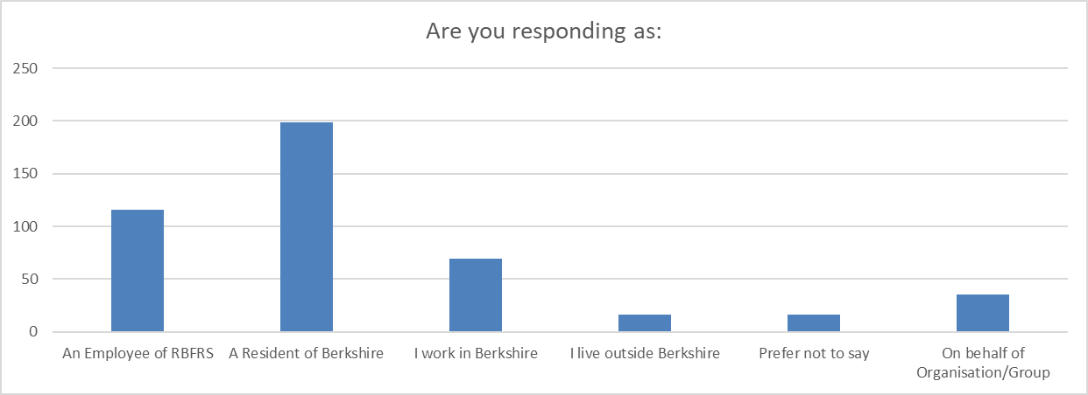

Answer Choices | Number of Responses | Percentage of Respondents
An Employee of RBFRS | 116 | 31.5%
A Resident of Berkshire | 199 | 54.1%
I work in Berkshire | 69 | 18.8%
I live outside Berkshire | 16 | 4.3%
Prefer not to say | 16 | 4.3%
On behalf of an Organisation/Group | 35 | 9.5%

Respondents were able to choose more than one group. 368 respondents answered this question. The figures above give the total number of responses, and the percentage of our respondents choosing each group, therefore these add to more than 100%.
- 84 respondents indicated they are both residents and employees
  - 38 of those live in West Berkshire
- 51 respondents who work in Berkshire are also Berkshire residents.
There were 35 responses on behalf of Organisations or Groups, 10 of these respondents also identified themselves as one of the other groups above (e.g. an employee or a resident).

Local Authority Area
We asked respondents to tell us which Unitary Authority area they live in. 345 people answered this question, although 22 of these said they preferred not to identify their local area, and 41 told us that they live outside Berkshire. The chart below shows the area the remaining respondents live in.
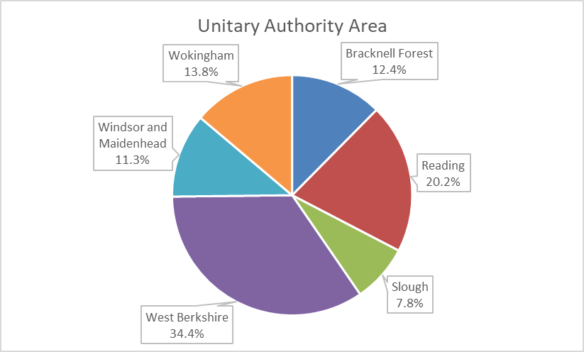
- Over a third of the responses from residents were from those living in West Berkshire.
- The smallest proportion of responses was from Slough.
The Unitary Authority areas in Berkshire have different size populations, so it is also helpful to compare the rate of response from each area, using data from the recent Census. The chart below confirms that our response rate is highest from West Berkshire, and lowest from Slough.
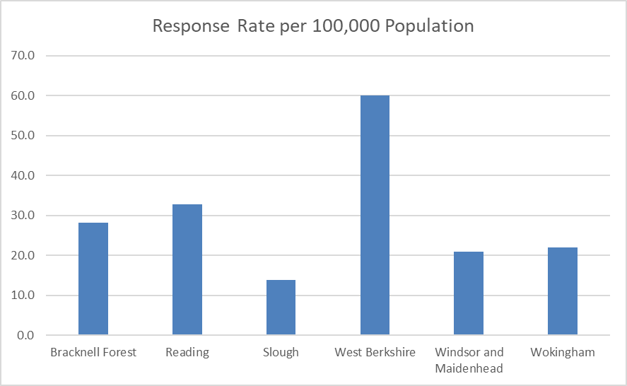
Response rate by Unitary Authority was monitored during the consultation. Where lag was identified targeted communications were utilised. Regular communications were also undertaken with Hub Managers in impacted areas in an attempt to foster increased Hub level activity.

Age
323 of our Respondents told us their age group, shown in the chart below.
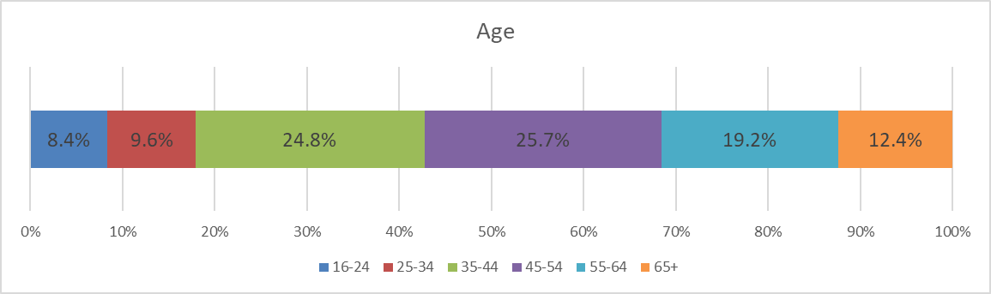
- Over half of the respondents who told us their age were between 35 and 54 years old.
- There were no responses from under 16 year olds.
The chart below compares the ages of our respondents with those of the Berkshire population of over 16 year olds in the 2021 Census. We have aligned our age categories to those of the Census to allow us to make this comparison.
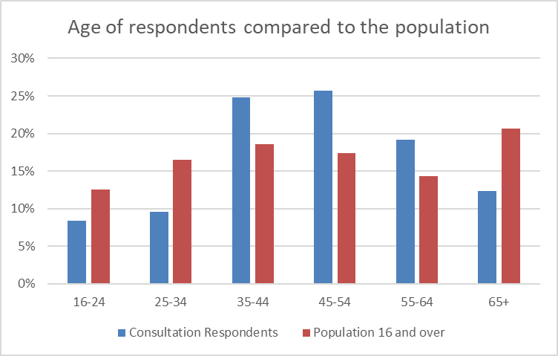
People under 34 and over 65 are under-represented in our consultation respondents. Given changes to the ages bandings recorded in this consultation and the previous IRMP consultation it is difficult to draw comparisons to evaluate changes in response levels.

Ethnicity
360 respondents responded to our question about their ethnic group. However 38 of these (10.6%) said they preferred not to answer. The chart below shows the ethnicity of those who did answer, in order to allow comparison with the 2021 Census.
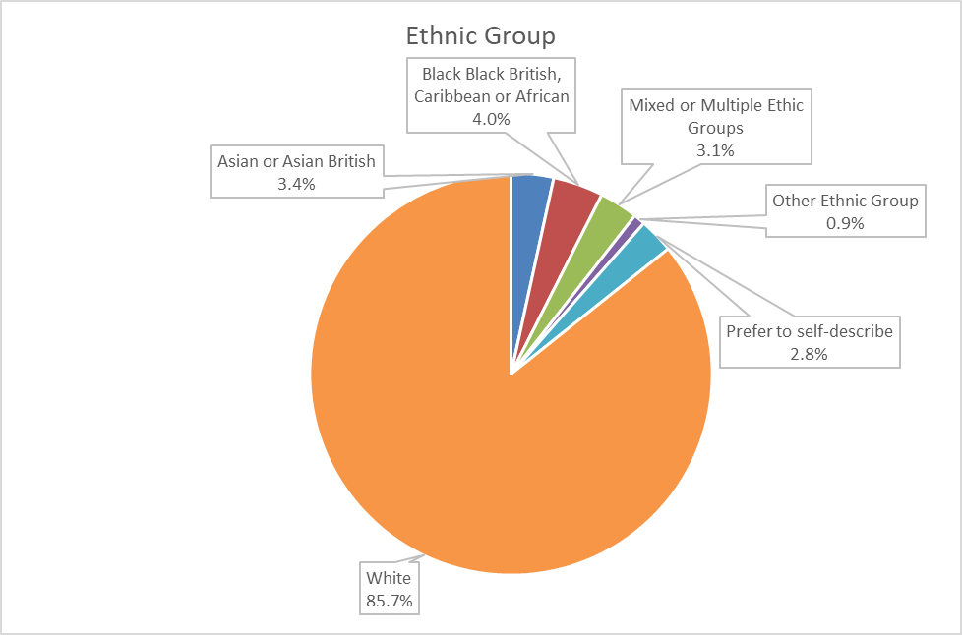
The 2021 Census found that just over 17% of Berkshire residents were from an Asian or Asian British group. This group is under-represented in our consultation respondents. The Census also tells us that there is a larger population of those with Asian backgrounds in Slough. As we have already discussed, Slough residents were also under-represented in the response. We have aligned our categorisation for this question with the groupings used in the Census, which allows us to more easily examine our progress.
 | 2019-23 CP IRMP | 2023-27 CP CRMP
Asian/British Asian | 0.9% | 3.4%
Black/British Black | 0.6% | 4.0%
Mixed Ethnicity | 0.9% | 3.1%
The proportion of those that prefer not to state their ethnicity has decreased compared to the previous IRMP consultation. This shows people either felt more able to describe themselves in the categories offered or were more willing to do so.
Note that the percentages expressed in the Ethnicity chart above differ from those in the comparison table below in Appendix A. This is due to the chart above excluding respondents who preferred not to state their ethnicity. Note that if those that chose not describe their ethnicity is included in response analysis the percentage of those that describe themselves as white has fallen from 85.7% to 65.8%.

Religion or Belief

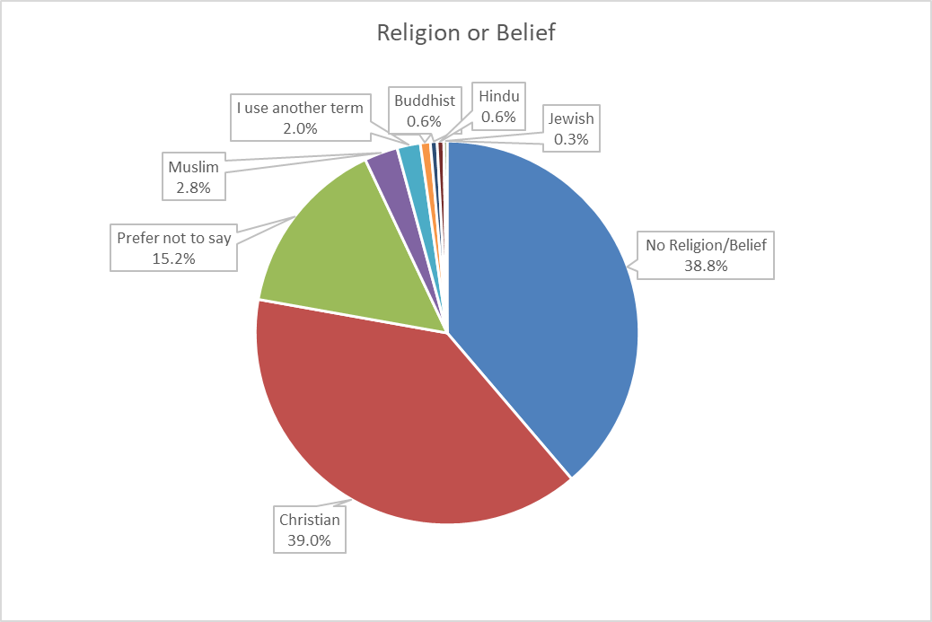
- 356 respondents answered this question.
- Christian respondents and those with no religion or belief made up the majority of respondents.
- 15.2% of respondents preferred not to state their religion or belief.
- All religious groups were under-represented, but Muslims and Hindus were particularly so. Muslims make up 8.8% of the Berkshire population according to the census, but only 2.8% of our survey respondents.
- There has been a small uplift in the number of responses from people who have a religion or belief in comparison to the 2019-2023 CP IRMP consultation. See Appendix A.

Disability

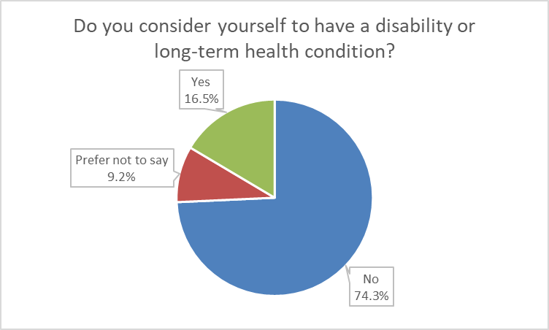
- 346 people responded to this question
- 16.5% considered themselves to have a disability or long-term health condition.
- 9.2% preferred not to say
In comparison to our previous consultation, we collected this data in the same way and the data suggests there has been an increase in respondents with a disability. RBFRS has a lower proportion of staff with a disability in comparison to the general public which may influence this data.
Data from the 2021 Census tells us that 19.8% of Berkshire residents are disabled or have a long-term health condition.

Gender Identity
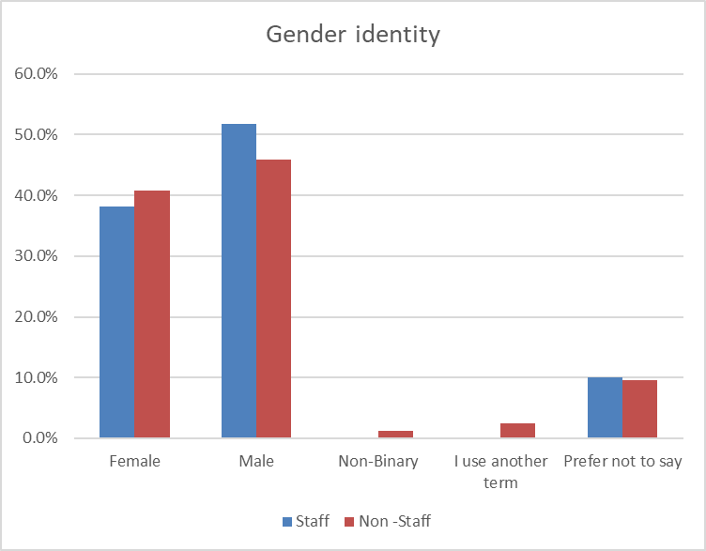
- 350 people answered this question. Overall, 47.7% of respondents identified as male, 40.0% as female, 0.9%% as non-binary with 1.7% using another term and 9.7% preferring not to say.
- The chart above compares staff and non-staff respondents. We know that RBFRS staff are more likely to be male than the general population as 76% of RBFRS employees are male, 23% are female and 0.2% are gender fluid.
- Within the non-staff group, females are under-represented compared to 2021 census data.
- Compare to the previous CP IRMP consultation there were 6.4% more responses from females and 10.1% fewer responses from males
- There was also an increase of 1.1% in those that preferred not to state their gender identity.
We asked respondents if the gender they identify with is the same as their sex registered at birth. 352 people responded to this question. One person (0.3%) told us that their gender identity was different to their sex registered at birth. A further 42 people (11.9%) preferred not to say.

Sexual Orientation
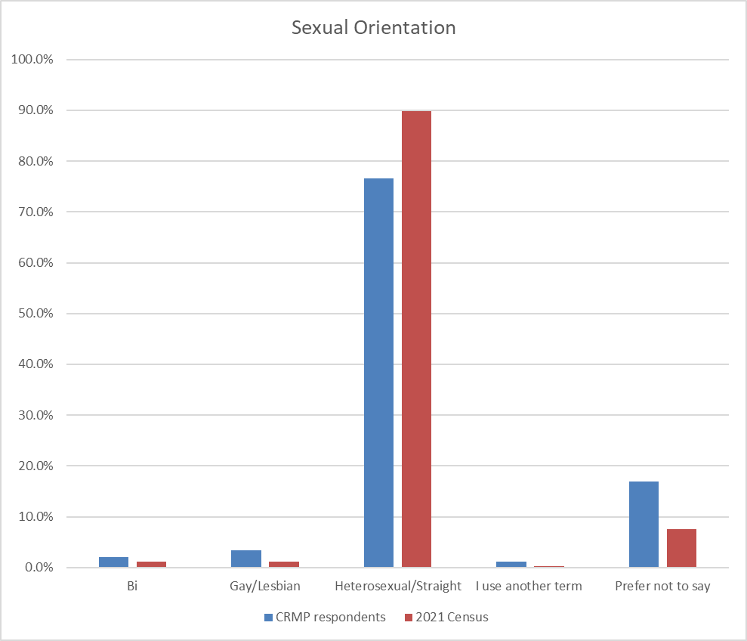
- 350 respondents answered this question.
- 76.6% described themselves as heterosexual/straight.
- 16.9% preferred not to say.
- Compared with the Berkshire population at the 2021 Census, our consultation has a greater representation from non-heterosexual groups.
- Compared to the CP IRMP consultation .there has been a drop in the percentage of responses from those that describe themselves as heterosexual, from 84.1% to 76.1%
- There has been an increase in all other sexual orientation descriptor categories

Summary and Next Steps
RBFRS will continue to review its consultation methods to ensure we communicate with our stakeholders in an effective and meaningful way. We welcome any feedback you may have, so please email consultations@rbfrs.co.uk with any suggestions.
On 27 April 2023, Royal Berkshire Fire Authority will conscientiously consider the outcomes of this report before deciding on the content of our Corporate Plan and Community Risk Management Plan.
This consultation will be evaluated in line with the RBFRS Consultation Strategy. The evaluation will consider:
- What worked well?
- What didn’t work well?
- Areas for improvement
- Resources needed for the future
- Next steps

Appendix A
This is the raw data comparison of EDI data from this consultation against the responses from the 2019-2023 Corporate Plan and IRMP consultation. Categories that were changed for this consultation can be seen in the tables with a grey box.

Respondent Group
 | Previous IRMP Consultation |  | 2023-27 CRMP Consultation
Business Owner
On behalf of an organisation or representative group | 3.4% | 12 | 9.5% | 34
RBFRS Staff member | 37.8% | 133 | 31.5% | 116
Resident |  |  | 54.1% | 199
Work in Berkshire |  |  | 18.8% | 69
Work within Royal Berkshire but not a resident | 4.8% | 17
Individual resident of Royal Berkshire | 54.0% | 190
Live outside Berkshire |  |  | 4.3% | 16
Prefer not to say |  |  | 4.3% | 16
Total |  | 352 |  | 450

In the table above respondents were able to choose multiple options. Therefore the overall percentage exceeds 100%.

Where do you live?
 | Previous IRMP Consultation |  | 2023-27 CRMP Consultation
Bracknell Forest | 9.0% | 32 | 10.1% | 35
Reading | 23.8% | 85 | 16.5% | 57
Slough | 8.1% | 29 | 6.4% | 22
West Berkshire | 24.4% | 87 | 28.1% | 97
Windsor and Maidenhead | 11.5% | 41 | 9.3% | 32
Wokingham | 16.2% | 58 | 11.3% | 39
Outside Berkshire |  |  | 11.9% | 41
Other (please specify) | 7.0% | 25
Prefer not to say |  |  | 6.4% | 22
Total |  | 357 |  | 345

Age
 | Previous IRMP Consultation |  | 2023-27 CRMP Consultation
Under 16 |  |  | 0.0% | 0
17 or under | 0.3% | 1
16-24 |  |  | 7.6% | 27
18-20 | 0.9% | 3
Under 25
21-29 | 12.0% | 42
25-34 |  |  | 8.7% | 31
26-35
30-39 | 24.9% | 87
35-44 |  |  | 22.5% | 80
36-45
40-49 | 26.9% | 94
45-54 |  |  | 23.3% | 83
46-55
50-59 | 18.1% | 63
55-64 |  |  | 17.4% | 62
56-65
60 and above | 9.2% | 32
65+ |  |  | 11.2% | 40
Prefer not to say | 7.7% | 27 | 9.3% | 33
Total |  | 349 |  | 356

Which of the following best describes your gender identity?
 | Previous IRMP Consultation |  | 2023-27 CRMP Consultation
Agender
Female | 33.6% | 117 | 40.0% | 140
Male | 57.8% | 201 | 47.7% | 167
Non-Binary |  |  | 0.9% | 3
Prefer not to say | 8.6% | 30 | 9.7% | 34
Prefer to self-describe |  |  | 1.7% | 6
Gender Fluid
Total |  | 348 |  | 350

Is the gender you identify with the same as your sex registered at birth?
 | Previous IRMP Consultation |  | 2023-27 CRMP Consultation
Yes |  |  | 87.8% | 309
No |  |  | 0.3% | 1
Prefer not to say |  |  | 11.9% | 42
Total |  | N/A |  | 352

Do you have a long term disability or health condition?
 | Previous IRMP Consultation |  | 2023-27 CRMP Consultation
Yes | 5.4% | 19 | 16.5% | 57
No | 84.5% | 295 | 74.3% | 257
Prefer not to say | 10.0% | 35 | 9.2% | 32
Total |  | 349 |  | 346

Which of the following best describes your Ethnic Group?
 | Previous IRMP Consultation |  | 2023-27 CRMP Consultation
African |  |  | 2.9% | 12
Arab |  |  | 0.5% | 2
Asian or Asian British (Indian, Pakistani, Bangladeshi, Chinese, Other) | 0.9% | 3 | 2.6% | 11
Bangladeshi |  |  | 0.0% | 0
Black African |  |  | 1.7% | 7
Black Caribbean |  |  | 1.0% | 4
Black or Black British (African, Caribbean, Other) | 0.6% | 2 | 3.1% | 13
Caribbean |  |  | 1.0% | 4
Chinese | 0.3% | 1 | 0.0% | 0
Gypsy or Irish Traveller |  |  | 0.0% | 0
Indian |  |  | 1.2% | 5
Mixed (White & Black Caribbean, White & Black African, White & Asian, Other) | 0.9% | 3 | 2.6% | 11
Other |  |  | 0.7% | 3
Other Asian |  |  | 0.5% | 2
Other Black |  |  | 0.2% | 1
Other Mixed |  |  | 1.0% | 4
Other White | 1.7% | 6 | 1.4% | 6
Pakistani |  |  | 1.0% | 4
Prefer not to say | 10.0% | 35 | 9.0% | 38
Prefer to self-describe |  |  | 2.1% | 9
Roma |  |  | 0.0% | 0
Unknown
White (White British, White Irish, Other) |  |  | 65.8% | 277
White and Asian |  |  | 1.4% | 6
White and Black African |  |  | 0.2% | 1
White and Black Caribbean |  |  | 0.0% | 0
White British | 84.3% | 296
White Irish | 1.4% | 5 | 0.2% | 1
Total |  | 351 |  | 421

Which of the following best describes your religion of belief?
 | Previous IRMP Consultation |  | 2023-27 CRMP Consultation
Buddhist | 1.2% | 4 | 0.6% | 2
Christian | 35.6% | 124 | 39.0% | 139
Hindu | 0.3% | 1 | 0.6% | 2
Jewish | 0.3% | 1 | 0.3% | 1
Muslim | 0.9% | 3 | 2.8% | 10
Sikh | 0.3% | 1 | 0.8% | 3
No Religion/Belief | 43.1% | 150 | 38.8% | 138
Prefer not to say | 14.1% | 49 | 15.2% | 54
Prefer to self-describe |  |  | 2.0% | 7
Other religion/belief | 4.3% | 15
Total |  | 348 |  | 356

Which of the following best describes your Sexual Orientation?
 | Previous IRMP Consultation |  | 2023-27 CRMP Consultation
Bisexual | 0.3% | 1 | 2.0% | 7
Gay/Lesbian | 2.3% | 8 | 3.5% | 12
Gay
Lesbian
Heterosexual/Straight | 84.1% | 291 | 76.1% | 261
Prefer not to say | 13.0% | 45 | 17.2% | 59
Prefer to self-describe |  |  | 1.2% | 4
Other (please specify) | 0.3% | 1
Total |  | 346 |  | 343

How did you hear about this consultation?
 | Previous IRMP Consultation |  | 2023-27 CRMP Consultation
Social Media | 31.7% | 113 | 26.3% | 90
Website | 16.3% | 58 | 10.2% | 35
Email | 11.5% | 41 | 24.6% | 84
Poster/flyer | 1.1% | 4 | 2.9% | 10
Newspaper | 1.4% | 5 | 0.6% | 2
Letter | 0.3% | 1 | 0.0% | 0
TV/Radio | 0.3% | 1 | 0.0% | 0
Friend or relative | 5.0% | 18 | 3.2% | 11
A member of RBFRS staff | 23.0% | 82 | 38.0% | 130
Other (please specify) | 9.5% | 34 | 7.6% | 26
Total |  | 357 |  | 342

Appendix B
NFCC Community risk engagement benchmarking report 2022 including RBFRS CP & CRMP consultation

 |  | Duration (weeks) | Responses | Website views | Focus Groups | Public Events | Online Survey | Press Release | Community groups | Facebook | Twitter | Youtube | Linkedin | Stakeholder emails | Partner comms | Internal comms / presentations | Flyers | Response/duration average per week
RBFRS | CP & CRMP 2023-27 | 11 | 662 | 1625 | ✔ | ✔ | ✔ | ✔ | ✔ | ✔ | ✔ | ✔ | ✔ | ✔ | ✔ | ✔ | ✔ | 60
FRS 4 | IRMP 2020-24 | 7 | 281 | 2235 |  |  |  |  |  | ✔ | ✔ |  | ✔ | ✔ |  | ✔ | ✔ | 40
FRS 2 | CRMP 2022-26 | 12 | 420 |  |  |  | ✔ | ✔ |  | ✔ | ✔ |  |  |  | ✔ | ✔ |  | 35
FRS 5 | CRMP 2022-25 | 6 | 183 | 502 |  |  | ✔ | ✔ | ✔ | ✔ | ✔ | ✔ | ✔ | ✔ |  | ✔ |  | 31
FRS 3 | IRMP 2017-21 | 10 | 302 |  |  |  | ✔ |  |  |  |  |  |  |  |  |  | ✔ | 30
FRS 6 | IRMP 2020-25 | 8 | 163 |  |  |  | ✔ |  |  | ✔ | ✔ |  |  |  |  |  |  | 20
FRS 3 | Our Plan 2020-2023 | 8 | 122 | 193 |  |  | ✔ | ✔ | ✔ | ✔ | ✔ |  |  | ✔ |  | ✔ |  | 15
FRS 2 | CRMP 2018-22 | 8 | 110 |  |  |  | ✔ | ✔ |  | ✔ | ✔ |  |  | ✔ |  |  |  | 14
FRS 3 | IRMP Interim 2016-17 | 4 | 55 |  |  |  | ✔ |  |  |  |  |  |  |  |  |  | ✔ | 14
FRS 6 | IRMP 2017-20 | 9 | 78 |  |  |  | ✔ |  |  |  |  |  |  |  |  | ✔ |  | 9
FRS 1 | 2021 - 2025 Public Safety Plan | 8 | 58 |  | ✔ |  | ✔ |  |  | ✔ | ✔ |  |  | ✔ | ✔ | ✔ |  | 7
Consultations highlighted green were considered non-controversial by the FRS

An Integrated Service Delivery Strategy is comprised of Prevention, Protection, Response and Resilience functions.

