Job Title: | Area Manager Response and Resilience
Post Reference |  | Permanent/ Temporary |  | Permanent
Role: | Grade 10 equivalent | Hours: |  | L4 Flexible Duty System
Reports to: | Director Service Delivery
Line Management responsibilities: | Direct - Managers/senior professionals: up to five staff Indirect - Staff: up to 400 staff inc. temp. and project staff
Directorate / department: | Service Delivery
Location: | Service Headquarters
Politically restricted: | Yes
Main Purpose of the Job:

Responsible for the effective management, performance and delivery of strategies and functions related to response and resilience in the Royal Berkshire area.

Responsible for developing and setting the response strategy for whole of the Service area, accounting for legislative, regulatory requirements.

Responsible for supporting and delivering on the resilience strategy for the whole of the Service, interacting with partners to ensure it supports the wider Thames Valley and national resilience arrangements.

Responsible for maintaining liaison with officers from other Directorates, Emergency Services, Local Authorities, Local Resilience Forum and the National Fire Chiefs Council, for matters relating to response and resilience.

Responsible for liaison with officers in other Fire Services, other emergency services, local authorities and other agencies, to further joint working arrangements and ensure alignment of practices and standards across response and resilience.

To ensure representation of the Service Delivery Directorate at meetings as required and work jointly with the Area Manager Prevention and Protection to ensure all Service Delivery resources are integrated so that services are delivered effectively, efficiently and safely

The post-holder will contribute effectively to the corporate objectives of the Service as an active member of the Strategic Leadership Team and take on strategic responsibilities as determined by the Assistant Chief Fire Officer.

Organisational Structure

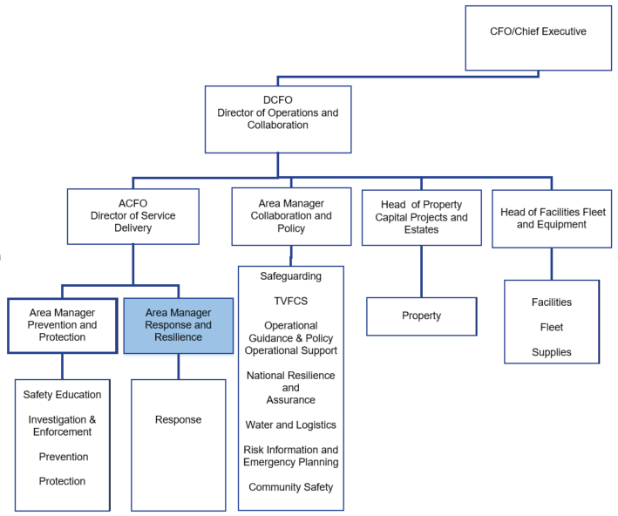

Staff/Managerial responsibilities:
Managers/senior professionals: up to five staff
Staff: up to 400 staff including temporary and project staff

Finance
Budgets-Direct: up to £1m Budgets-Indirect: up to £4m

Role Map Duties and Responsibilities
 | Ref | Title
 | EFSM2 | Lead, monitor and support people to resolve operational incidents
 | EFSM5 | Plan implementation of organisational strategy to meet objectives
 | EFSM6 | Implement organisational strategy
 | EFSM8 | Lead organisational strategy through effective decision making
 | EFSM9 | Implement and manage change in organisational activities
 | ESFM11 | Determine effective use of physical and financial resources
 | ESFM13 | Select required personnel
 | ESFM14 | Manage the performance of teams and individuals to achieve objectives
 | ESFM15 | Develop teams and individuals to enhance work based performance
 | ESFM16 | Manage yourself to achieve work objectives
 | ESFM20 | Exchange information to ensure effective service delivery
 | ESFM17 | Advise on development and implementation of quality policies
 | ESFM18 | Implement quality assurance systems
 | ESFM19 | Monitor compliance with quality systems
 | ESFM22 | Develop information systems to support service delivery objectives
 | ESFM23 | Agree project plan to meet specified objectives
 | ESFM25 | Manage project to meet objectives
 | ESFM25 | Manage project to meet objectives

Key Responsibilities and Deliverables Specific responsibilities of the post:

- Responsible for the effective management, performance and delivery of the response strategies, plans and functions across the Service Delivery Hubs in the Royal Berkshire area.

- Responsible for the development and production of the response strategy for the whole Service Area, accounting for legislative and regulatory requirements.

- Responsible for the effective support and delivery of strategies that provide resilience for Royal Berkshire Fire and Rescue Service, the Thames Valley Local Resilience Forum and to support national requirements.

- Develop, provide and maintain effective managerial systems to ensure efficient day to day management of the response and resilience functions of the Service, taking account of effective integration with specialist prevention and protection teams.

- Develop, provide and maintain effective monitoring systems to measure performance outcomes to maximise effectiveness, productivity and the resources available within the response and resilience functions of the Service.

- Responsible for the distribution, management and coordination of operational response resources so they are operationally ready for immediate deployment. .

- To support and ensure delivery of key projects that enable new ways of working, including collaboration, which ensure the future efficiency and effectiveness of the service.

- To manage the effective and efficient delivery of the On Call and Whole Time Duty Systems.

- Act as a Senior User in the management and implementation of the Community Risk Management Plan.

- Lead and champion the Services’ Equality, Diversity and Inclusion Objectives, ensuring integration across response and resilience activities.

- Support the improvement and maintenance of professional learning.

Generic responsibilities of the post

  - In conjunction with Senior Leadership Team, shape the strategic direction of the Service in order to deliver the Authority’s Vision, Commitments and Objectives.

  - To act as advisor to the Fire Authority and its committees to ensure the provision of professional advice in decision making processes.

  - To work closely with the Fire Authority, promoting a relationship that encourages confidence and constructive challenge, for the purpose of protecting and improving the quality of life of the people in Royal Berkshire.

  - To develop strategies and policies to deliver the Vision, Commitments and Objectives of the Fire Authority.

  - To ensure corporate policies are consistently adhered to within your own area of responsibility and across the organisation.

  - To provide clear direction and support to your teams, ensuring clarity of purpose and delivery of the RBFRS Vision, Commitments and Objectives.

  - To ensure the effective management of resources in line with organisational priorities and in accordance with delegated authority and corporate governance arrangements of the Service.

  - To lead, develop and manage performance of individuals and teams to support an inclusive and high performing culture.

  - To establish, develop and maintain relationships with internal and external stakeholders at local and national levels to deliver the Service’s purpose and aims.

  - To sponsor, lead and manage effective delivery of agreed key programmes and projects at both local and regional levels.

  - To ensure compliance with the law, policy, procedures and guidance within your areas of responsibility, enabling the RBFRS values and behaviours to promote a culture which embraces safety, safeguarding, sustainability, partnership working and inclusion.

  - To ensure the development of robust business continuity arrangements for the areas of managerial responsibility and manage these effectively during business disruption.

  - To maintain competence in order to take command of incidents and to act as the nominated Fire Gold as required.

  - To provide strategic leadership, direction and effective management arrangements of the Service’s corporate risk management activities.

  - To ensure that performance management is embedded in all aspects of emergency response and resilience functions, ensuring clear expectations are identified, agreed, monitored, managed and delivered within these functions.

  - To promote effective partnership working with relevant agencies, e.g. Thames Valley Local Resilience Forum, Local Strategic Partnerships and Local Authorities in order to deliver safe and secure communities.

  - To provide operational cover at Level 4 (and Level 3 as may be required) of the Services Incident Command System.
General Responsibilities of RBFRS Leadership Team

Uphold and promote the values of Royal Berkshire Fire and Rescue Service, complying with the required standards of conduct, integrity and behaviour at all times.

Comply with all finance and procurement policies, procedures and practices, demonstrating the highest level of integrity at all times.

Comply with all people management policies and practices, ensuring your teams are well managed and that corporate standards are achieved.

Practice and promote RBFRS health and safety policies and processes, ensuring a safe working environment for yourself and your staff.

Ensure you are familiar with Safeguarding policies and responsibilities and that teams are trained to relevant standard.

Deliver service plans and performance management information in line with corporate guidelines and deadlines, ensuring collaboration with other members of the Joint Management Team.

Ensure you are familiar with data security policies and management, that your teams are trained and that data protection and appropriate processing is given the highest priority.

Promote and adhere to the Service’s policies on equality and fairness, and treat colleagues and members of the public with respect.

Take responsibility for your own performance, participate positively in development activities and support development of others.

Participate, if required, in any investigations or procedures relating to health and safety, disciplinary, or legal matters.

Act in an environmentally responsible manner by minimising pollution and the wasteful use of energy and resources.
In order to secure the best possible service to the public or the welfare of their colleagues, all employees may from time to time be asked to undertake appropriate duties which fall outside their usual area of responsibility. You are expected to respond positively to such request and encourage your teams to do the same.

Personal Specification

Qualifications and training | CV / Supporting  statement | Selection Process | After Training
Evidence of continuing professional and personal development | x | x
Management qualification or relevant management training programme | x | x
Incident Command Level 4 Qualification |  | x
Incident Command MAGIC Qualification |  |  | x
Area Manager Development and Assessment Pathway |  |  | x
Competent Station Manager, or above | x

Knowledge, skills and experience | CV / Supporting  statement | Interview
Knowledge and understanding of the political, financial and resource implications for a Fire and Rescue Service. | x | x
Knowledge and understanding of Fire & Rescue Service specific legislation and statutory duties. | x
Knowledge of the current pressures for a progressive Fire and Rescue Service / Authority and an understanding of the implications. | x | x
Experience in developing strategies that deliver business outcomes. | x | x
Demonstrable ability to lead, motivate and develop a team of professionals, and manage operations to ensure delivery to defined performance standards and demonstrating VFM. | x | x
Experience of managing a demanding personal workload, effectively balancing strategic and operational responsibilities. | x | x
Able to cultivate effective relationships with a wide range of people including elected Members, based on trust and mutual respect. |  | x
Strong performance focus and commitment to improving public service delivery. | x | x
Confident and inspiring leadership, demonstrating self-confidence, personal resilience and integrity | x | x
Commitment to high professional standards, demonstrating sound  judgement and effective decision making. | x | x
Enthusiastic innovator/challenges status quo. | x | x
Demonstrable commitment to equality and diversity. | x | X
Full range of management skills: people, budget, performance, information, operations, contracts and procurement. | x | x
Strong analytical skills/able to disseminate complex data. | x
Highly influential, with well developed written and oral communication skill. | x | x
Experience of leading and delivering significant change and business improvement initiatives. | x | x
Proven experience of formulating, leading and implementing strategies and improvement programmes which cross service orprofessional  boundaries and raise performance standards. | x | x

Other Requirements
Ability to travel to other locations within the county of Berkshire
Flexible approach to working hours and attendance and ability to attend meetings out of hours on occasion.

RBFRS Behaviours
RBFRS Behaviours are contextualised into four levels. The level this role operates within is identified below:
- Leading Yourself
- Leading Others
- Leading the Function
- Leading the Service
Personal Impact | Comply with all finance and procurement policies, procedures and practices, demonstrating the highest levels of integrity at all times. Adhering to the RBFRS code of Conduct and related policies.  Take responsibility for your own performance (including personal fitness) and participate positively in development activities.
Working Together | Promote and adhere to the Service’s policies on equality and fairness. Value the contributions of a diverse workforce and respond to the different needs of individuals and group. Ensuring familiarity of Safeguarding Policy and practice.  Contribute to the development of others.
Delivering Quality and Service | Treat members of the public with respect.  Respond to the different needs of individuals and groups within the organisation and in the community.
Organisational Effectiveness | Uphold and promote the values of RBFRS complying with the required standards of conduct, integrity and behaviour.  Demonstrate commitment to helping the service achieve its corporate commitments and vision.
Safety and Wellbeing | Practice and Promote the Services policies to support the health and safety of themselves and their colleagues and anyone else who may be affected by their actions.

Profile prepared by: | T/ACFO Doug Buchanan
Approved by: | Katie Mills, Assistant Chief Fire Officer/Director of Service Delivery
Profile effective from: | 07/04/21 | Last reviewed: | 10/07/23
Post holder name |  | Signature
 |  | Date

