FREQUENTLY ASKED QUESTIONS
Wholetime Firefighter Apprentice Recruitment

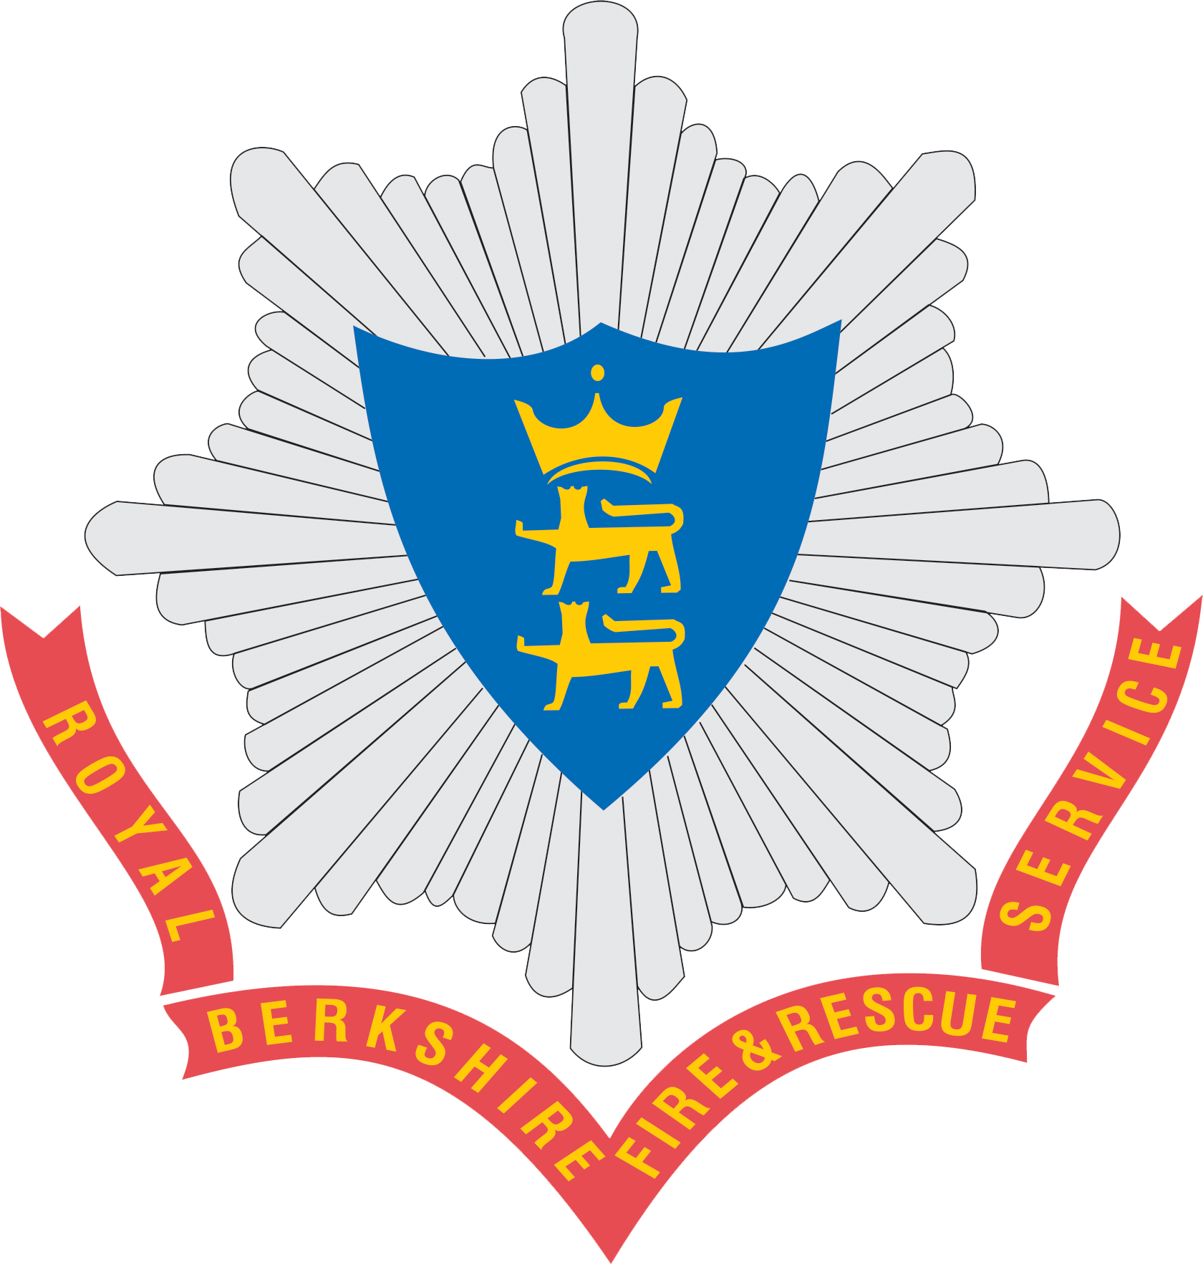

Frequently asked questions - information prior to applying

How do I apply?
Details of how to apply will be made available on our website prior to the commencement of any wholetime firefighter apprentice recruitment process.
How long does the recruitment process take?
The process will take approximately five to six months from the date of application to the date of commencing the training course. We will endeavour to keep candidates informed and updated at each stage of the selection process.

When can I apply?
The application window will be advertised on our website in advance of any campaign.

Who can apply?
We will be recruiting apprentices into this crucial role. Much like previous wholetime recruitment, anyone, from any background or walk of life can apply to be a firefighter apprentice, so long as they are new to the role. This could be someone at the beginning of their career, those returning to work after a career break or those looking for a change of career later in life. All applicants will be selected based on the same standards and decisions will be based on merit. All successful applicants must have Level 1 functional skills and must attain Level 2 by the end of the apprenticeship development period. Applicants must be 17 and six months or over, and live within a 30-mile radius of the centre of Reading.

Is the apprenticeship new?
Apprenticeships have changed a lot in recent years. They are now for everyone who hasn’t already acquired the knowledge, understanding, skills and behaviours that will be developed through the apprenticeship. The Operational Firefighter Apprenticeship Standard was created by a trailblazer group of representatives and stakeholders across a wide range of fire and rescue services. It was approved for delivery in 2018, and was further updated in 2020.

Can I be a wholetime firefighter apprentice if I’m already a firefighter in development?
You can’t join an apprenticeship programme as this focuses on the development of new knowledge, skills and behaviours. We run separate transfer processes for existing firefighters based on organisational need. Any transfer process will be advertised on our website.

What training will I undertake?
As a firefighter apprentice you will undertake a residential training course (out of County) lasting at least eight weeks, delivered by our external training provider. This will be followed by approximately five weeks of non-residential training at our Training Centre (Whitley Wood, Reading RG2 8FS).
Following this, and subject to progress, it is expected that firefighter apprentices will take up their station placements, where their development will continue with the support of their line manager and an apprenticeship talent coach.
There is a requirement for 20% off the job training associated with the apprenticeship. This time will be taken in blocks and single sessions, for example, during the initial training period and where attendance at one day courses is required.
The apprenticeship training and development route is anticipated to be completed within 24 months. When each firefighter apprentice is ready they will undertake an End Point Assessment (EPA) through an external provider. The Service will confirm you have the knowledge, understanding and skills required to do your role.
What are the working hours / shifts?
The current shift pattern is two day shifts, followed by two night shifts, then four days off duty. This cycle is then repeated. The day shifts are 9am to 6pm and the night shifts are 6pm to 9am.

Would I have to work weekend and public holidays?
Firefighters whose shift / work pattern falls on a weekend or public holiday will be required to work. There is the option to take leave subject to a maximum number of people being on leave at any one time. This is to make sure our fire engines have enough people on duty to crew them.

How much will I get paid?
Apprentices will be paid at the same rates of pay at the respective progression points (initial, development, competent) as firefighters recruited and developed through previous routes. Information on our pay scales can be found on our website.

Can I choose which fire station I am posted to?
You will be asked for your preference of which station you would like to be posted to, but, whilst consideration will be given to placing apprentices at their preferred station, the final decision will be based on the operational needs of the Service.

How old do I need to be to join the fire service?
You may apply at the age of 17 years old and six months but you have to be at least 18 years of age to be appointed. There is no rigid upper age limit.
I have a conviction may I still apply?
The Service undertakes to operate effective and appropriate systems to comply with, and fulfil the principles of, the Rehabilitation of Offenders Act 1974. Applicants for employment with criminal convictions will be assessed on their relevant skills, qualifications and experience. Applicants would only become ineligible to proceed if past offences are directly relevant to the job concerned and where it is judged that the applicant, if appointed, would pose a significant risk to the Service, the public, property or public funds.

I'm not a particularly strong swimmer and I understand some Fire Services require their applicants to be able to swim to a certain level - does RBFRS have these requirements?
While there is no formal requirement to swim in the role map of a firefighter, firefighters will be expected to be able to self-rescue in situations where there may be difficulties in water – e.g. during flooding periods etc. Hence the need for individuals to be confident in water. We have one Station which crews the rescue boat, as such there is a requirement for individuals posted to this station to be a skilled and confident swimmer.

Can I have a second job?
Royal Berkshire Fire and Rescue Service has a policy that secondary employment has to be authorised by the Service. Your secondary employment must not affect your ability to complete your initial firefighter training programme or compromise your ability to attend work on your allocated rota pattern.

If my faith requires me to fast, can I still be a Firefighter?
Yes, you can still fast, but it is important that all members of the Service are able to perform their core role whilst on duty. It is important to recognise that dehydration can affect a person very quickly. An individual may feel well but very quickly succumb to the adverse effects of dehydration. We encourage staff who choose to fast to discuss it with their line manager. Employees have a responsibility for being fit for duty and, where fasting has affected a member of staff adversely, they must tell their manager immediately.
As a practising Sikh, can I still be a Firefighter and wear a turban?
A new clause of the Deregulation Bill 2015 extends the existing exemption for Sikhs to have to wear a safety helmet under the Employment Act in all workplaces. However there are exclusions for emergency response services and the military, which apply only in hazardous operational situations when the wearing of a safety helmet is considered necessary. These include for example, entering a burning building where protective clothing needs to be worn to enclose the whole body, situations such as bomb disposal, or when dealing with hazardous materials like chemical leaks, bio-hazards or radiation.

I have a beard for religious reasons, will I have to shave it off in order to be a firefighter?
As a firefighter, you will be required to wear a facial mask when you are wearing breathing apparatus. To ensure that the mask forms an air-tight seal around the face, it is necessary to keep the face shaven to prevent any dangerous contaminant from entering the facial mask.

My faith requires me to allocate certain times of the day for prayer. Will this be accommodated?
Due to the nature of the role, there may be times when this is not possible. However, we actively support employees who wish to pray at work to balance their individual beliefs with operational needs.

Do you have quotas for women and ethnic minority recruits?
No, we don’t have quotas. We do encourage and welcome applications from these groups because they’re under-represented within our workforce. All applicants are assessed purely on merit and to the same standard.
I have a disability. Can I still apply?
Yes – as part of the recruitment process you will be able to share information with us regarding your disability, and we will work with you to identify adjustments with the aim of enabling you to participate in the selection process and fulfil the role of a Firefighter should you be successful. Royal Berkshire Fire and Rescue Service is a Disability Confident Leader and will do all that we reasonably can to support people to apply.

I’m neuro-divergent. What support are you able to give during the recruitment process?
We will work with you to make adjustments at relevant stages of the selection process to support you in completing the activities, which may include things like providing extra time for you to complete online tests. We may ask for further information in order to help us identify the most appropriate adjustments. All information provided will be treated as confidential and will only be available to the staff members responsible for arranging the recruitment process. We are committed to supporting all candidates to participate fully in the recruitment process, and any information shared will not affect your participation in the selection process beyond the arrangement of individual adjustments.

I wear glasses and have had corrective eye surgery. Can I apply?
Applicants will need to provide an optician’s report at medical stage. You will need to meet the following standards:
- The minimum uncorrected vision should be 6/18 in the better eye and 6/24 in the worse eye
- Will not have undergone refractive surgery in the past 12 months and provided the limit of surgical correction does not exceed 8D. Before being accepted into a role, recruits will be required to undertake a Log MAR test carried out by our Occupational Health team
- Normal binocular visual field in each eye
- Have no history of night blindness or ocular disease that is likely to progress and result in the failure of visual standards for operational Firefighters
- Have the appropriate level of colour perception

I am colour blind. Can I apply?
When you go for your eye test, the optician will test you for colour vision. Individuals with protanopia, deuteranopia, monochromatism and tritanopia/tritanomaly are unsuitable for employment as a Firefighter. Individuals with protanomaly rarely meet the required standards while deuteronamalous individuals should be fit subject to medical related testing.

Do you have to have good hearing?
Yes, there is a requirement to have good hearing in line with functional standards (with artificial aids, where applicable). If you are invited to the medical part of the selection process your hearing will be tested and if necessary followed up with a functional hearing test facilitated by Royal Berkshire Fire and Rescue Service (RBFRS).
Would somebody’s size affect their application?
No – this is a popular misconception, because there used to be restrictions on height, weight and chest expansion. Candidates are expected to pass fitness tests as part of the recruitment process. The tests are at a level that’s achievable by individuals of all different sizes and builds.
Why have you restricted applications to individuals who live within a 30 mile radius from the centre of Reading?
This requirement is in place to ensure applicants are invested in and committed to serving the communities of Royal Berkshire.

If I’m unsuccessful at any stage will I be able to obtain feedback?
Unfortunately, due to the volume of candidates that apply it is not possible to provide feedback on individual applications.

Is further interview guidance available?
An interview guidance booklet will be automatically sent to all those who are invited to interview later within the recruitment process. This will provide details on what to expect from the interview, how to prepare and some general tips / advice.

How can I improve on my interview?
Higher scoring candidates in the interview process tend to demonstrate the knowledge, skills and behaviours required to fulfil the role. Strong answers will provide evidence through a range of different examples as to how the applicant meets the behaviours within our organisations Behavioural Competency Framework (BCF). The BCF will be sent to all applicants ahead of interview.

Why don’t you give application packs to the individuals who attend ‘Have a Go’ events to take away / make them available at fire stations?
Our applications process is managed through an online portal which is why application packs are unavailable at ‘Have a Go’ events. We are also able to offer alternative formats for the application form on request, for example, enlarged paper based versions, colour ratios can be adjusted on the portal or we can seek to support application completion through voice activated technology.

