Job Title: | Business Support Officer
Post Reference |  | Temporary/Permanent |  |  |  | Temporary
Grade: | 4 |  | Hours: |  | 37
Reports to: | Business Support Manager
Line Management responsibilities:
(Direct and Indirect)
Directorate/  department: | Corporate Services, Support Services
Location: | Newsham Court
Politically restricted: |  |  |  | No
Main Purpose of the Job:
As part of Corporate Services, the Business Support Officer will be responsible for providing strategic support to the Senior Management Team and Directorates through an assigned portfolio of work.
The post holder will provide dedicated support to assigned members of the Senior Management Team and will be responsible for providing a strategic business support function including, but not limited to, budget monitoring, project management, report writing, event management and horizon scanning.
Assigned portfolios will also include business support to wider RBFRS service areas.
The post holder will be focused on delivery a high quality service focused on the customer.

Organisational Structure

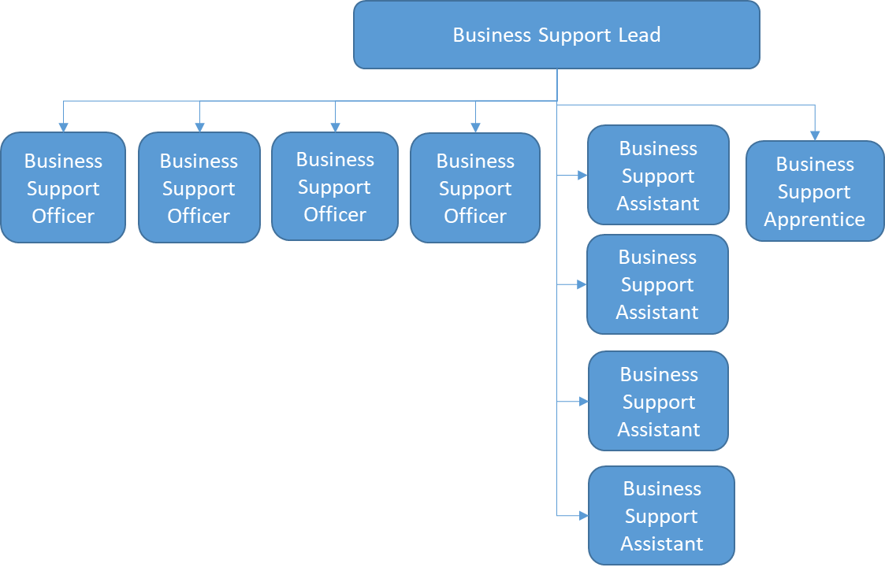

Key responsibilities and Deliverables:
- To take responsibility for specified areas of business support and develop and maintain an understanding of those specified areas, and any associated systems.
- Support the training and development of other members of the Business Support Team on areas of specific responsibility to ensure wider development of team.
- Undertake project management
- Undertake budget monitoring in support of the Senior Management Team.
- Prepare management and Committee reports
- Undertake analysis and research on specific issues.
- Diary management including an awareness of work programmes and associated deadlines
- Prepare and draft responses to correspondence, complaints, Freedom of Information requests, corporate requests for information and local and national matters of public, governmental and national interest.
- Minute meetings as required including CMT, Programme Boards and other meetings as appropriate.
- To lead on the organisation and successful delivery of specific events and visits
- Undertake systems based work through data entry, data interrogation and data assurance.
- Liaise with senior local and central government officers, politicians, community representatives and private and voluntary sector organisation representatives
- Ensuring confidentiality, professional integrity and discretion is maintained at all times.
- Ensure working practices of Business Support Team adhere to RBFRS policies.
- To promote a strong customer focus within the team and the organisation as a whole.

Personal Specification

Qualifications and training | On recruitment | After Training
Educated to 'A' level, or equivalent experience. | ✓

Knowledge, skills and experience | On recruitment | After Training
Knowledge related to relevant RBFRS policies and procedures including those relating to data protection and confidentiality | ✓
Experience of working in a multi-disciplinary team delivering a plan of work with competing priorities | ✓
Experience of system and database management including data entry, data interrogation and data assurance | ✓
Ability to make decisions within own area of responsibility, demonstrating strategic thinking skills | ✓
Ability to identify possible causes of problems and implement solutions to minimise future occurrence | ✓
Ability to effectively cope with conflicting and complex demands | ✓
Ability to prioritise and ensure timely delivery of quality outcomes/projects | ✓
Ability to communicate effectively verbally with high level of interpersonal skills | ✓
Ability to communicate to a high standard in writing producing documents in range of formats to suit a range of audiences including report writing and minute taking | ✓
High levels of political awareness and sensitivity | ✓
Able to exercise judgement in dealing with all enquiries at senior management level | ✓
High level of IT skills, using full Microsoft package | ✓
Able to attend venues in a variety of locations and to attend evening meetings and events as required | ✓
Public sector experience |  | ✓
Experience of project management |  | ✓
Experience of budget monitoring |  | ✓

Other Requirements

Ability to travel to other locations within the county of Berkshire
Flexible approach to working hours and attendance and ability to attend meetings out of hours on occasion.

RBFRS Behaviours
RBFRS Behaviours are contextualised into 4 levels. The level this role operates within is identified below
- Leading Yourself
- Leading Others
- Leading the Function
- Leading the Service
Personal Impact | Comply with all finance and procurement policies, procedures and practices, demonstrating the highest levels of integrity at all times. Adhering to the RBFRS code of Conduct and related policies.  Take responsibility for your own performance (including personal fitness) and participate positively in development activities.
Working Together | Promote and adhere to the Service’s policies on equality and fairness. Value the contributions of a diverse workforce and respond to the different needs of individuals and group. Ensuring familiarity of Safeguarding Policy and practice. Contribute to the development of others.
Delivering Quality and Service | Treat members of the public with respect.  Respond to the different needs of individuals and groups within the organisation and in the community.
Organisational Effectiveness | Uphold and promote the values of RBFRS complying with the required standards of conduct, integrity and behaviour.  Demonstrate commitment to helping the service achieve its corporate commitments and vision.
Safety and Wellbeing | Practice and Promote the Services policies to support the health and safety of themselves and their colleagues and anyone else who may be affected by their actions.

Profile prepared by: | Katie Mills, Head of Corporate Services
Approved by: | Nikki Richards, Director of Corporate Services
Profile Effective from: | November 2016 | Last reviewed: | 30 October 2023
Post holder name |  | Signature
Post holder name |  | Date

