WHOLETIME DUTY SYSTEM
FIREFIGHTER APPRENTICE
RECRUITMENT
Royal Berkshire Fire and Rescue Service
Information Pack

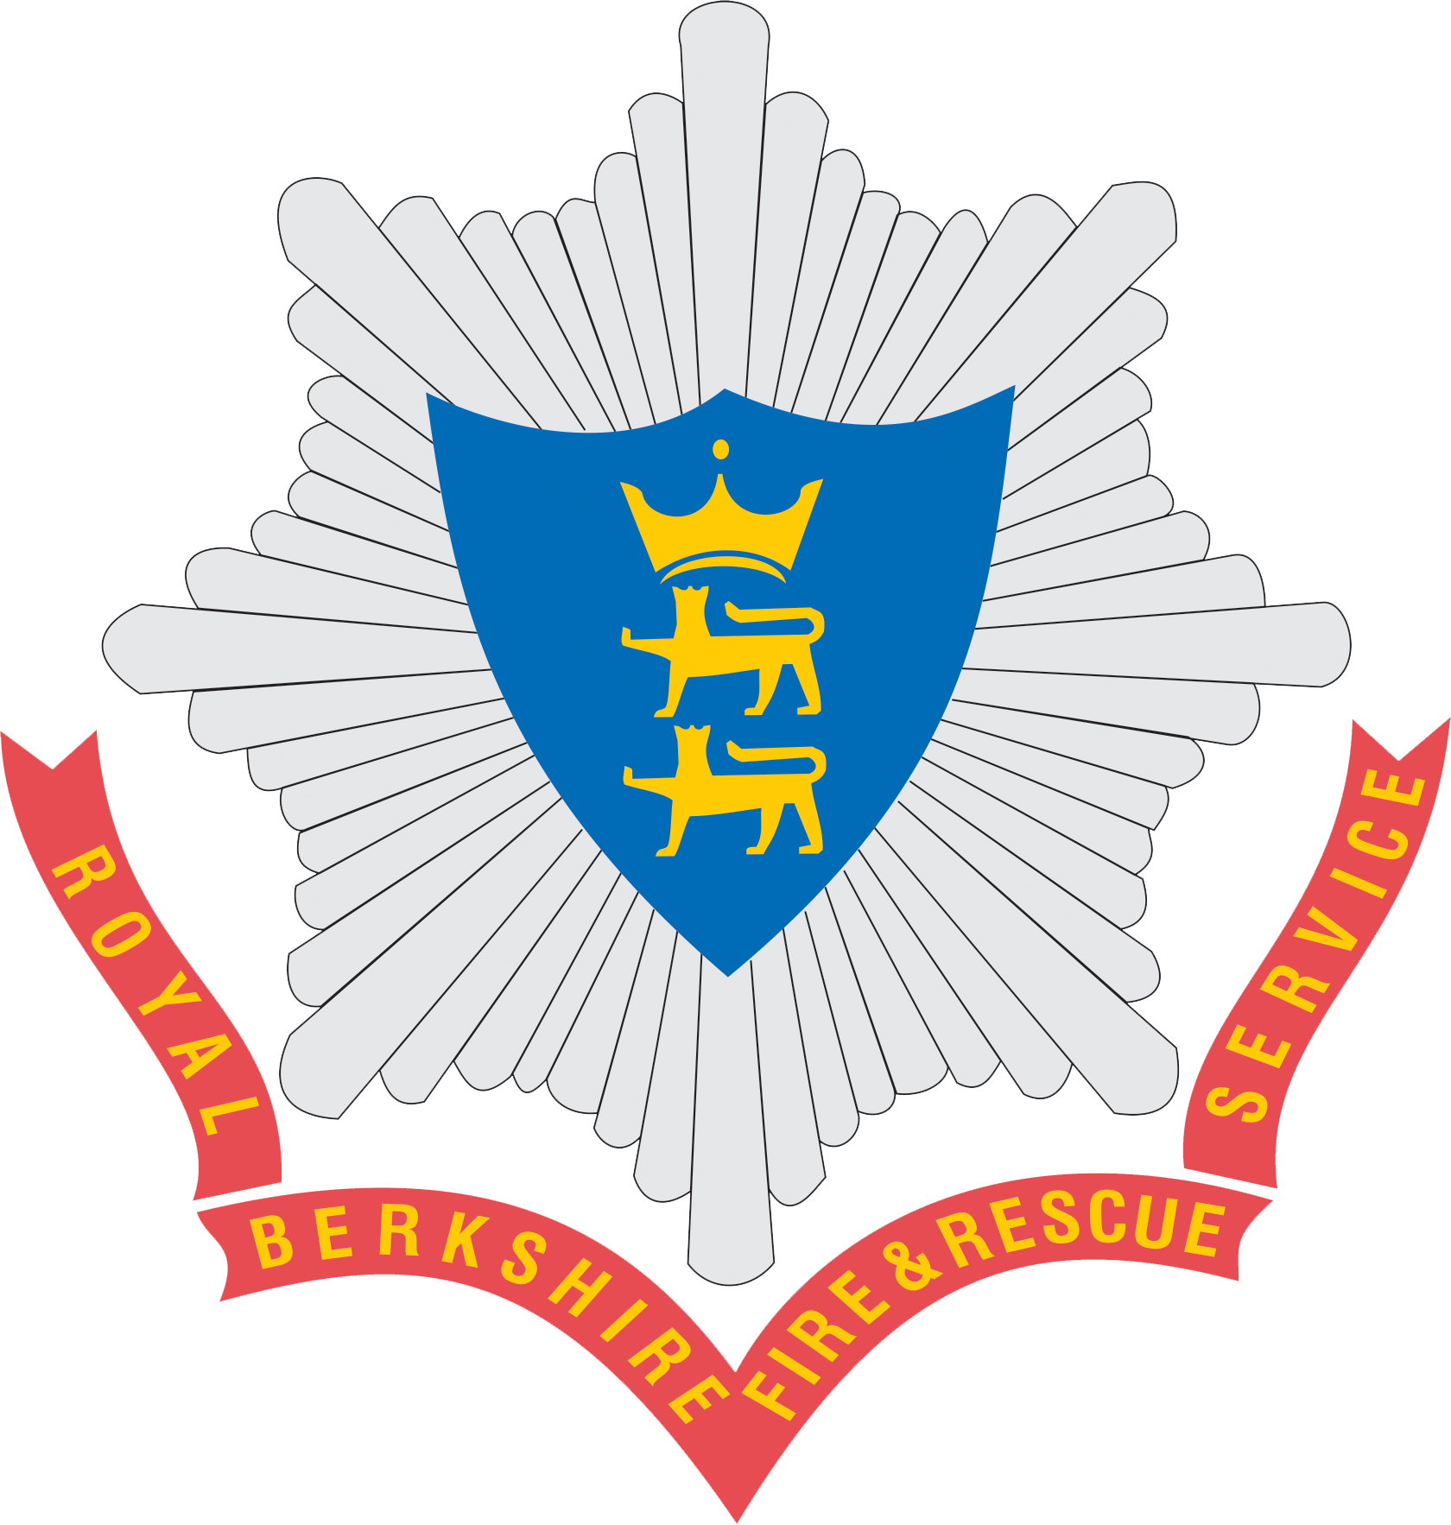

Contents
Wholetime Firefighter Apprentice Recruitment Campaign 3
Firefighter Job Profile 4
Do you really want to be a Firefighter? 6
The Recruitment Process 7
Appendix one – Postcodes within a 30-mile radius of the centre of Reading 14

Equal Opportunities

Royal Berkshire Fire and Rescue Service values your individuality, your diversity and your dignity. All are welcome here. Inclusion, diversity and equality are principles which guide our decisions and will be visible throughout the Service, and we will continually work to improve in these areas.
We are committed to creating an inclusive culture of dignity and trust where everyone feels safe and comfortable to bring their whole self to work.
Simply: The communities we serve are varied and diverse, we should be too.
Applications are welcome for job-share or part time arrangements please enquire on application.

All applications are considered on merit alone. We are a Disability Confident Leader – if you meet the essential criteria of the role, you will be guaranteed an interview if you choose to opt into the Disability Confident Scheme (formerly known as the Guaranteed Interview Scheme).

To find out more: https://www.rbfrs.co.uk/your-service/about-us/equality-diversity-and-inclusion/

Wholetime Firefighter Apprentice Recruitment Campaign

Royal Berkshire Fire and Rescue Service would like to encourage individuals to consider the challenging and highly rewarding career of a Wholetime Firefighter Apprentice. Details of how to apply will be made available on our website prior to the commencement of any Wholetime Firefighter Apprentice recruitment process.
The communities in Royal Berkshire value the services that we offer and need to feel confident in the highly skilled teams and the role they play in reducing risks as well as dealing with emergencies. We are continually evolving and improving how we operate whilst maintaining the highest standards. Appointing the right people is essential in helping us to achieve our ambitions for the future.

Royal Berkshire Fire and Rescue Service Wholetime Stations
- Caversham Road, Reading;
- Wokingham Road, Reading;
- Newbury;
- Wokingham;
- Bracknell / Ascot;
- Slough;
- Langley;
- Maidenhead /Windsor;
- Whitley Wood, Reading;
- Theale, Reading.

This document has been written to provide you with details of each stage of the Wholetime Firefighter recruitment process. It is important that you are aware of how you will be assessed and what you can expect at each stage. Additional details will be provided on our website during each campaign.

For more information visit:

Royal Berkshire Fire and Rescue Service

rbfrs.co.uk/careers/wholetime-firefighter.

Firefighter Job Profile

Main Purpose of the Job:
To protect and serve the community by working with and within the community to prevent emergencies occurring, and minimise their impact by providing professional operational firefighting, rescue and humanitarian services.

Main Duties and Responsibilities:
FF1. Inform and educate your community to improve awareness of safety matters | - Participate in special events designed to promote fire safety, both on RBFRS premises and in the community.  - Distribute safety information, either in response to requests or through leaflet drops.  - Facilitate learning by demonstrating fire safety, first-aid firefighting, calling Emergency Services and fire survival methods  - Help raise the role and profile of the Fire Service in the local community  - Host and guide members of the public visiting Fire Service premises
FF2. Take responsibility for effective performance | - Take responsibility for personal performance, including your own health and fitness  - Continually improve your performance through self-assessment and action to address your development needs.  - Establish and maintain effective working relationships with people within the organisation and externally  - Maintain standards of dress and personal appearance in keeping with the image of a professional service
FF3. Save and preserve endangered life | - Conduct searches to locate life involved in incidents  - Rescue life involved in incidents, including animal life  - Provide treatment to casualties  - Instigate protective measures to safeguard members of the public from hazards resulting from dangerous buildings or structures.
FF4. Resolve operational incidents | - Control and extinguish fires  - Respond to a range of emergency and non-emergency incidents other than those which involve fire or hazardous materials (eg lock-outs, pump-outs, emergency provision of water)  - Give physical and emotional support to people directly and indirectly involved in incidents  - Liaise with other agencies to maintain security at the scene and resolve the incident.
FF5. Protect the environment from the effects of hazardous materials | - Mitigate actual and potential damage to the environment from hazardous materials  - Decontaminate people and property affected by hazardous materials  - Support individuals and other agencies involved in hazardous materials incidents
FF6. Support the effectiveness of operational response | - Collect information from a range of sources on actual and potential life, property and process risks in your community  - Collect information on operational resource availability in your community  - Check, test and conduct routine maintenance con internal resources (eg appliances & equipment, PPE)
FF7. Support the development of colleagues in the workplace | - Communicate your own skills and knowledge to colleagues to improve their understanding and performance  - Support development of colleagues by using instruction and demonstration to help them develop skills and competence
FF8. Contribute to fire safety solutions to minimize risks to your community | - Inspect premises, individually and as part of a team, to minimise risks to people, property and the environment  - Prepare and produce written and verbal reports on Fire Safety inspections, to specified deadlines
F9. Drive, manoeuvre and redeploy fire service vehicles | - Drive vehicles safely to incidents in optimum response time dealing with contingencies which may arise enroute  - Site your vehicle at a safe location at events and return your vehicle safely to its next appointed location

Rates of pay
Rates of pay for Operational Wholetime Duty System (WDS) Firefighters can be found on our website:
https://www.rbfrs.co.uk/careers/wholetime-firefighter/wholetime-pay-scales/

Hours of Work
Royal Berkshire Fire and Rescue Service operate a 2/2/4 rota system consisting of two day shifts (9am-6pm), two night shifts (6pm-9pm) followed by four days off. Wholetime Firefighters are required to work anti-social hours, weekends and public holidays.

Do you really want to be a Firefighter?

The following list of questions has been designed to help you decide whether being a Firefighter is really for you. Simply tick YES or NO to each of the following questions. | Yes | No
Are you genuinely interested in people?
Can you get on with people from different backgrounds and cultures?
Do you want to work as part of a close knit team?
Can you work under pressure?
Can you think on your feet and solve problems when you know a lot depends on the suggestion you come up with?
Do you have the sensitivity to deal with members of the public when they are distressed, confused or being obstructive?
Can you take responsibility for representing the Service when you are at work and when you are not?
Are you committed to always maintaining and developing your skills?
Are you prepared to study to develop and expand your knowledge and skills?
Are you prepared for the demands of working in a disciplined uniformed service in which you will have to take orders from other people?
Can you accept the need to keep to rules that tell you what you can and cannot wear?
Are you committed to maintaining your overall health and wellbeing (both physical and mental)?
Is regular exercise and maintaining your physical fitness part of your everyday life?
Are you a practical person who likes to work with your hands/equipment?
Do you enjoy making things or finding out how things work?
Are you someone who can always be relied on to be somewhere on time?
Are you someone that others see as dependable?
Are you confident in water?
Are you prepared to work outside in all types of weather, when it is wet and cold?

If you answered ‘Yes’ to ALL of the above, and you think that you have what it takes to serve and protect the community you live and work in, read the information provided and join our recruitment campaign.

The Recruitment Process

The following notes are designed to give you an indication of the Recruitment Process, what to expect and what will be required of you. There are five stages:

In the event that you encounter any access to technology, technical or log in issues for any of the online aspects of the process it is essential to let us know prior to any associated deadline by emailing recruitment@rbfrs.co.uk. Failure to do so will terminate your application process.
We are a Level Three Disability Confident Leader and member of the Business Disability Forum, as such we are committed to making our recruitment process as inclusive as possible for all applicants. If you have a disability or long-term health condition and feel that you are able to meet the essential requirements of an Operational Firefighter Apprentice, but any stage of the recruitment process prevents you from fully demonstrating your abilities, adjustments to the process will be considered. Any information you provide will remain confidential. Please contact recruitment@rbfrs.co.uk if you would like to discuss what adjustments are available.

Stage 1 – Initial Online Application / Supporting Statement

The start of the recruitment process involves completing an Application / Supporting Statement.
This requires you to complete an online application form that will include:
- Your personal details such as full address, contact details and National Insurance number
- Your education and employment history
- Equality monitoring data.
You will also be asked some basic questions to ensure that you are eligible to apply for the role. As part of your eligibility assessment, we will identify:
- Whether you are over the age of 17 years and six months.
- Whether you have the right to work in the UK.
- Whether you have any unspent criminal convictions.
- Whether you live within a 30-mile radius of the centre of Reading, please see Appendix 1 at the end of this document for a list of eligible postcodes.
- Whether you have been ill-health retired from another fire and rescue service.
- Whether you are currently employed as a member of the police force.
- If you have any previous experience as a firefighter.

Within your initial application you will also be required to submit a supporting statement. Within your supporting statement you will be required to evidence how your knowledge, skills and behaviours meet the criteria in the job profile.

At the end of this stage you will be advised as to whether you are eligible to continue with your application or not.

It is important to note that you can complete this, or any of the online stages, at any time during day (i.e. day or night). Please complete your application before any advertised deadlines. It is important that you check that you know your correct e-mail address as you will require this to register. The system will communicate with you using the e-mail address that you provide during the registration. If you provide an incorrect e-mail address, the system will be unable to provide you with relevant information regarding your application. If you do not complete the Application / Supporting Statement you will not be able to progress within the campaign.

You will only be able to register with us once during a recruitment campaign so please ensure the details you give are correct. Please do not register again with another email as we can only accept one application per person, if you do make an error in your application it is important to contact us as soon as possible. Do not resubmit another application.

Access to the Application / Supporting Statement will be available on the vacancy page of our website: rbfrs.co.uk/careers/vacancies.

Please note that CVs or any other form of application will not be required or accepted, unless an adjustment is agreed.

Stage 2 – Group Exercise

If you meet the requirements at Stage 1, and are shortlisted following the Initial Online Application / Supporting Statement you will be invited to complete a group exercise.
The group exercise will be a face to face event where you will be part of a small group. The event will include:
- A welcome and overview of Royal Berkshire Fire and Rescue Service. This will not be assessed but will instead allow you to get to know the Service and meet your cohort before the assessed part of the group exercise commences.

- An assessed group exercise based on a scenario task(s) that will require you to work with the other candidates, demonstrating both your individual behaviours and skills, and how you work as part of a team.

Stage 3 – Interview
Candidates who successfully complete the group exercise will be invited to interview.
The main aim of the interview is to find out about you and your motivation to become a firefighter. The interview will be conducted by two people who will take it in turns to ask you questions about you and your experience, taking a set of notes to ensure a record is kept of the examples you give.
Interview questions will be behavioural based, during the interview you will be asked to give examples of when and how you have demonstrated the behaviours that are important for potential firefighters, in line with RBFRS’ Behavioural Competency Framework. You should answer based on your personal experience. More information about the interview structure and how to prepare will be sent to those invited for interview.
During this stage of the process you may also be invited to complete online functional skills tests that will enable you to demonstrate your knowledge and skills applicable to the role (e.g. English and Maths).

Stage 4 – Physical Assessment Day

If successful following the interview and online skills tests, you will be invited to attend a physical assessment day at our Training Centre, Whitley Wood Road, RG2 8SF whereby you will undergo a number of physical tests as detailed below. Please note due to resource requirements we will run a limited number of physical assessment days, therefore it is important that you make yourself available to attend one of the physical assessment dates when they are advertised as we will be unable to provide alternative dates. More information about the physical tests, including videos can be found on our website https://www.rbfrs.co.uk/careers/wholetime-firefighter/step-four-physical-tests/

Ladder climb

Candidates wear a safety harness and ascend two-thirds of the way up a 13.5-metre ladder and take a leg-lock. They are then asked to lean backwards and outstretch their arms to the sides, and then whilst looking over their shoulder they are to say out loud what symbol is being shown by the assessor at ground level. This will test confidence at heights.

Confined space exercise

Candidates put on a facemask with un-obscured vision although this will be in a dark environment. They will make their way through a crawl and walkway. Once inside the crawl/walkway, they have their vision obscured and return to the start. This will test confidence, agility and stamina.

Equipment assembly

Candidates are given a demonstration of the test before having to assemble and disassemble a number of components to make an item of equipment which will test manual dexterity.

Drill ground Assessment

Candidates are required to complete a series of tasks that simulate firefighting activities such as carrying equipment, running out hose and casualty evacuation, within a set time. This is a test of physical fitness.

The tests on this day are designed to assess your level of physical fitness in line with requirements of the role.

Ladder Lift Exercise

Candidates are required to lift the ladder lift simulator to the required height and lower it safely under control. The cradle is loaded with 15kg but including the weight of the equipment the total is approximately 25kg.

Physical Fitness

Firefighting can be a physically demanding and hazardous activity. To ensure effective and safe operational performance an appropriate level of physical fitness is essential.

Your level of physical fitness will be determined by measuring your performance during a number of physical and practical firefighting tasks. You will be required to perform an ‘aerobic’ fitness test to predict your aerobic capacity (in mlsO2/kg/min). This allows us to assess your ability to perform exercise for longer periods which is important for safe firefighting. The minimum requirement for candidates at recruitment is 42.3 mls/O2/kg/min, by achieving a time of 11 minutes, 11 seconds or under in the drill ground assessment. If you progress to medical, you will be required to demonstrate this level of fitness again on a treadmill walk test to ensure that you have maintained the appropriate level of fitness. Achieving Level 8, Shuttle 8 on the standard bleep test would provide an indication of fitness but is not a guarantee.

Stage 5 – The Medical

Firefighters may be exposed to extreme physical and psychological demands in hostile and dangerous environments. Candidates reaching this stage of the process will be required to attend a medical.

Candidate must meet the minimum eyesight standards. Corrected visual acuity should be 6/9 binocularly, and a minimum of 6/12 in the worse eye. The minimum uncorrected vision for recruits should be 6/18 in the better eye and 6/24 for the worse. There is an upper hypermetropic (long-sighted) limit of +3.00, and colour vision must reach the required standard. Prior to attending a medical appointment candidates will be required to visit an opticians for a full eyesight test, bringing the results to their medical appointment. We must stress that Royal Berkshire Fire and Rescue Service will be unable to reimburse any costs that may be incurred by booking and attending this appointment.

Hearing and lung function will also be tested during the medical and candidates will undergo screening for use of illegal drugs and alcohol misuse.

If you have any of the following conditions you should consider carefully whether the nature of the work and the attendance pattern, (which includes the possibility of very long hours at major incidents), would be detrimental to your health:

- Significant joint injury or disease, especially if it affects the back or knees.
- A chronic respiratory problem, e.g. asthma.
- A history of hypertension, diabetes, epilepsy, cardiac or circulatory disease.
- Contact dermatitis, psoriasis or eczema.
- Vertigo, claustrophobia or acrophobia (fear of heights).

Your medical records from your General Practitioner may be required, for which you will be asked to give consent at the appropriate time.

More detailed information regarding the medical will be available to candidates later in the recruitment process.

You will also be required to undergo a Chester Treadmill Walk Test. The Chester Treadmill Walk Test is a 12 minute graded, treadmill walk test designed to assess whether or not a candidate can achieve the firefighter fitness standard of 42mls O2 /kg/min.
You will also be required to complete a Breathing Apparatus (BA) Mask fitting and a Fire Kit PPE fitting.

We would like to thank you for your interest in the role of Wholetime Firefighter Apprentice.
If you have any queries please ensure you have read through the FAQ document or email: recruitment@rbfrs.co.uk

Appendix one – Postcodes within a 30-mile radius of the centre of Reading
GU1 | GU10 | GU11 | GU12 | GU13 | GU14 | GU15 | GU16 | GU17 | GU18
GU19 | GU2 | GU20 | GU21 | GU22 | GU23 | GU24 | GU25 | GU26 | GU27
GU3 | GU30 | GU33 | GU34 | GU35 | GU4 | GU46 | GU47 | GU5 | GU51
GU52 | GU7 | GU8 | GU9 | GU95
HA0 | HA1 | HA2 | HA3 | HA4 | HA5 | HA6 | HP1 | HP10 | HP11
HP12 | HP13 | HP14 | HP15 | HP16 | HP17 | HP18 | HP19 | HP20 | HP21
HP22 | HP23 | HP27 | HP3 | HP4 | HP5 | HP6 | HP7 | HP8 | HP9
KT1 | KT10 | KT11 | KT12 | KT13 | KT14 | KT15 | KT16 | KT2 | KT22
KT23 | KT24 | KT5 | KT6 | KT7 | KT8 | KT9
OX1 | OX10 | OX11 | OX12 | OX13 | OX14 | OX2 | OX3 | OX33 | OX39
OX4 | OX44 | OX49 | OX5 | OX9
RG1 | RG10 | RG12 | RG14 | RG17 | RG18 | RG19 | RG2 | RG20 | RG21
RG22 | RG23 | RG24 | RG25 | RG26 | RG27 | RG28 | RG29 | RG30 | RG31
RG4 | RG40 | RG41 | RG42 | RG45 | RG5 | RG6 | RG7 | RG8 | RG9
SL0 | SL1 | SL2 | SL3 | SL4 | SL5 | SL6 | SL7 | SL8 | SL9
SL95 | SN7 | SO21 | SO23 | SO24 | SP10 | SP11
TW1 | TW10 | TW11 | TW12 | TW13 | TW14 | TW15 | TW16 | TW17 | TW18
TW19 | TW2 | TW20 | TW3 | TW4 | TW5 | TW6 | TW7 | TW8 | TW9
UB1 | UB10 | UB11 | UB18 | UB2 | UB3 | UB4 | UB5 | UB6 | UB7
UB8 | UB9
W13 | W5 | W7 | WD1 | WD17 | WD18 | WD19 | WD2 | WD23 | WD24
WD25 | WD3 | WD4 | WD5

