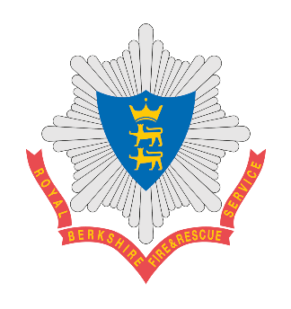

Anticipated Process dates for On-Call Recruitment

November 2026 cohort
The On-Call Firefighter Process for 2026 is open with the next course scheduled to take place in June.
The anticipated key process dates for the June intake are detailed below.
Please ensure you are familiar with the anticipated timeframes and that you are available to attend should you be successful at the various stages of the process. For the physical testing you will only need to attend 1 session.

4th July 2026 | Physical testing day
16th July 2026 | Physical testing day
25th July 2026 | Physical testing day
27th July 2026 – 21st August 2026 | Interviews, Functional Skills and Treadmill Fitness Test
24th August 2026 – 31st August 2026 | Medicals/BA Mask Fitting, Start DBS Checks
12th October 2026 | Start date/first drill night
19th & 26th October 2026 | Drill nights
2nd, 9th &16th October 2026 | Drill nights
30th November - 11th December 2026 | On-Call Initial Training Course

There will also be other key training following this course should you be offered a place on the On-Call Initial Training Course.


1

