STRATEGIC ASSET INVESTMENT FRAMEWORK
15 Year Strategy

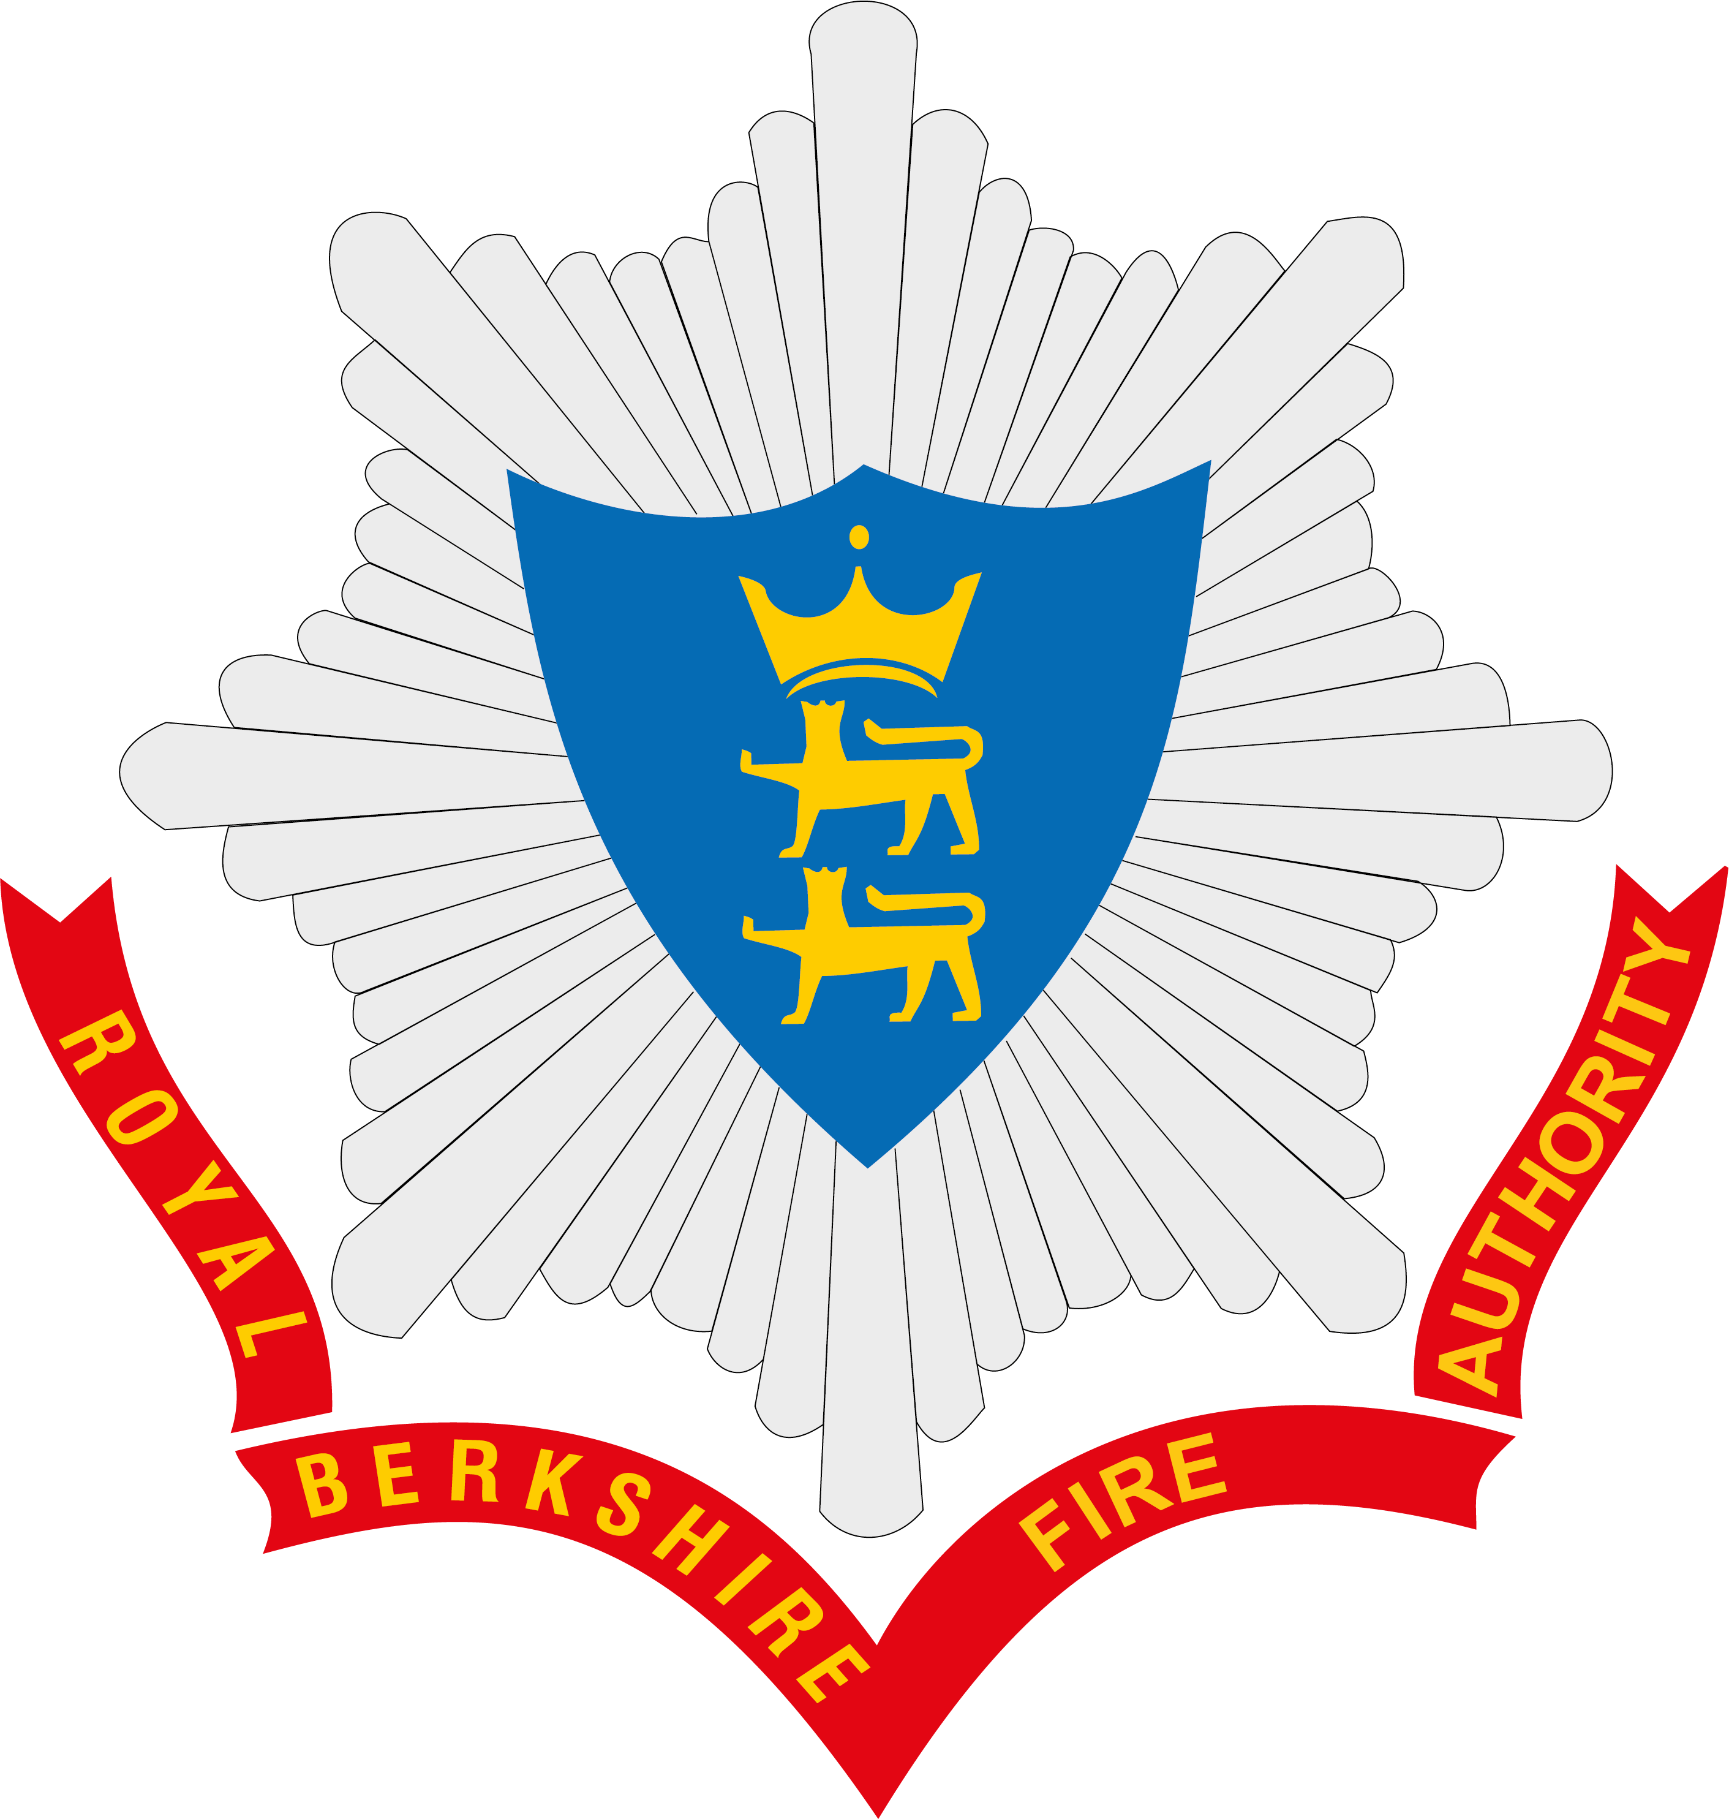

Published February 2022

CONTENTS

FOREWORD FROM COUNCILLOR ANGUS ROSS | 1 | OUR ICT | 13
INTRODUCTION | 2 | GENERATING CONTRIBUTIONS TO RUNNING COSTS FROM ASSETS | 17
OUR BUILDINGS | 4 | FINANCIAL IMPLICATIONS | 18
OUR FLEET | 9 | GOVERNANCE ARRANGEMENTS | 20

If you require this document in an accessible format, please contact communications@rbfrs.co.uk.
For more information on accessibility at Royal Berkshire Fire and Rescue Service, please read our Accessibility Statement.

FOREWORD
Councillor Angus Ross, Lead Member for Strategic Assets

It is my pleasure, as the Lead Member for Strategic Assets to introduce the latest annual refresh of our 15-year Strategic Asset Investment Framework (SAIF) which was first introduced in 2018. The detailed report which follows sets out a programme of investment in our buildings, vehicle fleet and equipment and also our ICT systems. This supports the Service’s capabilities and aligns with the Community Risk Management Plan (CRMP) which develops the Service’s prevention, protection and response policies.
It is noteworthy that in making the Service more efficient, the total number of our vehicles has decreased over 7 years from 145 to 113. The Service has introduced 19 new front line fire appliances since 2017. We have replaced the Aerial Ladder Platform (ALP) with an improved configuration and capability. A new 4x4 appliance has been delivered and six 4x4 multi-use vehicles have entered service, mainly used by on-call stations. Over the next year, we plan to order 3 hybrid and 3 electric vehicles support vehicles to continue our transition to alternatively fuelled vehicles, making our fleet more environmentally friendly. Work on updating the Fleet Strategy will start as the current 5 year one concludes in 2023.
Our ICT systems are fundamental to almost everything we do as a Service. The introduction of new technologies both in the office, at the station and in the vehicle are key to more efficient and effective use of time, so freeing up valuable resources to modernise the way we operate. A Strategy of Simplification, Collaboration and Virtualisation continues to improve user experience and increase the resilience and performance of our systems, thus adding value to the organisation.
Last September we opened our new ‘state-of-the-art’ Fire Station in Theale, replacing Dee Road (Tilehurst) and Pangbourne stations. Theale is ideally located for accessing the west parts of Reading and the M4 and A4 west of Reading. Modern standards of operational and firefighter facilities are in place and the site accommodates some of RBFRS’s support functions, accommodation for Thames Valley Police (TVP) as well as a touchdown point for South Central Ambulance Service (SCAS). We have set aside £1.25m to provide operational and firefighter facility improvements to 6 major stations over the next two years.
As we get nearer to the end of Phase 1 of the SAIF, detailed work will continue to develop a financially and environmentally sustainable Phase 2, including looking at joint ventures, private sector involvement and value creation.
All this will sustain the efforts of the whole service, supported by the Fire Authority, to attain the highest possible standards to protect the residents and businesses of the county.

INTRODUCTION
Royal Berkshire Fire Authority is a Combined Fire Authority and is made up of 20 elected councillors from the six unitary authorities in Berkshire. The Chairman is Councillor Colin Dudley, of Bracknell Forest Council and the Lead Member with responsibility for strategic assets is Councillor Angus Ross, of Wokingham Borough Council. You can find out more about the Fire Authority via the link: www.rbfrs.co.uk/fireauthority
The Fire Authority’s key responsibility is to make sure it provides an effective fire and rescue service for the communities across Berkshire. The Authority has made six commitments to the people of Berkshire:
1. We will provide education and advice on how to prevent fires and other emergencies.
2. We will ensure a swift and appropriate response when called to emergencies.
3. We will provide advice, consultation and enforcement in relation to fire safety standards in buildings.
4. We will seek opportunities to contribute to a broader safety, health and wellbeing agenda, whilst delivering our core functions.
5. We will ensure that RBFRS provides good value for money.
6. We will work with Central Government and key stakeholders in the interests of the people of Royal Berkshire.
To deliver on these Strategic Commitments, Royal Berkshire Fire and Rescue Service (RBFRS) provides prevention, protection and response services across the County of Berkshire, serving a diverse population, 24 hours a day, 365 days a year.

Our Vision focuses on three key themes:
Service Delivery – Fire Stations at the Heart of Communities;
Service Support – Capacity, Capability and Resilience and
Culture – One Team working collaboratively for the people we serve.
To ensure that we have the right resources, in the right place, at the right time to deliver on these key themes, we need to maintain a significant asset base. This document sets out the Authority’s 15-year strategy for the replacement and improvement of these assets.

In simple terms, the strategic assets of RBFRS can be broken down into three broad categories:
- Our buildings, which includes 16 fire stations.
- Our fire appliances, equipment and support fleet.
- Our ICT infrastructure and systems
By working in collaboration with relevant partners – particularly those from the blue light services – RBFRS can deliver greater monetary and non-monetary benefits for the communities we serve. Therefore, at the core of this framework is the concept of collaboration.
RBFRS is rightly proud of the success to date in this area. This programme provides more opportunities to collaborate further and deliver greater efficiency and effectiveness for the future of the Service.

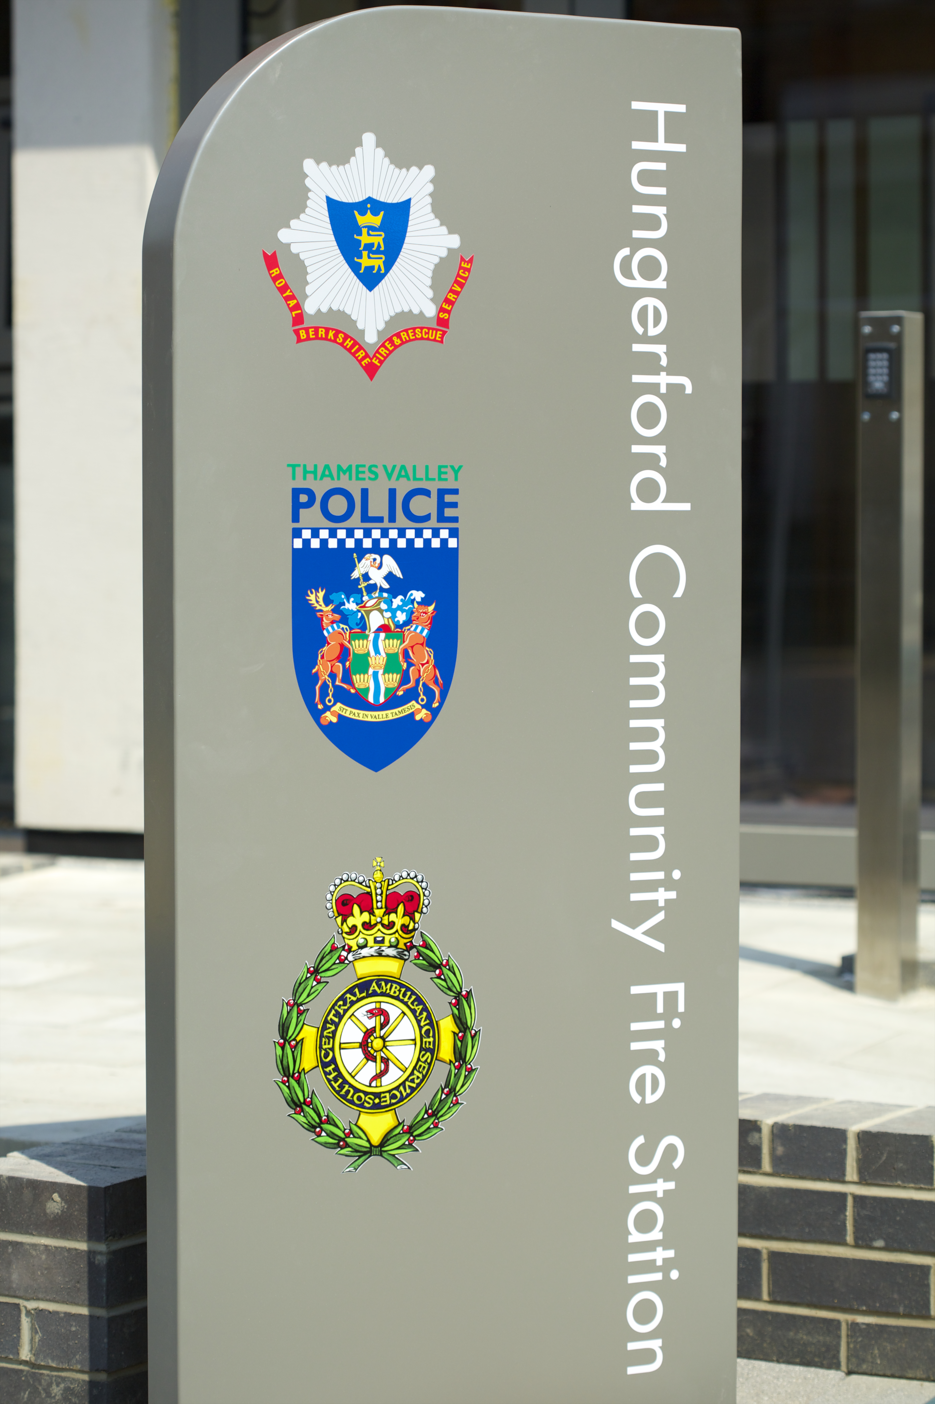
OUR BUILDINGS
The annual refresh and development of the SAIF provides the Fire Authority with a clear view of the long term financial pressures on meeting the planned property improvement, replacement and refurbishment programmes that are urgently needed to ensure the built estate continues to meet its workforce delivery requirements now and into the future.
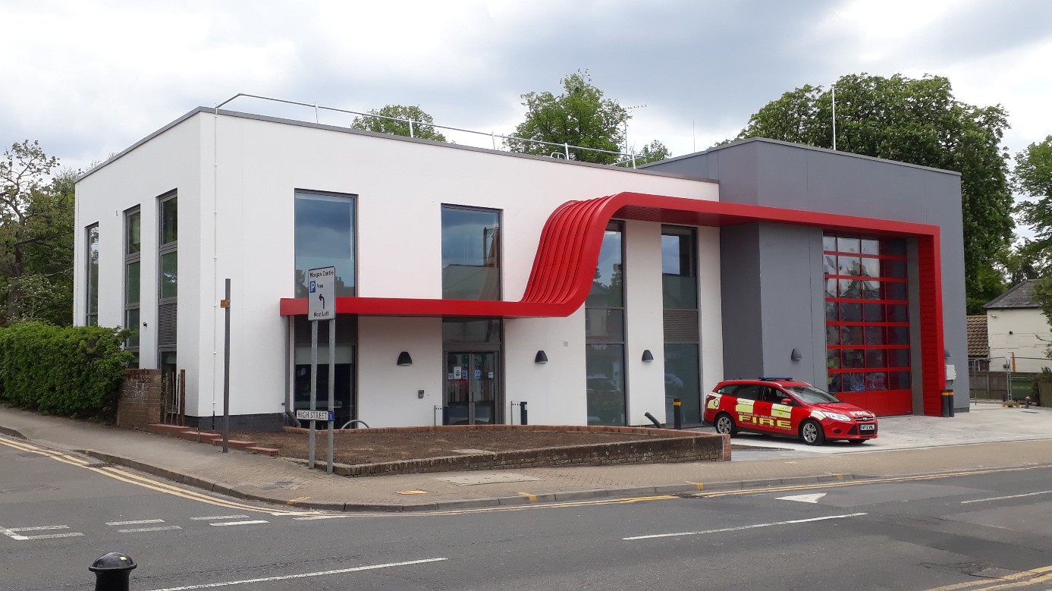
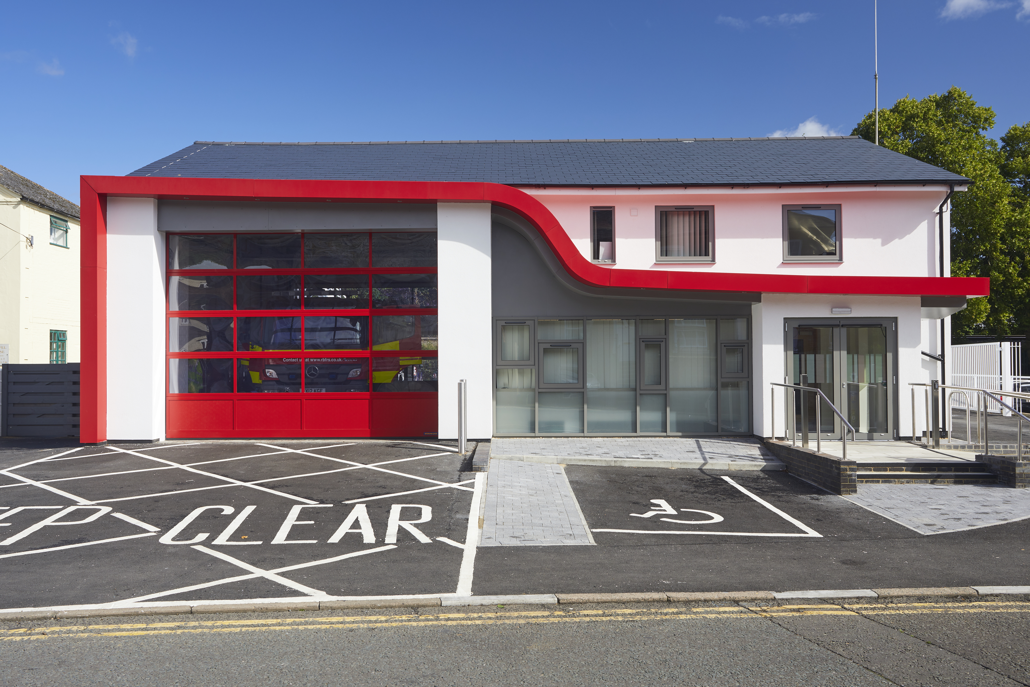
This past year has seen considerable steps towards completing Phase 1, with the successful delivery of the new tri-service wholetime community fire station at Theale in October 2021. The high profile project at Theale was delivered on time and on budget during a period of extreme challenges with the uncertainty brought about by the continuing impacts of the Covid-19 pandemic, as well as the aftermath of the EU transition process that introduced nationwide supply chain issues and risks. A more detailed case study on this project has been included later within this section.

Only one project now remains to be commissioned within Phase 1 – the refurbishment of the Learning & Development facilities based at the Whitley Wood site. The established scope of requirements for the complete re-provision of the facilities is not currently supported by the allocated provision of £2m and this will either need further challenge to the scope or an increased funding allocation. As is now established practice, this project will be developed into a full business case for more detailed consideration by Officers and Members during the coming year.
In continuing to deliver on the investment pathway of this framework, the small in-house Capital Projects team are not only meeting the strategic direction of the Authority, but working hard with end-users to ensure that what is delivered meets their specific operational needs and supports a more diverse workforce. The project elements of ‘Collaboration, Co-ordination and Communication’ are front and centre in the team’s thinking, ensuring that the valuable investment by the Fire Authority is fully aligned across all Service departments.
Member oversight continues to be a key component of the success of the property capital strategy. This is led by the Lead Member for Strategic Assets, ably supported by Members of the Property Development Working Group.
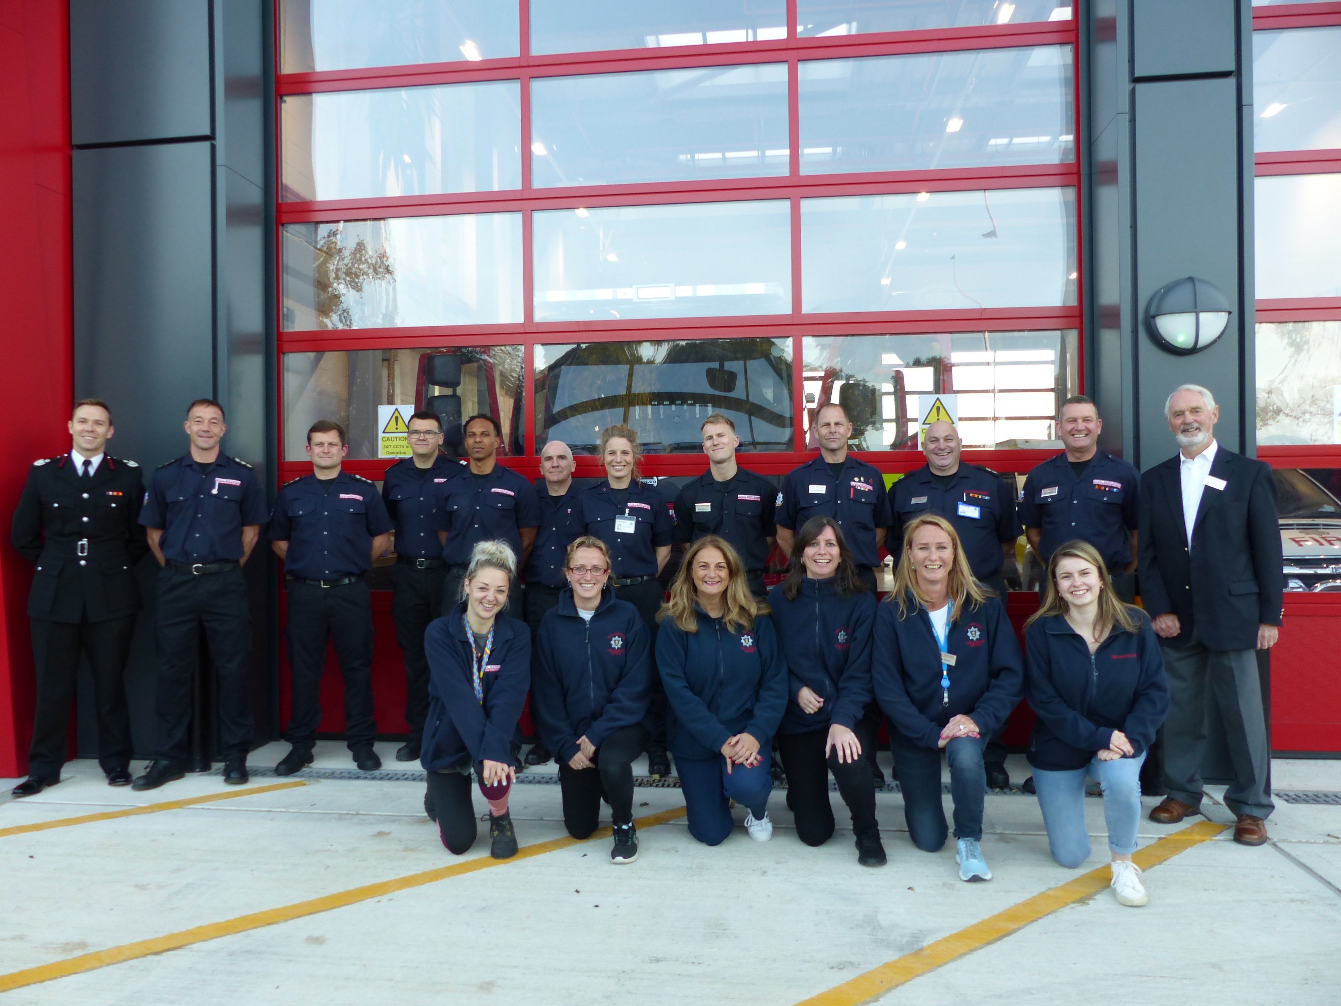
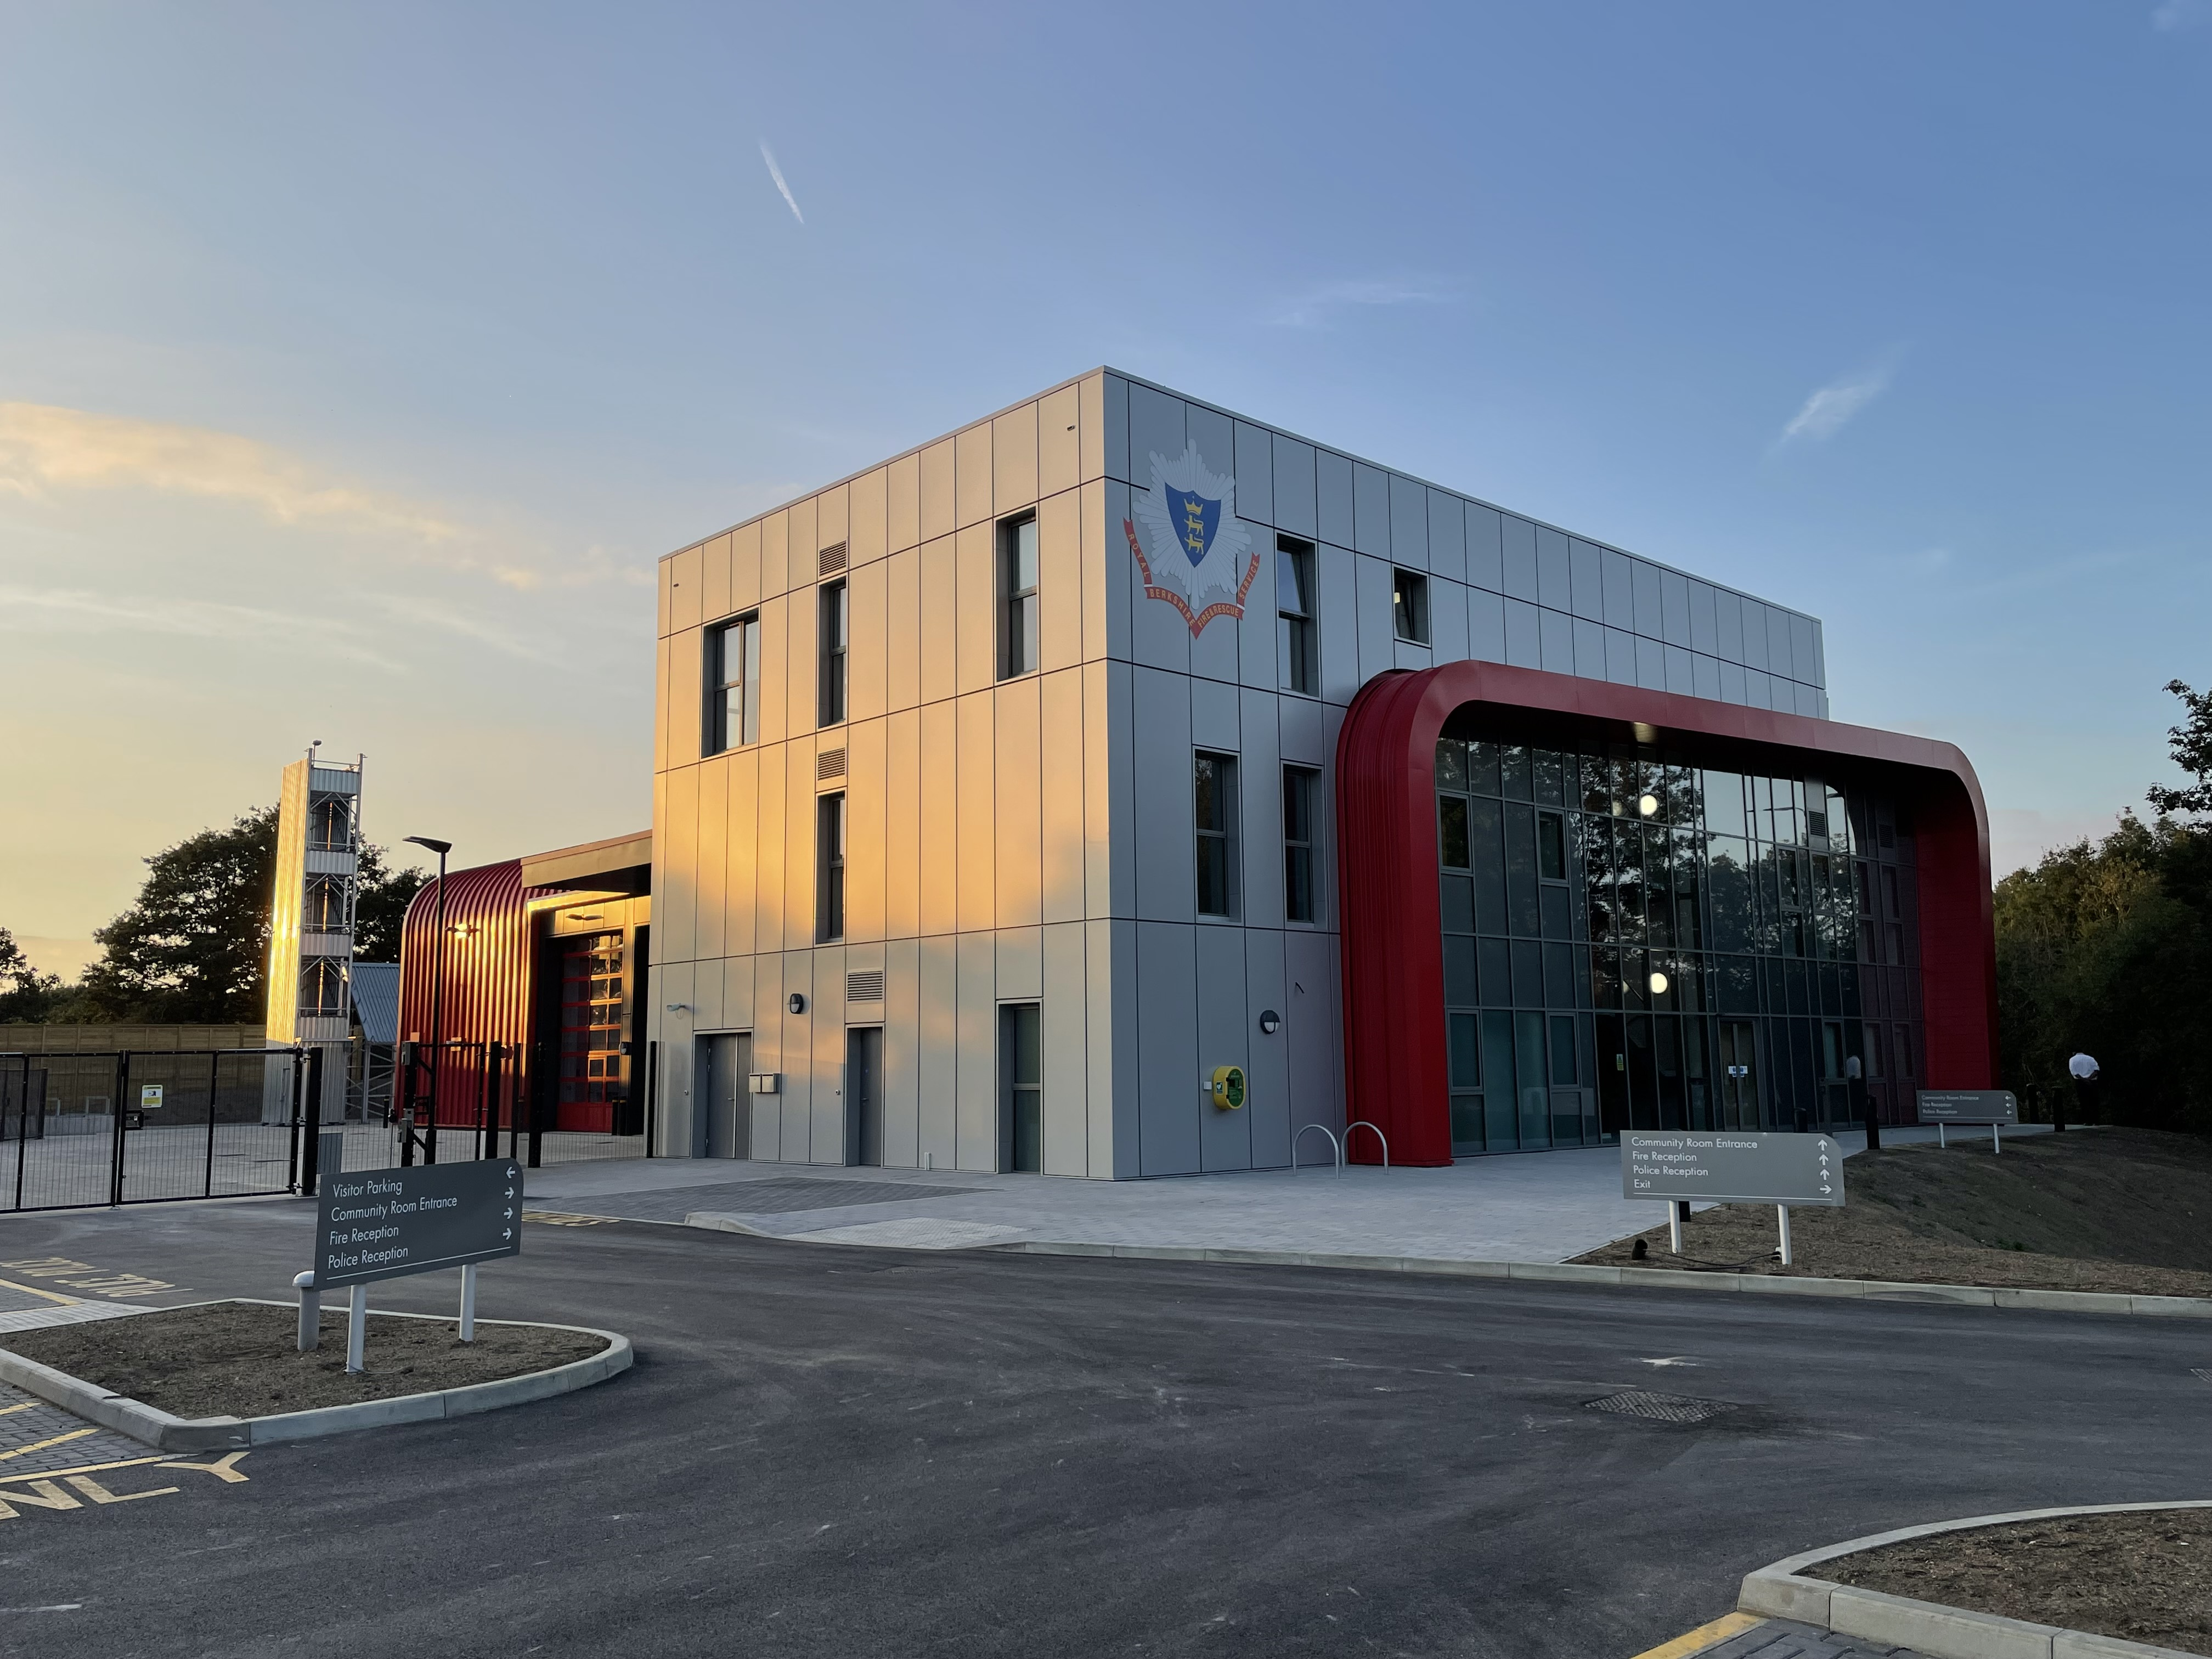
Whilst it is anticipated that the successful delivery of the Asset Release Programme will now provide additional capital receipts compared to initial estimates, these receipts will still be insufficient to bridge the funding gap in relation to the property element of the SAIF. It is therefore essential to make the most efficient and effective use of these funds to ensure we get the best return on investment. Given the continued lack of large scale capital funding, more creative solutions will need to be explored, such as collaborative ventures with blue light or local authority partners, joint ventures with private sector investors, as well as the opportunity for redevelopment value creation utilising the existing property portfolio where deemed suitable and appropriate.

Understandably, the drive to improve our premises must also include key Service objectives; one of which is making our buildings fully accessible and supportive of a more diverse workforce. The planned work within the first tranche of the Authority approved Minor Capital Works Programme, totalling £1.25m, focuses on three key themes. Firstly, as mentioned, we need to ensure that our properties support a more diverse workforce; secondly, the works will provide suitable separation of operational and ‘clean’ areas to prevent cross contamination in the workplace; and finally there will be a focus on improving the general working and living environments for all of our staff based on fire stations. There will need to be a continued investment in future phases of the Minor Capital Works Programme until sufficient capital investment can be secured to re-provide our key property assets.
Following on from “Cop-26: Towards a more sustainable, low-carbon world”, the Fire sector must do far more to reduce its carbon footprint to achieve the Government’s aim of Carbon Net Zero by 2050. For the Authority, the first step in terms of our built estate is to establish a baseline of our current carbon emissions; only then will we be able to track our positive steps in reducing those emissions. This will require targeted investment to first identify and then invest in ways to reduce our carbon output.

Theale Case Study
One of the high profile projects within Phase 1 of the SAIF was the successful delivery of a new tri-service community wholetime station at Theale. This station will strengthen the Service’s reach into West Berkshire, as well as playing its part in supporting an efficient delivery of operational response to the whole county. Providing a new blue light hub will also support closer working and property sharing with our colleagues within the police and ambulance services, further strengthening the emergency response to the local communities and also supporting a more efficient use of public sector property. In line with the Authority’s Vision, this station will also provide facilities that will support community use of public assets.

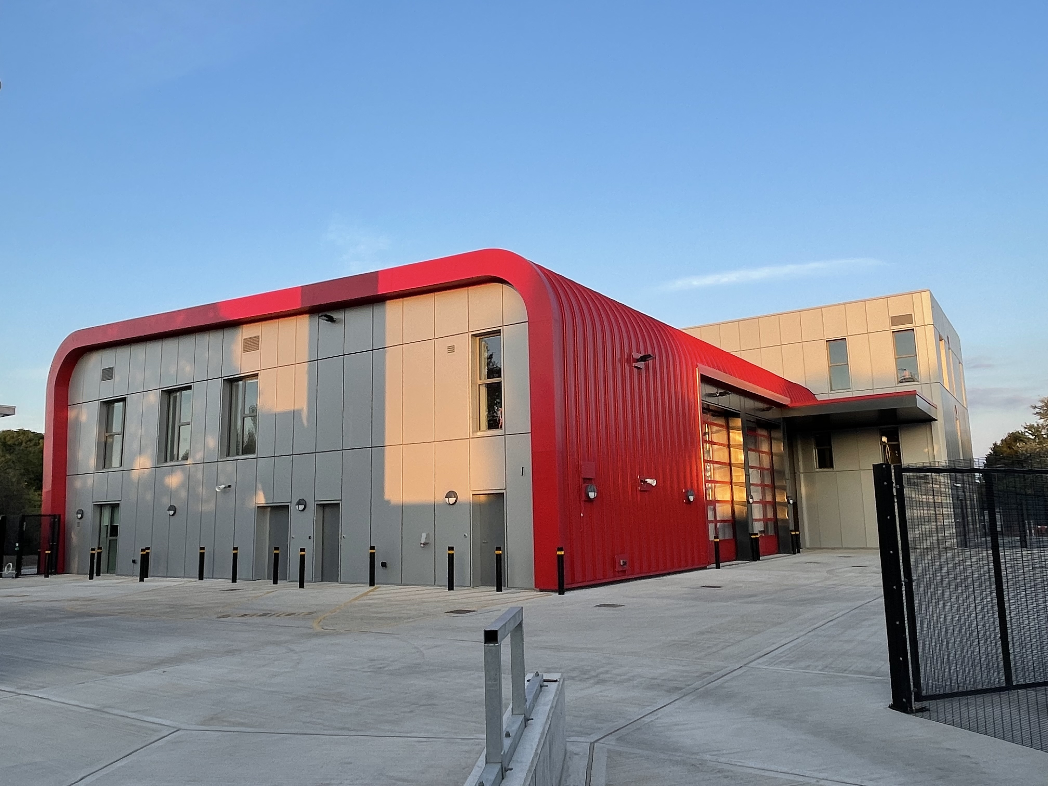
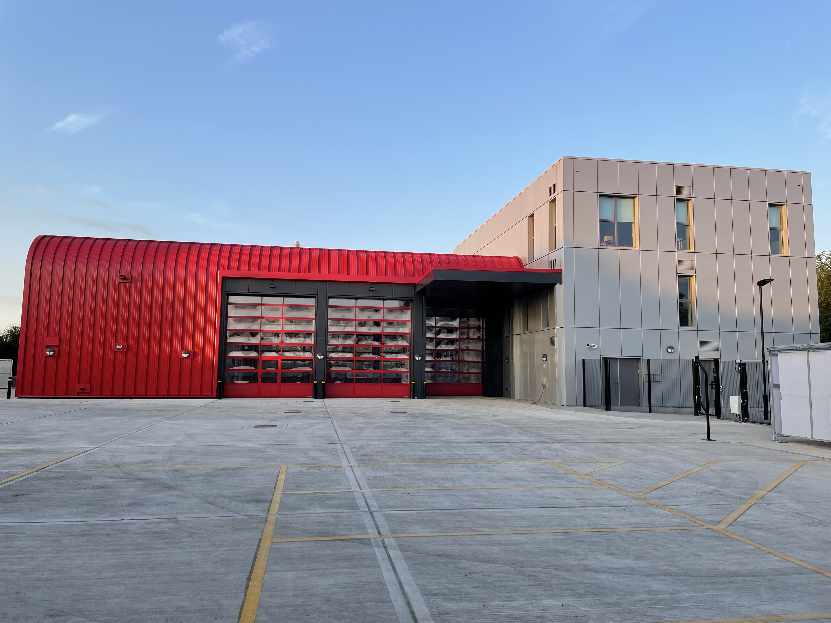

The Capital Projects team were able to build on the previous capital investment success at Hungerford and Crowthorne. Utilising the lessons learned from these two projects, the team were able to fine tune the collaborative design aspects to further enhance working relationships between all site users. In terms of wider Service requirements, the new station fully aligns with our People Strategy, by providing facilities that support a more diverse workforce and the entire station is fully accessible to any user.
Ensuring that the station is fully utilised, there are areas for any member of staff to use as a touchdown or team space, further strengthening the ties between operational and corporate members of staff. Another key area of focus was with regard to introducing suitable work flows around the station to avoid the potential for contaminant transfer between operational and non-operational areas. This station now sets a strong best practice baseline for the Service, clearly separating key areas to ensure the best possible working conditions.
The successful completion of this project in terms of quality, time and cost is a continuing demonstration of the sound strategic planning of the Authority and the strong working relationship between Officers and Members.

Disposals

Following the opening of the new wholetime fire station at Theale, the Service has successfully brought three sites to the market for disposal during the last year – Wargrave, Pangbourne and Dee Road. These sites were identified for disposal as part of the 2017 Service Redesign and the receipts from these sales will fund future phases of the SAIF.

All properties are disposed of in accordance with the Authority’s Guiding Principles for Property Asset Release to ensure full transparency in relation to the management of valuable assets.

Future Phasing of Property Projects
Property projects have been grouped into four phases. Provision for the costs of Phase 1 has been built into the Fire Authority’s Medium Term Financial Plan. The projects listed in subsequent phases have been grouped based on the capacity to undertake the necessary work and the service delivery needs of the organisation. It should be noted however, that through the Thames Valley Collaboration Programme, the Berkshire One Public Estate Programme and the future CRMP processes, this ordering may change.
The Fire Authority has also built in the necessary due diligence processes to scrutinise and approve the building of new fire stations and major redevelopments. The move from making provision to authorising spend can only be agreed by the Fire Authority once funding is in place and the appropriate feasibility studies and tendering exercises have been completed.

 | Phase 1  to 2023/24 | Phase 2  2024/25 – 2027/28 | Phase 3  2028/29 – 2031/32 | Phase 4  2032/33 – 2036/37
New Fire Stations | Theale  (completed)  £9.2m
Major Redevelopment | Hungerford  (completed)  £0.8m | Langley  £5.5m | Newbury  £5.5m | Maidenhead  £1m
 | Whitley Wood Firehouse  (completed)  £0.35m | Slough  £5.5m | Lambourn  £1.5m | Mortimer  £1.5m
 | Crowthorne  (completed)  £2.1m | Wokingham Road  £2m | Ascot  £2m | Whitley Wood Fire Station  5.5m
 | Whitley Wood Learning & Development Centre  £2m | Caversham Road  £5.5m | Bracknell  £5.5m
Minor Works | £1.25m | £0.52m | £0.52m | £0.71m
Total | £15.7m | £19.02m | £15.02m | £8.71m

OUR FLEET
The RBFRS fleet has undergone a significant transformation in recent years following the strategic vision and investment made by the Fire Authority in Phase 1 of the SAIF. Since an initial fleet review conducted in 2015 identified RBFRS as having the second oldest pumping appliance fleet amongst English fire and rescue services, the Fire Authority have purchased 19 new front line pumping appliances. These appliances have been procured in collaboration with Oxfordshire and Buckinghamshire & Milton Keynes Fire and Rescue Services and provide our staff with a modern and efficient fleet that can deliver an effective service to the residents of Berkshire.
The investment by the Fire Authority in Phase 1 of the SAIF has also included the purchase of an Aerial Ladder Platform which was procured as part of a collaborative procurement process in partnership with Oxfordshire and Staffordshire Fire and Rescue Services. The appliance became fully operational in August 2021.
The Fire Authority approved the purchase of a replacement 4x4 appliance at Maidenhead and the purchase of 4x4 multi role utility vehicles, which support our on-call stations, provide additional resilience during periods of adverse weather and due to their multi use, support further rationalisation of the overall fleet. These vehicles have all come into Service in 2021 and have increased the Service’s 4x4 capabilities.
Recent investment in white fleet (support vehicles) has seen orders placed for the Service’s first alternative fuel vehicles. Manufacturing delays and the global pandemic have meant extended lead times on delivery but it is anticipated that these vehicles will be on the fleet in the autumn of 2022. These vehicles will represent the start of a transition to a more sustainable and green fleet where operationally and financially viable.

Aerial Ladder Platform (ALP) Case Study
The Aerial Ladder Platform (ALP) previously used by RBFRS was a Cela/Magirus ALP, mounted on a Daimler Benz Econic chassis. This was the only ALP of its type in the UK, after the retirement of a similar design of vehicle from London Fire Brigade. The vehicle was becoming increasingly unreliable with the availability of spare parts becoming more difficult to obtain causing lengthy repair times.

The procurement exercise to purchase a new ALP was done in collaboration with Oxfordshire Fire & Rescue Service who were also purchasing a new ALP. The collaborative nature of the project worked well with opportunities to learn and share best practice with the partners in the project. The tender evaluation was also more robust with multiple parties able to challenge the responses and each other to ensure that all areas were well understood and assessed fairly.
By forming a user group early on, made up of end users and ALP instructors from Whitely Wood fire station, it was possible to fully capture all requirements. It also meant that if any elements of the user requirement were unachievable users were fully involved in the decision making process to resolve the issue.

End user engagement revealed that the previous ALP was limited at incidents by a lack of horizontal outreach. The vehicle specification was developed after the Grenfell Tower fire which enabled lessons to be drawn from that incident. A review of the current and planned building stock in Royal Berkshire showed a trend towards taller buildings being built where height would be an advantage to the vehicle. It also revealed a trend for large area commercial buildings being developed along the main transport corridors where outreach would be an advantage. As height and outreach are characteristics of the vehicle that are directly linked, the specification was developed to target a vehicle with a height greater than 40 meters to improve both vertical and horizontal reach.

The vehicle build was tracked closely by the project delivery team with a very robust acceptance testing program put in place. This uncovered several deficiencies with the quality of the build and provided ample opportunity for those deficiencies to be corrected before the vehicle ownership was transferred to RBFRS. This meant that they were corrected prior to final invoicing and no additional costs were incurred. It also reduced the likelihood of the vehicle having to be removed from service for a prolonged period of time after becoming operationally available, due to quality issues.

Despite the production delays caused by the pandemic, the vehicle became fully operational in August 2021. The user group was central to the final delivery of the vehicle onto station and in delivering the training required to bring the vehicle into operation. The residents of Berkshire now have a 45m Bronto Skylift ALP on a Volvo chassis that provides improvements in height and reach capabilities from the previous 32m ALP.

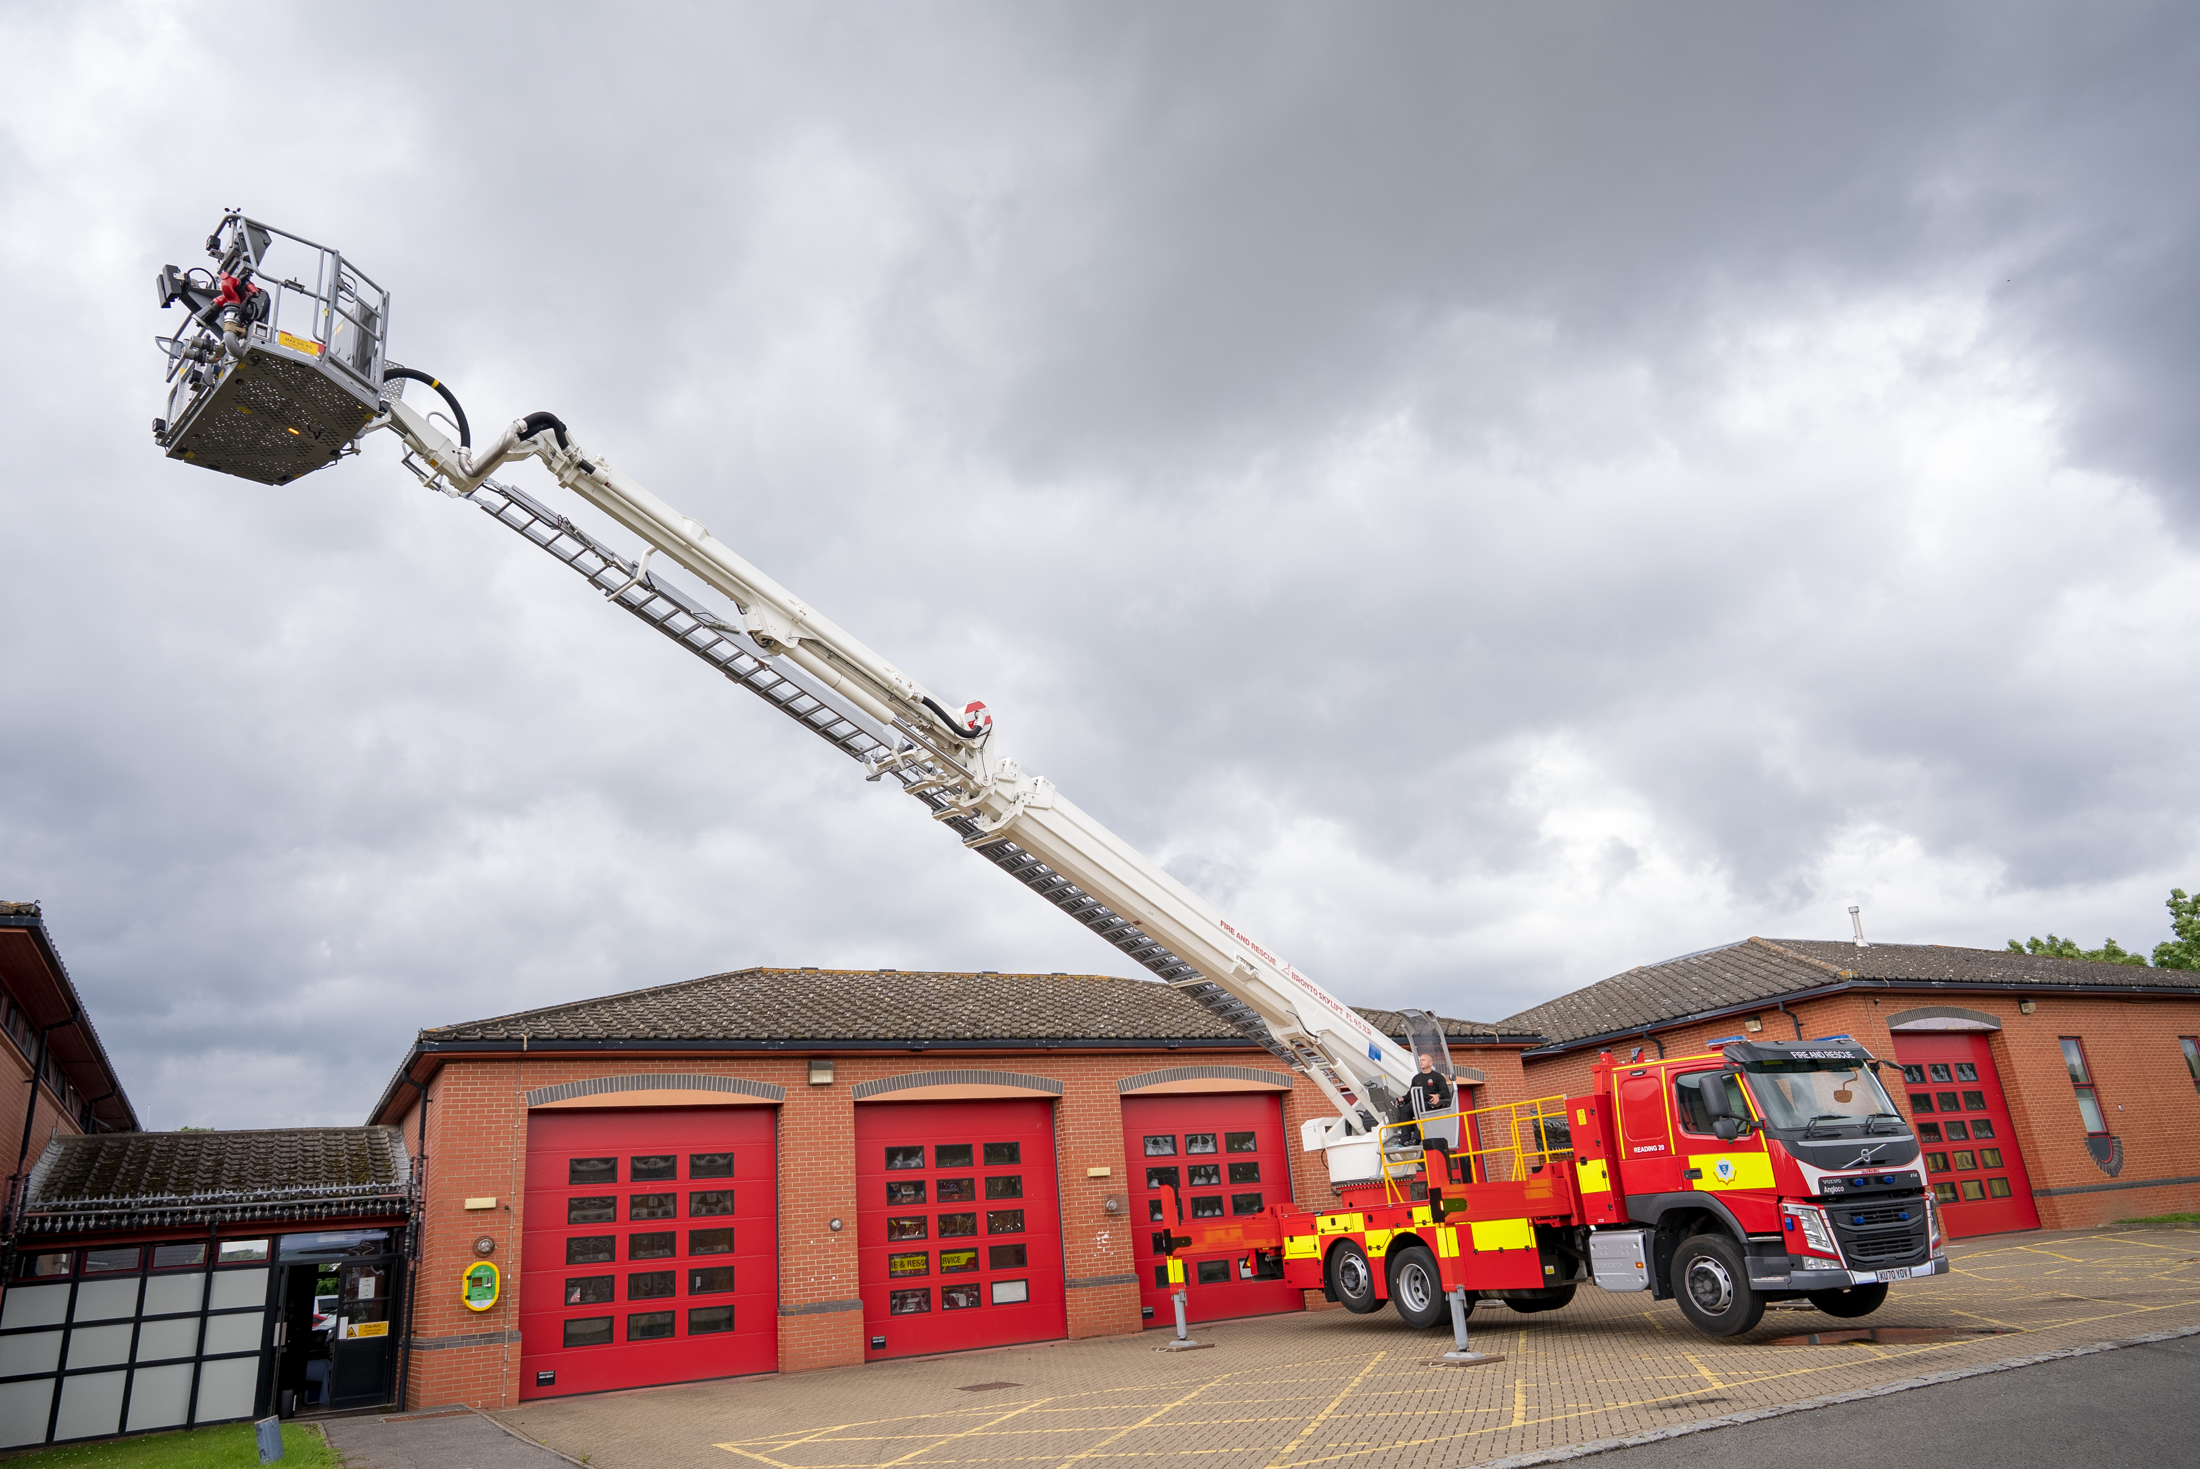

Future Phasing of Fleet & Equipment Projects
The phasing of works is purely indicative and based on operational requirements as well as opportunities to work with partners, any of which may alter the phasing of the works.
To continue to build on our current success, and as we move through towards the end of Phase 1 and into Phase 2, the renewal of further specialist appliances and white fleet vehicles will be required. Work to define functional requirements of technical rescue and operational support capabilities will continue in 2022-23, and where operationally viable seek to develop combined functionality within vehicles to maximise efficiency and continue to further rationalise overall fleet numbers. Greater use of short-term hire contracts will also support continued rationalisation of the white fleet, thereby reducing both on-going capital and revenue expenditure in future years.
The transition towards alternative fuelled vehicles, in line with wider environmental impact reduction initiatives as well as the development of organisational sustainability goals, is something that we will look to continue for the coming year, with a view to this informing elements of the future Fleet Strategy which is due to be refreshed in 2023. The aim is to reach a steady state rolling fleet replacement over the coming years to continue on the journey of fleet improvements which will provide a fit for purpose modern fleet from which RBFRS can effectively and efficiently deliver its services to the people of Berkshire.

 | Phase 1  to 2023/24 | Phase 2  2024/25 – 2027/28 | Phase 3  2028/29 – 2031/32 | Phase 4  2032/33 – 2036/37
Fleet | Fire Appliances  (completed)  £4.847m | Fire Appliances  £2.25m | Fire Appliances  £2.45m | Fire Appliances  £3.25m
 | Special Appliances  £0.985m | Special Appliances  £0 | Special Appliances  £0.19m | Special Appliances  £0
 | Aerial Ladder Platform  (completed)  £0.756m | Aerial Ladder Platform  £0 | Aerial Ladder Platform  £0 | Aerial Ladder Platform  £0
 | Other Ancillary Vehicles  £0.486m | Other Ancillary Vehicles  £0.32m | Other Ancillary Vehicles  £0.4m | Other Ancillary Vehicles  £0.5m
Equipment | Other Equipment  £0.972m | Other Equipment  £0 | Other Equipment  £0 | Other Equipment  £0
Total | £8.046m | £2.57m | £3.04m | £3.75m

OUR ICT
ICT is a key enabler and data is a core business asset. Both need to be effectively managed, keeping in-step with appropriate technological changes, national initiatives and security standards in order to support and improve the Service that we provide to the people of Berkshire.
The advent of a global pandemic, as well as other external factors, has increased the cost of some key elements of the ICT strategy, particularly in the hardware space, which has resulted in anticipated expenditure for 2022/23 being £191,000 higher than previous estimates. However, these increases have been mostly offset by spreading hardware replacement spending to span the final year of Phase 1 and the first year of Phase 2. Overall, these changes mean a slight increase in Phase 1 expenditure of £29,000 compared to last year’s SAIF.

The pandemic, RBFRS’ reaction to it, and the transition into the “new normal” has fully validated the current ICT strategy. Much progress has been made in consolidating RBFRS’ collaboration platforms and work is underway to implement the core network upgrades funded in the 2021/22 financial year. With foundational work well underway, in the coming year RBFRS ICT will focus on refreshing our operational communications equipment to provide modern, fit-for-purpose, and secure Mobile Data Terminals, Fireground radios, and Station End mobilising equipment. Where applicable, all equipment will comply with the future Emergency Services Network, meaning that further investment within the normal working life of the equipment will be minimised as far as possible. Additionally, funding will be allocated to increasing accessibility to mobile data services across RBFRS staff, in order to support future opportunities for increased deployment of mobile apps and automated workflows, and to further increase opportunities for flexible working.
The categorisation of investments to support the ICT Strategy, is unchanged from the previous year. The structure therefore retains five key categories:

- Hardware
- Software
- Network infrastructure
- Services
- Emergency Services Mobile Communications Project

Microsoft Teams Case Study
As part of the response to the global pandemic, and reflected in the SAIF update for 2021/22, much effort was expended in a short period of time to implement remote meeting and collaboration capabilities across the service. This initially took the form of a tactical product which offered some opportunities in terms of ease and speed of deployment. It was recognised however that this should be replaced as soon as practicably possible with a more strategically aligned product that offered downstream opportunities for greater integration with other desktop applications.
Microsoft Teams is an intrinsic element of the Microsoft 365 suite of productivity and group collaboration applications. Microsoft 365 was scheduled for deployment across RBFRS in 2022/23 & 2023/24 as part of the ICT Strategy action plan. The pandemic accelerated these plans by over a year.
From having no effective remote collaboration tools to fully embedded Microsoft Teams ubiquitously deployed across the organisation took place over the period of about 12 months. The journey was neither straightforward nor without its challenges.

In total the ICT team managed to deploy, refine, guide and embed the sequential implementation of one strategic and three tactical collaboration tools during the height of the pandemic.
Microsoft Teams several overall benefits to the organisation:
- Removing or reducing the necessity for individuals to physically travel between locations to meet, offering a significant time saving and reducing travel expenses costs;
- Better integration with other Microsoft tools notably email and calendar. This makes scheduling and joining meeting significantly simpler than other tools;
- The introduction of presence indicators – instantly and pervasively shows individuals work status – offline, free, busy and do not disturb. This allows users to make better choices in ways to interact with each other;
- Better management of preventative measures against ongoing COVID-19, notably minimising the need to hire large venues for meetings to adhere to social distancing restrictions;
- The introduction of group collaboration work spaces for persistent storage and access to meeting based content – material, comments, recordings, polls etc.
- The possibility to automate certain workflows that currently rely on manual activity;
- Full alignment with the other Thames Valley Fire and Rescue Services as well as many others nationally who are using the same collaboration tools.

The programme was completed in mid-2021 and has been highly successful in delivering against all of the above benefits. The deployment was carried out with no major outages or service disruption. When pandemic restrictions were relaxed, many staff continued to use Teams as their preferred meeting tool in order to minimise travel time and/or in support of their work/life balance.

Future Phasing of ICT Projects
The phasing of works is purely indicative and based on business needs, keeping in step with appropriate technological advances, national initiatives and security standards; any of which may alter the phasing of works.
 | Phase 1  to 2023/24 | Phase 2  2024/25 – 2027/28 | Phase 3  2028/29 – 2031/32 | Phase 4  2032/33 – 2036/37
ICT | Hardware  £1.466m | Hardware  £ 1.162m | Hardware  £1m | Hardware  £1.25m
 | Software  £0.779m | Software  £0.235m | Software  £0.16m | Software  £0.2m
 | Services  £0.665m | Services  £1.304m | Services  £1.344m | Services  £1.9m
 | Networks  £0.538m | Networks  £0.32m | Networks  £0.32m | Networks  £0.4m
 | ESMCP  £0.191m | ESMCP  £0m | ESMCP  £0 | ESMCP  £0
Total | £3.639m | £3.021m | £2.824m | £3.75m

GENERATING CONTRIBUTIONS TO RUNNING COSTS FROM ASSETS
Thames Valley Fire Control Service Case Study

The Thames Valley Fire Control Service (TVFCS), based at RBFRS’ Headquarters, was established in 2015 to answer 999 calls and mobilise fire engines to incidents across the Thames Valley. TVFCS operates on behalf of the three Thames Valley fire and rescue services, serving a combined population of over two million people.

This collaboration delivers a single joint emergency call handling, mobilising and resource management function, which has delivered significant cost efficiencies to all three fire services. Increased resilience, efficiency and improved performance is resulting in collective savings of over £1 million a year.
Whilst the initial cost of the control centre was funded by grants from Government, it was decided that a renewals fund should be set up to fund an IT refresh half way through the current agreement which ends in 2030. A decision regarding the extent and form of this refresh will be taken in 2022/23.

FINANCIAL IMPLICATIONS
As evidenced by the recent HMICFRS inspection, Royal Berkshire Fire and Rescue Service is delivering an effective and efficient service that meets the needs and expectations of residents and taxpayers within the County.
When considering the renewal or enhancement of our capital assets, we consider the extent to which capital expenditure increases the effectiveness and efficiency of the organisation, thus, balancing the needs of the users of our services against the needs of those who are required to fund those services. An example of this is the new Fire Station at Theale which will provide better response times to high risk areas than current arrangements. In addition, the running costs of a newly built fire station with the same footprint are over 40% lower than the running costs of existing fire stations.
The Authority has committed to financing Phase 1 of the SAIF through a mixture of revenue funding, earmarked reserves, capital receipts and additional borrowing. However, the level of resources required to deliver Phase 2 in a similar manner do not exist. With this in mind, the Fire Authority has chosen to use the flexibility granted by the Government for the financial year 2022/23 to increase the precept by £5. This will not only go some way to balancing the Revenue Budget over the medium-term, but just as importantly, it will also be used to provide some funding for capital projects.
This additional precept funding, along with capital receipts due in 2022, will form the basis for planning for Phase 2 of the SAIF, although it must be emphasised that these sources of finance are still insufficient to meet all of our capital requirements going forward. It will therefore be necessary to consider different approaches to allow the progression of Phase 2. As an example, where appropriate, we could work with partners and other stakeholders to explore joint-venture options which could lead to the building of a new fire station at a reduced cost to the Authority.
Whilst recognising that novel approaches to enhancing our properties may be possible in some instances, it remains the case that such options will be limited. Much work therefore needs to be done over the next 12 months to develop a financially and environmentally sustainable capital programme for Phase 2 based on the limited resources available.
Finally, given the capital-intensive nature of fire and rescue services, the Authority is keen to see the establishment of a national Transformation Fund against which fire authorities could bid to secure funding for capital projects that are both environmentally sustainable and deliver savings in running costs.

Summary of Capital Investment Requirements
 | Phase 1  to 2023/24 | Phase 2  2024/25 – 2027/28 | Phase 3  2028/29 – 2031/32 | Phase 4  2032/33 – 2036/37
Buildings | £15.7m | £19.02m | £15.02m | £8.71m
Fleet & Equipment | £8.046m | £2.57m | £3.04m | £3.75m
ICT | £3.639m | £3.021m | £2.824m | £3.75m
Total | £27.385m | £24.611m | £20.884m | £16.21m

The total provision since the start of Phase 1 of the Strategic Asset Investment Framework is £89.09 million.

GOVERNANCE ARRANGEMENTS
Approval by Senior Leadership Team (SLT)
Final business case for project
Approval by Fire Authority
Approval by SLT
Approval by Fire Authority
Approval by SLT
Stakeholder engagement in relation to individual projects
Procurement process
Outline business case for project
15-year Strategic Asset Investment Framework
Appropriate oversight and scrutiny by officers / members depending on scope and scale of project
Approval by Fire Authority
Project proposal developed by officer working group
Project implementation

